CENTURY Tutorial

Supplement to CENTURY User’s Manual

(Please Note that EVENT100 and FILE100 are no longer distributed with Century. All schedule and parameter files must be created and edited in a text editor).

Bill Parton

Dennis Ojima

Steve Del Grosso

Cindy Keough

Table of Contents

1. CENTURY Model Overview 1

1.1. Introduction 1

1.2. CENTURY Model Description 1

1.3. Soil Organic Matter Model 4

1.4. Soil Water and Temperature Model 10

1.5. Plant Production and Management Model 12

1.6. Use and Testing of the CENTURY Model 15

1.7. DAYCENT Model Description 16

2. Downloading and Installing the PC Version of CENTURY 18

3. CENTURY, Associated Files, and Utility Programs 20

4. Preparing for a CENTURY Simulation 24

5. Running CENTURY and its Utility Programs 26

5.1. FILE100 27

5.1.1. Reviewing All Options 28

5.1.2. Adding an Option 28

5.1.3. Changing an Option 29

5.1.4. Changing the <site>.100 File 30

5.1.5. Deleting an Option 32

5.1.6. Comparing Options 32

5.1.7. Generating Weather Statistics 33

5.1.8. XXXX.100 Backup File 34

5.2. EVENT100 35

5.2.1. The Concept of Blocks 35

5.2.2. Defaults and Old Values 36

5.2.3. What EVENT100 Needs 37

5.2.4. Using EVENT100 37

5.2.5. Explanation of Event Commands 42

5.2.6. Explanation of System Commands 45

5.2.7. The -i Option: Reading from a Previous Schedule File 48

5.3. CENTURY 49

5.4. LIST100 50

6. Viewing CENTURY Output Listing from LIST100 51

6.1. Using a text editor 51

6.2. Using Microsoft Excel 51

6.3. Create a Graph of Your CENTURY Output in Microsoft Excel 51

7. CENTURY Output Variables 54

8. Advanced Options 63

8.1. Run LIST100 Using Command Line Parameters 63

8.2. Run CENTURY Using a DOS Batch File 64

8.3. Combining the Above Options 65

9. Appendices

Appendix 1 Literature on CENTURY model Appendix 1-1

Appendix 2 CENTURY Output Variables - By Category Appendix 2-1

CO2 Output Variables Appendix 2-1

Crop and Grass Output Variables Appendix 2-4

Forest Output Variables Appendix 2-6

Nitrogen Output Variables Appendix 2-9

Phosphorus Output Variables Appendix 2-14

Soil Output Variables Appendix 2-18

Sulfur Output Variables Appendix 2-22

Water and Temperature Output Variables Appendix 2-27

Appendix 3 CENTURY Parameterization Workbook Appendix 3-1

<site>.100 Appendix 3-1

crop.100 Appendix 3-12

tree.100 Appendix 3-17

fix.100 Appendix 3-26

Appendix 4 CENTURY Command Lines Appendix 4-1

Figures

Figure 1-1 Overall flow diagram for the CENTURY model. 2

Figure 1-2 Flow diagram for the soil carbon submodel. 4

Figure 1-3 Impact of soil temperature (a) and rainfall (b) on decomposition. 5

Figure 1-4 Flow diagram for the nitrogen submodel. 6

Figure 1-5 Flow diagram for the phosphorus submodel. 7

Figure 1-6 Flow diagram for the water flow submodel. 9

Figure 1-7 Flow diagram for the grassland/crop submodel. 11

Figure 1-8 Flow diagram for the tree growth submodel. 12

Figure 1-9 General flow diagram for the DAYCENT model. 15

Figure 3-1 The CENTURY model environment showing the relationship between programs and the file structure. 19

Figure 7.1 Flow diagram for the grassland/crop submodel. 50

Figure 7-2 Flow diagram for the forest production submodel. 51

Figure 7.3 Flow diagram for the water submodel. The structure represents a model set up to operate with NLAYER set to 5. 52

Figure 7-4 The pools and flows of carbon in the CENTURY model. The diagram shows the major factors which control the flows. 53

Figure 7-5 The pools and flows of nitrogen in the CENTURY model. The diagram shows the major factors which control the flows 54

Figure 7-6 The pools and flows of phosphorus in the CENTURY model. The diagram shows the major factors which control the flows. 55

Figure 7-7 The pools and flows of sulphur in the CENTURY model. The diagram shows the major factors which control the flows. 56

1. CENTURY Model Overview

**1.1. Introduction**

This document presents information about the monthly version of the CENTURY Model (Version 4.0). We will also present an overview about the status on the DAYCENT model which simulates plant-soil systems using a daily time step. The DAYCENT model is capable of simulating detailed daily soil water and temperature dynamics and trace gas fluxes (CH4, N2O, NOx and N2) which are not simulated in CENTURY Version 4.0.

The CENTURY model is a generalized plant-soil ecosystem model that simulates plant production, soil carbon dynamics, soil nutrient dynamics, and soil water and temperature. The model has been used to simulate ecosystem dynamics for all of the major ecosystems in the world and has been used for the dominant cropland and agroecosystems. The model results have been compared to observed plant production, soil carbon, and soil nutrient data for the most common global natural and managed ecosystems. The model has been used to simulate the response of these ecosystems to changes in environmental driving variables (i.e. maximum and minimum air temperature, precipitation and atmospheric CO2 levels) and changes in the management practices (grazing intensity, forest clearing practices, burning frequency, fertilizer rates, crop cultivation practices, etc.) for grasslands, crop, forest and savanna ecosystems. Appendix 1 includes the list of papers in which the CENTURY model has been used to simulate ecosystem dynamics for different ecosystems. We have provided copies of four of the papers that describe the theoretical basis for the CENTURY model and examples where the model was used to simulate the ecosystem dynamics and compared with observed field data. This document will describe 1) the theoretical basis and overall structure of the model, 2) the procedures used to set up and run the model for a specific site, and 3) the process used to adjust model parameters for best fit representation of site specific ecosystem dynamics.

## 1.2. CENTURY Model Description

The CENTURY model represents plant growth, nutrient cycling, and soil organic matter (SOM) dynamics for grassland, agricultural, forest, and savanna systems (Figure 1-1). The savanna system simulates the growth of trees and grasses (crop growth can also be represented) separately and includes competition for light, nutrients and water. The grass/crop and forest systems have different plant production submodels that are linked to common soil organic and nutrient cycling submodels. The model was developed with the bias that growth of cropland, grassland and forest systems can be increased by adding soil nutrients. The model structure reflects this bias with the soil nutrient cycling and soil organic matter dynamics being represented in great detail, while plant growth is represented using relatively simple submodels.

The soil organic matter and nutrient submodels represent the flow of C, N, P and S in plant litter and different organic and inorganic soil pools, with mineralization of soil nutrients primarily resulting from turnover of soil organic matter pools. The plant production model calculates plant production and allocation of nutrients to live aboveground and belowground compartments as a function of climatic factors and available soil nutrients. The model uses a monthly time step. The major input variables include: 1) monthly precipitation, 2) monthly average maximum and minimum air temperature, 3) soil texture, 4) lignin, N, S, and P content of plant material and 5) soil and atmospheric N inputs. This paper presents a description of the model, the method used to test and validate the model, and a summary of the application of the model for an environmental impact assessment.

Figure 1-1 shows that the major structural components of the CENTURY model are the plant production, soil organic matter, and the soil water and temperature submodels. The plant production submodel calculates potential plant production and nutrient demand as a function of monthly average soil temperature and precipitation, reduces plant production based on available soil nutrients and allocates new C, N, and P to the different live plant compartments. The monthly soil water flow model calculates water balance, soil water storage, soil water drainage and stream flow, while monthly average soil temperature is calculated as a function of aboveground plant biomass. Monthly precipitation, stored soil water, and soil temperature control the rate of decomposition of the soil organic matter pools and the release of nutrients from the SOM pools. The soil organic matter submodel simulates the dynamics of carbon and soil nutrients for the different SOM pools. Decomposition of the SOM pools results in the release of soil nutrients from the SOM pools which is then available for plant uptake. Dead plant material from the plant production submodel flows into the surface and belowground litter pools, which are inputs to the SOM model.

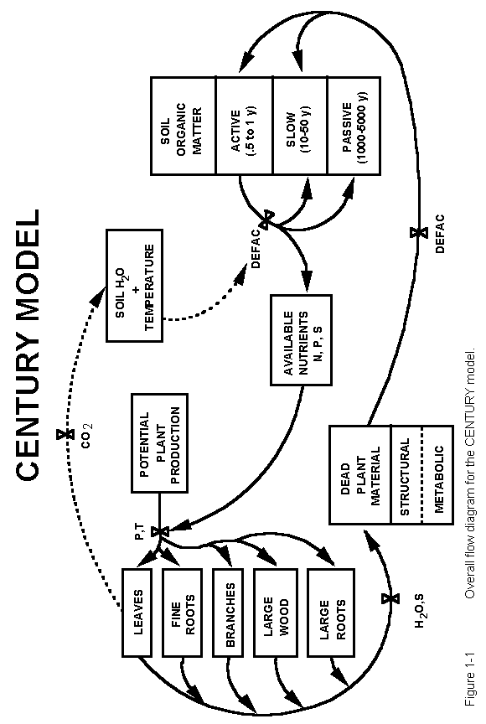

**1.3. Soil Organic Matter Model**

The soil organic matter model simulates SOM dynamics for soil active, slow and passive pools, while dead litter material is represented using aboveground and belowground structural and metabolic pools (Figure 1-2). The active pool (approximately 2% of the total SOM pool) includes soil microbes and microbial products with short turnover times (1-3 months). The slow SOM pool (45 to 60% of total soil SOM) includes resistant plant material derived from structural plant material and stabilized soil microbial products that have turnover times ranging from 10 to 50 years depending on the climate. The passive pool (45 to 50% of total SOM) includes physically and chemically stabilized SOM that is very resistant to decomposition (turnover times from 400 to 4000 years). The structural material includes cellulose, hemi-cellulose and lignin fraction of plant material (resistant to decomposition), while the metabolic material is readily decomposable. Plant litter material is split into structural and metabolic material as a function of the lignin to nitrogen ratio (L:N) of the litter (more structural with higher L:N ratios).

The CENTURY model assumes that decomposition of plant residues and the SOM pools is microbially-mediated with an associated microbial respiration CO2 loss. Microbial respiration losses from decomposition of active SOM increase with the soil sand content (from 30 to 80% as sand content increases to 90%), while microbial respiration losses are approximately 50% for decomposition of all of the other litter and SOM pools. Each of the litter and soil SOM pools have pool specific maximum decomposition rates with the maximum rate being reduced by an abiotic soil decomposition factor that is controlled by the soil moisture and soil temperature (Figure 1-3). The soil temperature function increases exponentially with increasing temperature, while the soil moisture function increases as the ratio of stored water plus current rainfall to potential evapotranspiration increases (the curve is most sensitive to changes in the ratio below 0.6). The decomposition rate of structural litter is also a function of the fraction of the structural material that is lignin (lower for higher fractions) and the lignin fraction of plant material is assumed to flow directly to slow SOM as plant structural material decomposes. The model also assumes that the fraction of the passive pool formed during the decomposition of active and slow SOM increases with clay content. The net effect of the soil texture controls on decomposition of active and slow SOM is to increase soil carbon stabilization for soils with low sand content and high clay content. A through description of the CENTURY SOM model and justification for the approach used in the model are presented by Parton et al. (1994).

The CENTURY model has N (Figure 1-4) and P (Figure 1-5) pools that are analogous to all of the soil carbon pools. The amount of N and P flowing out of a particular pools is equal to the product of the carbon flow out of the pool and the carbon to the element ratio of the pool. A similar approach is used to calculate the flow of different elements into a specific pool but the carbon to element ratio of the receiving pool is a function of the labile inorganic mineral nutrient concentration. Low levels of available nutrients result in high C to element ratios for the different pools. Each pool has an allowable carbon to element ratio. The C:N ratios of the SOM pools are narrow (5-20) compared to the C:P ratios (100 to 400). Mineralization (release of nutrients from SOM) or immobilization of N and P (uptake of nutrients by SOM) occurs as a result of decomposition of dead plant material and the SOM fractions. Immobilization of nutrients into SOM generally occurs during the decomposition of structural plant material (high C:element ratio material), while mineralization of nutrients occurs as a result of decomposition of active and slow SOM (low C:element ratio material). The nutrient content of structural material is quite low and nutrients are immobilized into microbial biomass during decomposition of structural material, while slow and active SOM have high nutrient contents and release nutrients (mineralize) while they are being decomposed. A complete description of the soil nutrient model is presented by Parton et al. (1988).

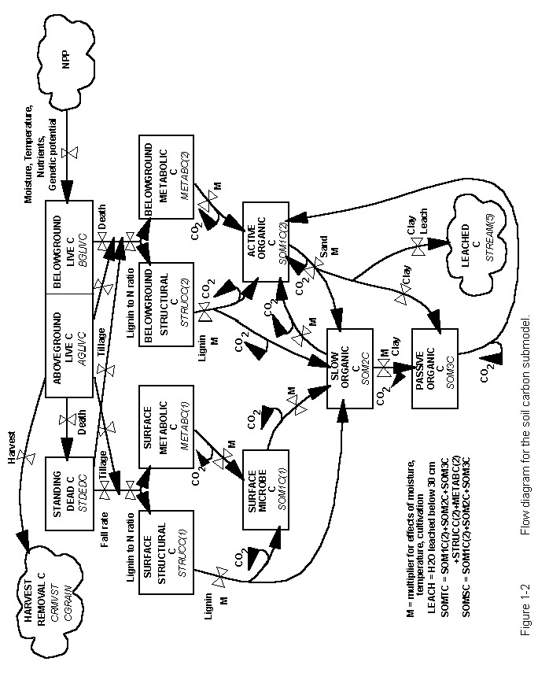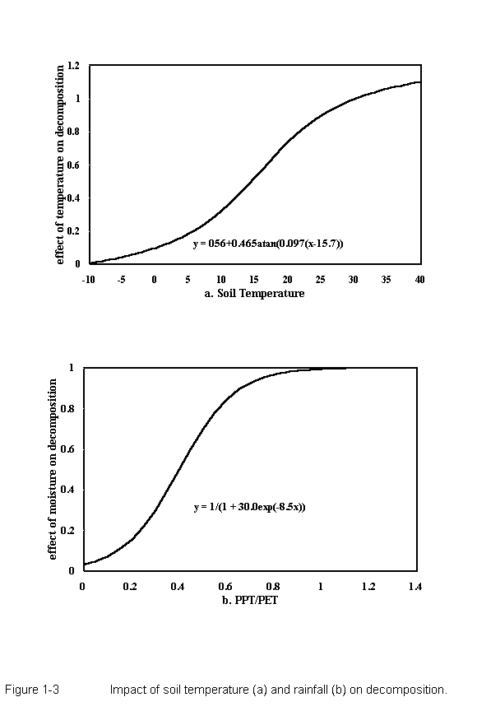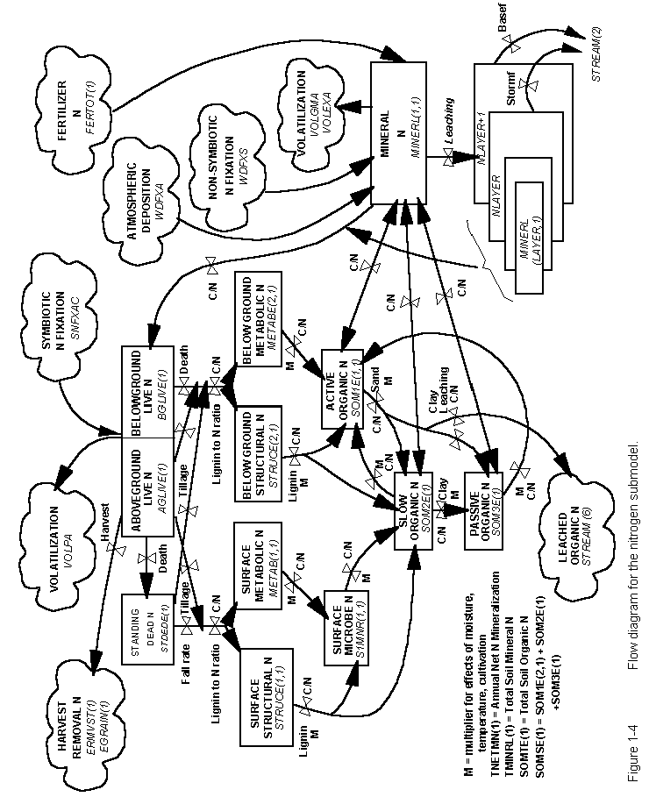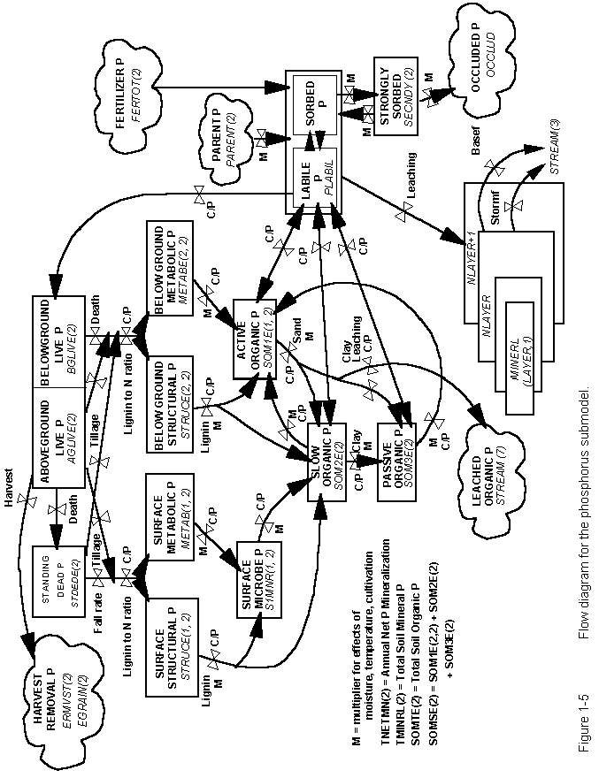

## 1.4. Soil Water and Temperature Model

The CENTURY model uses a simplified water budget model to calculate monthly bare soil evaporation, interception and transpiration water loss, stored soil water, snow water content, stream flow and saturated water flow between soil layers (Figure 1-6). Interception and bare soil water loss are calculated as fractions of the monthly precipitation and are subtracted from monthly precipitation before the water is added to the soil. Bare soil water loss is a function of aboveground biomass (decreasing with increasing biomass), while interception water loss increases with increasing aboveground biomass. Transpiration water increases as a function of live leaf biomass. Water loss occurs first as interception, followed by bare soil water loss and transpiration with the sum not exceeding the potential evapotranspiration (PET) water loss (PET is calculated as a function of maximum and minimum air temperature). Precipitation in excess of PET is stored in soil water layers by adding the water to the top layer.

Near surface average soil temperature (STEMP) is used to calculate the abiotic decomposition rate and the temperature effect on plant growth. STEMP is calculated using equations where the maximum soil temperature is a function of maximum air temperature and the canopy biomass (lower for high biomass) and the minimum soil temperature is a function of minimum air temperature and canopy biomass (higher for high biomass). It is important to note that both the soil water balance and soil temperature models include the effect of simulated live and dead aboveground plant biomass on soil temperature and soil water balance.

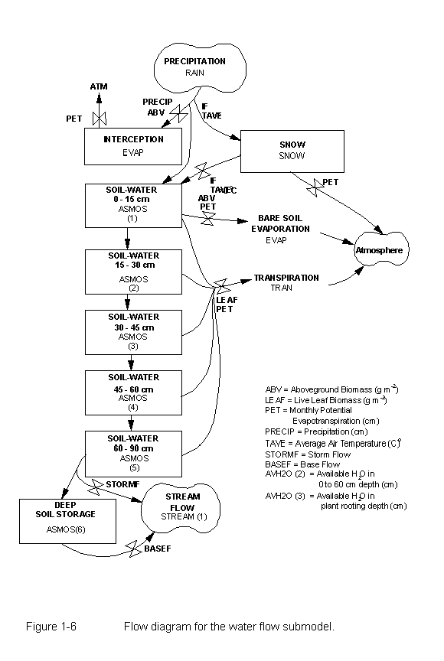

**1.5. Plant Production and Management Model**

The CENTURY model is set up to simulate the dynamics of forests, grasslands, agricultural crops and savanna systems. The grassland/crop submodel (Figure 1-7) simulates growth of different crops (corn, wheat, potatoes, sugarcane, etc.), natural plant communities (temperate warm and cool season grasslands, tropical grasslands, etc.), and managed grassland systems (alfalfa, clover, and improved grasslands). The forest submodel (Figure 1-8) simulates the growth of evergreen (pine and fir systems and evergreen tropical systems), temperate deciduous and drought deciduous systems. The savanna system simulates a tree-grass system by simultaneously running the tree and grassland/crop submodels with the submodels interacting through shading effects and nitrogen competition. Both submodels assume that monthly maximum production is controlled by soil moisture and temperature with maximum rates decreased if soil nutrients supply is insufficient (the most limiting nutrient controls production). The grassland/crop model also includes the effect of shading from dead vegetation, while the forest model includes the effect of live leaf area on plant production. Potential production is a function of the maximum growth rate for each grassland/crop or forest system and is reduced by 0-1 scalars depending on the factors that limit production. Plant nutrient uptake is a function of live root biomass with uptake increasing as live root biomass increases up to 300 grams per square meter. As mentioned earlier, most forest and grassland/crop systems will increase plant production with addition of nutrients.

The forest and grassland/crop models are generic plant growth models that can be parameterized to represent a large variety of crop, grassland, and forest systems by altering crop and forest specific parameters. The grassland/crop model includes live shoots and roots and standing dead plant parts, while the forest system includes live shoots, fine roots, large wood, fine branches and coarse roots. The effect of grazing and fire on the grassland/crop system is represented in the model with the major effect of fire being the increase in root to shoot ratio, increase in the C:N ratio of roots and shoots, removal of vegetation and return of nutrients from the fire (Ojima et al. 1900). Grazing removes live and dead vegetation, alters the root to shoot ratio, increases the N content of live shoots and roots and returns nutrients to the soil (Holland et al. 1992). All of the natural fire effects and standard forest management practices can be represented by the model (selective logging, clear cutting, etc). A complete description of the parameterization of the model for different plant systems and the use of the different management option is presented in the CENTURY User Manual (Metherell et al. 1994).

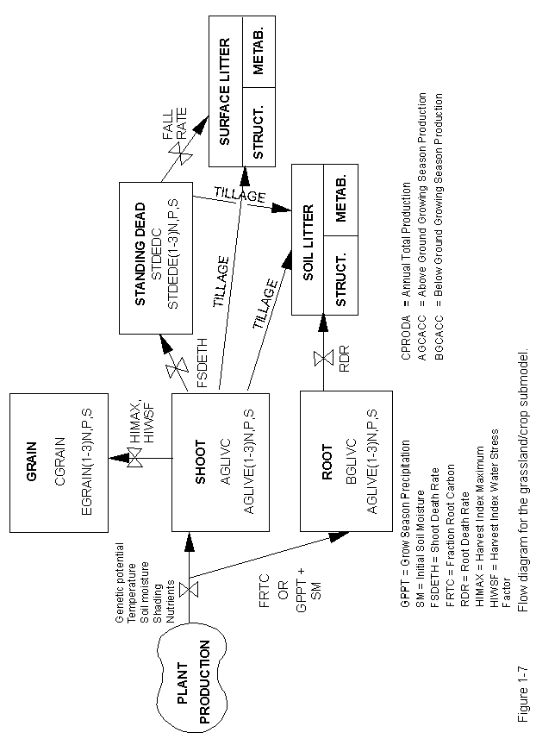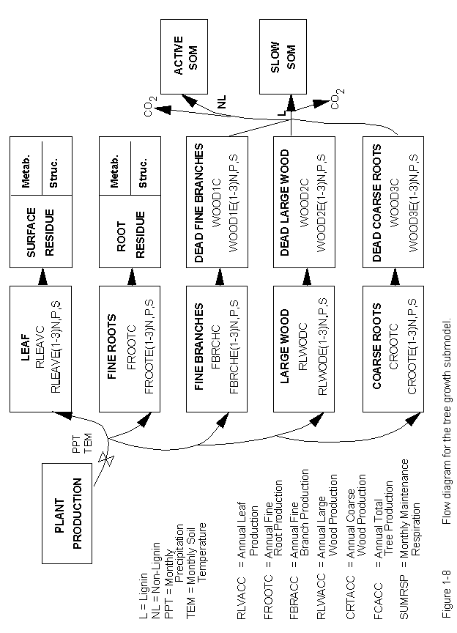

**1.6. Use and Testing of the CENTURY Model**

Extensive data sets from long-term agricultural experiments and grasslands have been used to test the CENTURY model. We used the observed data to test the model and as a tool for integrating and interpreting the data sets. Plant production and soils data from extensive tropical and temperate grasslands around the world (Parton et al. 1993, Gilmanov et al. 1998) show that the model correctly simulated the effects of burning, irrigation, fertilization, and grazing on plant production and the seasonal patterns for live and dead biomass. The model has been used to simulate the long-term (30-60 year) dynamics of soil organic matter and plant production for corn, winter and spring wheat systems in Australia (Carter et al. 1993, Probert et al. 1997), Canada (Liang et al. 1996), Sweden (Paustian et al. 1992), and sites in Oregon and Nebraska (Metherell et al. 1994, Parton and Rasmussen 1994). The model was used to correctly simulate the impact of adding different amounts and types of organic matter (pea vine, saw dust, straw, green manure and manure), straw burning, the use of different fertilizer levels, different tillage practices (stubble mulch, conventional plow, and no-till) and wheat pasture rotations on soil temperature, soil water dynamics, soil C and N levels, plant production, soil NO3 leaching and soil N mineralization (Paustian et al. 1992, Probert et al. 1997). The forest model has been evaluated for tropical, temperate and boreal systems and used to simulate the response of forests to different natural disturbances and management practices (Sanford et al. 1991, Kelly et al. 1998, Peng et al. 1998).

The CENTURY model has been used extensively to simulate the effect of environmental changes and management practices on natural and managed ecosystems at the site, regional and global level. The grassland model has been used to simulate the impact of climate change and increased atmospheric CO2 levels on grasslands around the world (Parton et al. 1995) with a detailed analysis for the US Great Plains region (Burke et al. 1991, Schimel et al. 1990). The combined effect of future environmental change and improved land use practices on soil carbon storage and plant production has been evaluated for the US Corn Belt (Donigian et al. 1995), while Paustian et al. (1996) have used CENTURY to evaluate soil carbon storage in the US resulting from the conservation reserve program. The Vegetation/Ecosystem Modeling and Assessment (VEMAP) program (VEMAP 1996) has used the CENTURY model to evaluate the impact of climate change and increased CO2 levels on the natural ecosystem in the US using a 0.5 x 0.5 degree resolution and compared model results with two other biogeochemistry models. The model has also been used to simulate ecosystem dynamics at the 0.5 x 0.5 degree scale for global ecosystems (Schimel et al. 1996). We are currently developing a daily version of the model (Parton et al. 1998) which simulates all of the ecosystem dynamics using more mechanistic soil water and temperature submodels and also simulates daily trace gas fluxes (N2O, N2, NOx and CH4).

**1.7. DAYCENT Model Description**

DAYCENT (Parton et al. 1998, DelGrosso et al. 2001, Kelly et al. 2000) is the daily time step version of the CENTURY ecosystem model. Simulation of trace gas fluxes through soils requires finer time scale resolution because a large proportion of total gas fluxes are often the result of short term rainfall, snow melt or irrigation events and the processes that result in trace gas emissions often respond non-linerly to changes in soil water levels. DAYCENT and CENTURY both simulate exchanges of carbon and the nutrients nitrogen (N) and phosphorus (P) among the atmosphere, soil, and plants and use identical files to simulate plant growth and events such as fire, grazing, cultivation, harvest, and organic matter or fertilizer additions. In addition to modeling decomposition, nutrient flow, soil water and soil temperature on a finer time scale than CENTURY, DAYCENT also uses increased spatial resolution for soil layers. DAYCENT includes submodels for plant productivity, decomposition of dead plant material and SOM, soil water and temperature dynamics, and trace gas fluxes (Figure 1-9).

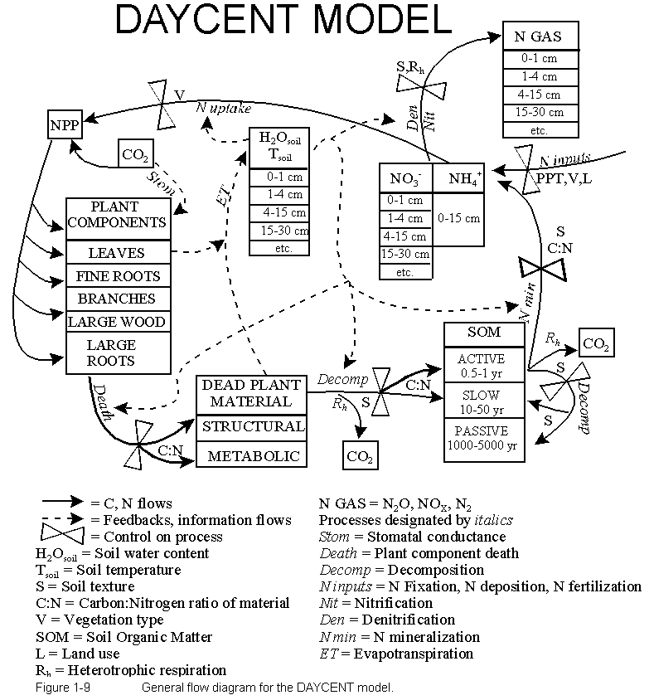

2. Downloading and Installing the PC Version of CENTURY

The PC standalone version of the CENTURY model and a Windows Help file version of the CENTURY manual can be downloaded from the CENTURY homepage:

http://www.nrel.colostate.edu/projects/century/

using a browser application such as Internet Explorer or Netscape. Select the **Download PC Century** button on the CENTURY homepage. This will take you to an ftp download site where you will see the files cent40.exe and README. To download the files right click on the file icon and select the **Copy to Folder** option from the popup menu to save the file on your system.

Or you can download the PC standalone version of the CENTURY model and the CENTURY manual via anonymous ftp. Open a DOS window by selecting **Start | Programs | MS-DOS Prompt** from the Windows Start menu. Use the **cd** command to change to the directory into which you wish to download the downloaded files. Use the following ftp commands to download the CENTURY installation files:

ftp ftp.nrel.colostate.edu

anonymous

<your email address>

cd CENT/century4.0/CENTX/PC_VERSION

bin

prompt

mget cent40.exe

ascii

mget README

bye

The file cent40.exe is an installation file that will install CENTURY, its associated utility programs, sample parameter and schedule files, and the Windows Help file version of the manual on your PC. To run the installation file select **Start | Run** from the Windows Start menu and use the **Browse** button to locate the cent40.exe file which you have downloaded. Once you have located the cent40.exe file select the **Run** button to start the installation process and follow the instructions on the screen. The README file can be viewed using Windows Notepad and contains additional information about the installation file.

The executable files that will be installed are:

CENTURY.EXE CENTURY executable

EVENT100.EXE Event scheduler for CENTURY

FILE100.EXE Parameterization utility

LIST100.EXE Used to create ASCII output file

This version of CENTURY runs from a DOS window in Windows 9x and Windows NT. The *.100 files are CENTURY parameter files. The *.def files are definitions that go with the *.100 files are will be used when you run FILE100. The *.sch files are sample schedule files.

With all of these files in one directory, you should be able to run the model using the following command line in a DOS window after changing to the CENTURY directory:

century -s <sch file> -n <out file>

<sch file> is the schedule file you will be using without the .sch extension and <out file> is the name that you wish to use for the file which will contain the output from your simulation run. Do not include an extension on the <out file> name. For example, if you want to run the c3grs.sch schedule file and store the results in a file named test.bin you would enter the following at the command line:

century -s c3grs -n test

The installation also includes two Windows Help files. One is the complete text of the CENTURY User's Manual. The other contains information about the CENTURY input parameters and output variables.

3. CENTURY, Associated Files, and Utility Programs

The CENTURY environment (Figure 3-1) consists of the CENTURY model and three utility programs, FILE100, EVENT100, and LIST100. The FILE100 program assists the user in creating and updating any of the twelve data files used by CENTURY. The EVENT100 program creates the scheduling file which contains the vegetation types and events that are to occur during the simulation. The LIST100 program extracts selected output variables from the CENTURY binary output file and creates an ASCII listing of the variables values for the output intervals specified in the schedule file. This listing can be viewed using any text editor or imported into a spreadsheet application for examination and graphing.

The CENTURY model obtains input values by reading up to twelve data files. Each file contains a certain subset of variables; for example, the *cult.100* file contains the values related to cultivation. Within each file there may be multiple options in which the parameters are defined for multiple variations of the event. For example, within the *cult.100* file, there may be several cultivation options defined such as plowing or rod-weeder. For each option, the parameters are defined to simulate that particular option. Each data input file is named with a ".100" extension to designate it as a CENTURY file. These files can be updated and new options created through the FILE100 program.

The timing variables and schedule of when events are to occur during the simulation are maintained in the schedule file, named with a ".sch" extension. This file can be created and updated through the EVENT100 program.

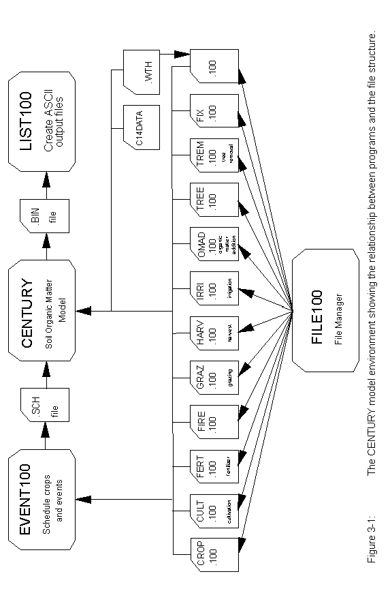

When running CENTURY the directory from which you will be running your simulations must contain the following files:

century.exe the CENTURY executable

The parameter files, these files contain options which used by the schedule file to set the values for the events in your simulation. The files crop.100, cult.100, fert.100, fire.100, graz.100, harv.100, irri.100, omad.100, tree.100, and trem.100 can have one or many options in the file. The option from the file that will be used in your model run depends on the option abbreviation used in the schedule file. The files fix.100 and <site>.100 have only one option in the file.

crop.100 crop parameterizations for one to many crops

cult.100 cultivation parameterizations for one to many cultivation options

fert.100 fertilization parameterizations for one to many fertilization options

fire.100 fire parameterizations for one to many fire options

fix.100 fixed parameters, for the most part these will not be changed

graz.100 grazing parameterizations for one to many grazing options

harv.100 harvest parameterizations for one to many harvest options

irri.100 irrigation parameterizations for one to many irrigation options

omad.100 organic matter addition parameterizations for one to many organic matter addition options

tree.100 tree parameterizations for one to many trees

trem.100 tree removal parameterizations for one to many trees

<site>.100 site specific parameters

*.sch schedule file for the simulation

*.wth optional, a historical weather data file for your site

Other files which should be in your CENTURY directory are:

CENTURY utilities:

EVENT100 used to create and/or modify schedule files

FILE100 used to modify parameter files

LIST100 used to extract output from the binary output file created by CENTURY to an ASCII text file

The parameter definition files:

crop.def

cult.def

fert.def

fire.def

fix.def

graz.def

harv.def

irri.def

omad.def

tree.def

trem.def

site.def

NOTE: When running FILE100 the parameter definition files, *.def, must be in the directory from which you will be running FILE100.

4. Preparing for a CENTURY Simulation

You will need to create a parameterization for you site. Site specific information that is required for a CENTURY run includes:

monthly precipitation in centimeters

monthly mean minimum temperatures in degrees Celsius

monthly mean maximum temperatures in degrees Celsius

site latitude and longitude

% sand, silt, and clay in top 20 cm layer of mineral soil

bulk density of the top 20 cm layer of soil (g/cm^3)

rooting depth and root distribution of the vegetation (in cm)

best estimate of annual wet and dry N deposition

C in the soil organic matter in the top 20 cm of soil

N in the soil organic matter in the top 20 cm of soil

Determine the type of system you will be simulating:

grassland/cropping

forest

savanna

You will need to know at least the following about the vegetation growing at your site in order to parameterize the model:

productivity of vegetation (gC/m^2 per year or growing season)

C:N ratio of aboveground and belowground vegetation if modeling a crop/grassland or split into leaves, branches, large wood, fine roots, and coarse roots for a forested system

root to shoot ratio of vegetation if modeling a crop/grassland or % allocation of production to leaves, branches, large wood, fine roots, and coarse roots for a forested system

lignin content of vegetation, aboveground and belowground for grasses; split into leaves, branches, large wood, fine roots, and coarse roots for a forested system

Work through the CENTURY Parameterization Workbook to help you create the parameterization for your site and crop and/or tree. The CENTURY Parameterization Workbook is a supplement to the CENTURY User’s Manual. The workbook is designed to lead you through the full parameterization of CENTURY for a particular site, adjusting the appropriate parameters that control short-term and long-term behavior. The goal is to help you work through the maze of parameters and understand how they can be estimated from real-world data.

Another tool that will help you set input parameter values for your CENTURY simulation is the Excel workbook, century_curves.xls. This spreadsheet contains interactive graphs for several of the CENTURY curves. You can modify the input parameter values for a given curve, for example the temperature growth curve, and see how the parameter values you have selected effect the shape of the curve as computed by the CENTURY model.

Decide what types of events you want to simulate. For example, do you want to include fire in your simulation of the system? Is the system tilled? Is fertilizer added (how many gN/m^2). Do you want to simulate grazing? What type of harvest is conducted? How many cm of water are added through irrigation? How much and what type of organic amendment is added (manure, fish meal, green manure)? Is your system flooded at any point during the year? Etc.

Now decide the order and duration of the events and create a schedule file for your simulation.

# 5. Running CENTURY and its Utility Programs

The PC version of CENTURY and its utility programs must be run from a DOS box in Windows 9x or Windows NT. To open a DOS box select **Start | Programs | MS-DOS Prompt** from the Windows Start menu. Use the **cd** command to change to the directory where you CENTURY files are located. For example, when you open the DOS box you will most likely be in the Windows directory and the DOS prompt will show C:\WINDOWS, to change to the root directory enter the following command at the DOS prompt:

cd ..

You should now be in the root directory. In most cases the DOS prompt should now read C:\. If you used the default CENTURY installation the CENTURY files will be in the C:\century directory. To get to the CENTURY directory enter this command at the DOS prompt:

cd century

If the command has executed successfully the DOS prompt will show C:\CENTURY. Use the **dir** command ensure that you are in the correct directory. If you enter the command as:

dir *.exe

you should the CENTURY executable and its utility programs listed:

century.exe

event100.exe

file100.exe

list100.exe

The usual sequence of events when running CENTURY:

1. Create the desired parameterizations in the *.100 files using FILE100.

2. Use EVENT100 to create the schedule file for your simulation.

3. Run the CENTURY simulation.

4. Use LIST100 to extract the desired output from the binary output file produced by your CENTURY run.

**5.1. FILE100**

The FILE100 program is designed to help the user create new options or change values in existing options in any of the *.100 data files used with EVENT100 and CENTURY. This utility also provides parameter definitions, units, and valid values or ranges.

To run FILE100 enter:

file100

and follow the on screen menus.

The program begins with a numbered list of the *.100 files, and asks the user to enter the number of the file s/he wishes to work with:

*File Updating Utility*

*Enter the number of the file you wish to update:*

*0. quit*

*1. crop.100*

*2. cult.100*

*3. fert.100*

*4. fire.100*

*5. fix.100*

*6. graz.100*

*7. harv.100*

*8. irri.100*

*9. omad.100*

*10. tree.100*

*11. trem.100*

*12. <site>.100*

*13. weather statistics*

*Enter selection:*

Within that .100 file, the user may take any of five actions, as shown by the next menu:

*What action would you like to take:*

*0. Return to main menu*

*1. Review all options*

*2. Add a new option*

*3. Change an option*

*4. Delete an option*

*5. Compare options*

*Enter selection:*

Reviewing a file will list the abbreviations and descriptions found in the file. Adding an option will allow the user to choose an existing option to copy, and then allow the user to enter a new abbreviation and new values for the new option. Changing an option will allow the user to change the abbreviation or any of the values associated with that option. Deleting an option will completely remove the option from the .100 file. Comparing shows the differences between options in the .100 file. Each of these actions is described in more detail in the following sections.

Entering a "q" or "quit" at any point will return the user to the next highest menu.

**5.1.1. Reviewing All Options**

"Review all options" will print a list on the screen of the options found in that .100 file by listing each option's abbreviation and corresponding descriptions. After reviewing, the user may choose any of the five actions, or return to the main menu to choose another .100 file. Note that reviewing automatically causes the file to be re-formatted to the specifications needed by the PC version of CENTURY.

**5.1.2. Adding an Option**

The user may choose to add a new option to the file. After entering 2, for adding, the program will display each option already existing in the file and ask if the user would like to begin with that option:

*Current option is W1 Wheat-type-one*

*Is this an option you wish to start with?*

A response of "Y" or "y" will cause the program to copy this option to begin the addition phase. If no option is responded to with a yes answer, the program will return to the previous menu of five actions. Once an affirmative response has been given, the user will be asked for a new abbreviation and description:

*Enter a new abbreviation:*

The abbreviation must be unique to that file and no more than 5 characters; if a duplicate is entered, the user will be asked to enter another abbreviation.

*Enter a new description:*

The description may not be longer than 65 characters.

Then, for each value in that option, the program will display the value which the original option had for that parameter and ask the user for a new value:

*Commands: D F H L Q <new value> <return>*

*Name: PRDX(1) Previous value: 300*

*Enter response:*

The user may enter any of these possible responses, as shown on the Command line:

see the definition of that parameter enter D

find a specific parameter in that option enter F

see a help message enter H

list the next 12 parameters enter L

quit, retaining the old values for

this and the remaining parameters

in this option enter Q

take the old value enter <return>

enter a new value enter a new value

The command and previous value lines will continue to be shown until the user enters Q, to quit, or until the end of the option is reached.

**5.1.3. Changing an Option**

The user may change values of parameters within an existing option. After entering 3, for changing, the program will display each option which exists in the file and ask if the user would like to change that option:

*Current option is W1 Wheat-type-one*

*Is this an option you wish to change?*

A response of "Y" or "y" will cause the program to move on to the change phase. If no option is responded to with a yes answer, the program will return to the previous menu of five actions. Once an affirmative response has been given, the user will be asked for a new abbreviation and description:

*Enter a new abbreviation or a <return>*

*to use the existing abbreviation:*

A new abbreviation must be unique to that file and no more than 5 characters; if a duplicate is entered, the user will be asked to enter another abbreviation.

*Enter a new description or a <return>*

*to use the existing description:*

The description may not be longer than 65 characters.

Then, for each value in that option, the program will display the existing value for that parameter and ask the user for a new value:

*Commands: D F H L Q <new value> <return>*

*Name: PRDX(1) Previous value: 300*

*Enter response:*

The user may enter any of these possible responses, as shown on the Command line:

see the definition of that parameter enter D

find a specific parameter in that option enter F

see a help message enter H

list the next 12 parameters enter L

quit, retaining the old values for

this and the remaining parameters

in this option enter Q

take the old value enter <return>

enter a new value enter a new value

The command and previous value lines will continue to be shown until the user enters Q, to quit, or until the end of the file is reached. Finally, the user is asked if changes made should be saved:

*Do you want to save the changes made?*

If this is answered with "y" or "Y", the changed values will be saved. Otherwise, the changes will be lost.

**5.1.4. Changing the <site>.100 File**

Making changes to the *<site>.100* file is different in that the parameters in this file are subdivided for easier review. After selecting *<site>.100* from the main menu, enter the name of the site file without the .100 extension. The user may name a new *<site>.100* file to save these changes to:

*Enter a new site filename to save changes*

*to or a <return> to save to (original filename).100:*

The program will then display the existing abbreviation and description and allows the user to provide new ones:

*Enter a new abbreviation or a <return>*

*to use the existing abbreviation:*

Enter an abbreviation of no more than 5 characters.

*Enter a new description or a <return>*

*to use the existing description:*

The description may not be longer than 65 characters.

The next menu will show the subheadings within the file:

*Which subheading do you want to work with?*

*0. Return to main menu*

*1. Climate parameters*

*2. Site and control parameters*

*3. External nutrient input parameters*

*4. Organic matter initial parameters*

*5. Forest organic matter initial parameters*

*6. Mineral initial parameters*

*7. Water initial parameters*

*Enter selection:*

Entering a response of 1 through 7 will cause the first parameter shown to be from that subheading. The program then continues as with the regular Change function.

For each value in that subheading, the program will display the value which the original had for that parameter and ask the user for a new value:

*Commands: D F H L Q <new value> <return>*

*Name: PRDX(1) Previous value: 300*

*Enter response:*

The user may enter any of these possible responses, as shown on the Command line:

see the definition of that parameter enter D

find a specific parameter in that option enter F

see a help message enter H

list the next 12 parameters enter L

quit, retaining the old values for

this and the remaining parameters

in this option enter Q

take the old value enter <return>

enter a new value enter a new value

The command and previous value lines will continue to be shown until the user enters Q, to quit, or until the end of the subheading is reached.

After selecting choice 0, Return to the main menu, from the subheadings menu, the user is asked if the changes made should be saved:

*Do you want to save the changes made?*

If this is answered with "y" or "Y", the changed values will be saved. Otherwise, the changes will be lost.

**5.1.5. Deleting an Option**

The user may choose to delete one or more options from that .100 file. After entering 4, for delete, each abbreviation and description of each option found is shown:

*Current option is W1 Wheat-type-one*

*Is this an option you wish to delete?*

If the user responds with a "Y" or "y", a double check is made to insure that no error was made:

*Are you sure you want to delete W1 Wheat-type-one?*

If the answer is again "Y" or "y", the option is completely deleted from the .100 file and is not recoverable.

**5.1.6. Comparing Options**

The user may choose to compare options from that .100 file. After entering 5, for compare, all abbreviations found in the file are shown:

*W1 W2 W3*

*G1 G2 G3*

*G4 G5 SYBN*

*Current limit of options to compare is 5.*

The user is then asked to enter all of the options, up to 5, that should be compared at one time:

*Enter an option to compare, <return> to quit:*

After entering up to five options, the differences between the options are displayed. For example, the differences between two wheat crops may be:

*Difference: Abbrev Name Value*

*W2 HIMAX 0.35*

*W3 HIMAX 0.42*

*Difference: Abbrev Name Value*

*W2 EFRGRN(1) 0.65*

*W3 EFRGRN(1) 0.75*

Note that format differences are not displayed. There is no difference, for example, between "1.00" and "1".

After four differences are displayed on the screen, the user may continue to see more differences, if they exist, or quit:

*"Hit <return> to continue, Q to quit."*

**5.1.7. Generating Weather Statistics**

If the user has access to actual weather data for a minimum ten year period, those weather values may be used to generate precipitation means, standard deviations, and skewness values, minimum temperature means and maximum temperature means. These statistical values can then be used to drive the stochastic weather generator in CENTURY. These statistical values are maintained in the *<site>.100* file.

The name of the actual weather file must have a maximum of eight characters with a ".wth" extension.

The format of the file is the standard format as required by CENTURY:

a four character name field ("prec", "tmin", or "tmax")

two spaces

a four character year field

12 number fields of the format 7.2

such that the length of each line is 94 characters. For example:

prec 1915 0.31 2.55 5.07 7.01 8.87 5.13 1.61 8.83 3.55 3.53 0.99 0.92

tmin 1915 ‑13.50 ‑8.33 ‑8.17 0.78 1.67 7.00 9.72 8.33 5.39 ‑0.28 ‑6.06 ‑8.78

tmax 1915 4.44 8.56 4.33 16.33 17.50 21.06 26.83 26.06 22.89 18.89 10.78 8.50

prec 1916 1.57 0.31 0.37 1.68 8.07 2.90 4.27 2.84 1.06 2.64 2.06 3.06

tmin 1916 ‑16.50 ‑9.50 ‑4.89 ‑2.28 1.56 6.28 10.56 9.89 3.33 ‑2.44 ‑9.28 ‑14.78

tmax 1916 ‑0.61 8.67 14.22 14.33 20.28 25.44 32.39 27.28 24.56 14.78 8.78 1.56

To generate the weather statistical values, choose "13" from the main menu, "weather statistics". Then enter the name of the actual weather file without the ".wth" extension:

*Enter the name of the actual weather file:*

FILE100 will generate the weather statistics and place the new monthly values for PRECIP, PRCSTD, PRCSKW TMN2M, TMX2M into the named *<site>.100* file. Missing values in the weather file, given as "-99.99", are ignored when statistics are calculated.

FILE100 will then ask for the name of a *<site>.100* file to write the values to:

*Enter the site file name:*

Enter the site file name without the .100 extension.

The user may name a new *<site>.100* file to save these changes to:

*Enter a new site filename to save changes*

*to or a <return> to save to (original filename).100:*

**5.1.8. XXXX.100 Backup File**

In the event that FILE100 should abort from the program at some point, the user should attempt to locate the "*XXXX.100*" backup file in the current directory. This file should contain the original version of the file that was being edited. If necessary, the user can copy this backup file into a file of the original file name.

**5.2. EVENT100**

EVENT100 is the scheduling preprocessor for the CENTURY Soil Organic Matter Model. This preprocessor allows the user to schedule management events and crop growth controls at specific times during the simulation and produces an ASCII output file which is read in by CENTURY. EVENT100 uses a grid-like display to allow the user to move among months and years to schedule crop type, tree type, planting and harvest months, first and last month of growth (for grassland or perennial crops), senescence month, cultivation, fertilizer addition, irrigation, addition of organic matter (straw or manure), grazing, fire, tree removal and erosion.

**5.2.1. The Concept of Blocks**

EVENT100 produces a scheduling file which drives events in CENTURY. It also produces the general time information about the simulation, such as the starting time and ending time. The scheduling of crop rotations and management events uses the principle of repeating sequences within blocks of time. A block is a series of events which will repeat themselves, in sequence, until the ending time of the block is reached. For example, a series of historical farm practices might have been: breaking of the native sod in 1920, a wheat-fallow rotation with plow cultivation and straw removal until 1950, wheat-fallow with stubble-mulch management until 1980, followed by wheat-sorghum-fallow. To model this series the model user would set up the following blocks in EVENT100.

Block Years Management Repeating sequence

1 0 - 1919† Grass with grazing 1 year

2 1920 Cultivation to break the sod 1 year

3 1921 - 1950 Wheat-fallow, plow, straw removal 2 years

4 1951 - 1980 Wheat-fallow, stubble-mulch 2 years

5 1981 - 1992 Wheat-sorghum-fallow 3 years

† This period needs to be long enough to establish equilibrium conditions. To check for equilibrium look at the output variables for SOM. If the values for these variables have leveled off then the system is said to be in equilibrium.

Block 3 in this example is a 2 year repeating sequence of wheat-fallow that begins in 1921 and ends in 1950. The length of the block is 30 years. Since the length of the repeating sequence is 2 years the entire block will be completed 15 times within the 30 year period. Year 1921 is year 1 in the repeating sequence, year 1922 is year 2 in the repeating sequence, year 1923 is year 1 in the repeating sequence, year 1924 is year 2 in the repeating sequence, an so on. The two years of management events repeat to the end of the block with year 1949 being year 1 of the repeating sequence and year 1950 being year 2 of the repeating sequence.

If the number of years in the repeating sequence and the number of years in the block do not match up, for example, if you have a two year repeating sequence that runs for 9 years, EVENT100 will warn you of this when you save your schedule file. The model will run without any problem in this case with year 1 repeated 5 times and year 2 repeated 4 times. The warning is to inform you of what is happening at the end of your repeating sequence. This information will be helpful if you need to have the repeating sequence stop at the end of the repeating years rather than in the middle of the sequence.

Each block in the schedule file starts with a set of header lines showing:

the block number and an optional comment

the last year of simulation for the block

the number of years in the repeating sequence

the output starting year

the output month

the output interval

the weather choice for this block

The events scheduled for this block follow next. The last line of the block is the End of Block Marker "-999 -999 X". The output starting year may be any year greater than or equal to the starting year. The output month may be any month 1 through 12. The output interval indicates how many times the state variables are written to the output file. A value of 1 writes the output annually; 0.0833 (1/12) writes monthly output. As a smaller value results in a larger output file size, the user may wish to specify different interval values for each block.

For example, the simulation might run to equilibrium with grassland and check peak standing crop and SOM in September from 1800 to 1899:

Start year: 0

End year: 1899

Output starting year: 1800

Output month: 9

Output interval: 1

Then, the simulation might initiate an agricultural agent and examine seasonal trends with monthly output:

Start year: 1900

End year: 1919

Output starting year: 1900

Output month: 1

Output interval: 0.0833

The weather choice may also be different in each block. The user should not only consider the events but also the output file requirements and weather source changes when determining what blocks a particular simulation will consist of.

**5.2.2. Defaults and Old Values**

Where a default or old value is shown, the user may accept this value by merely hitting the <Enter> key. Any other value should be explicitly entered by typing it in.

**5.2.3. What EVENT100 Needs**

To run the EVENT100 event scheduler, the user will need the EVENT100 executable program and the twelve *.100 data files. EVENT100 uses these data files to limit the user's entries to those that exist. Therefore, the user should set up any necessary options of specific .100 file entries before beginning work in EVENT100.

**5.2.4. Using EVENT100**

To use EVENT100, make sure that the executable program, event100.exe, and the *.100 data files are in the same directory. To start the program, enter:

event100

at the DOS prompt. After showing the program title, several initial questions need to be answered.

*CENTURY Events Scheduler*

*Enter the name of the site-specific .100 file:*

Enter the file name without the .100 extension. EVENT100 checks to see that this file exists in the current directory and if so, that the file is not empty. If either of these error conditions is met, the user may still go on. Note, however, that CENTURY is no longer interactive in this respect and will not allow the name of the *<site>.100* file to be re-entered if the file does not exist or is not readable.

*Enter the type of labeling to be done:*

*0. No labeling*

*1. 14C labeling*

*2. 13C labeling (stable isotope)*

*Default: 0. No labeling*

Enter 0, 1 or 2. If a value of 1 is entered, the next question will be:

*In what year will labeling begin?*

Enter a value greater than or equal to the simulation starting year. If no labeling is to occur, a zero will automatically be filled in for the year to begin labeling.

*Enter Y if a microcosm is to be simulated:*

*Default: N*

Enter a "y" or "Y" to indicate that a microcosm is to be simulated in CENTURY. If a "y" or "Y" is entered, a constant temperature must be entered:

Enter the constant microcosm temperature (>= 0):

Enter a temperature greater than or equal to 0.

*Enter Y if a CO2 effect is to be simulated:*

*Default: N*

Enter a "y" or "Y" to indicate that a CO2 effect is to be simulated. If a "y" or "Y" is entered, the initial and final times for the effect to take place over must be entered:

*Enter the initial time:*

*Enter the final time:*

Enter the initial time, which must be greater than or equal to 0, and the final time, which must be greater than the initial time.

*Under what management was the site before the simulation began?*

*1. Cropping/Grassland*

*2. Forest*

*3. Cropping/Grassland and Forest*

*Default: Cropping/Grassland*

Enter the system which is to be simulated in CENTURY.

If answers 1 or 3 are chosen:

*In order for the cropping system to run correctly,*

*you must specify an initial crop that will be used*

*to initialize the lignin values.*

*Enter an initial crop:*

Enter a crop choice; this crop will be used by CENTURY to initialize the lignin content of standing dead, surface, and belowground litter pools before the actual simulation begins. Hitting the return key will give a list of options from the crop.100 file

If answers 2 or 3 are chosen:

*In order for the forest system to run correctly,*

*you must specify an initial tree that will be used*

*to initialize the lignin values.*

*Enter an initial tree:*

Enter a tree choice; this tree will be used by CENTURY to initialize the lignin content of the wood and litter pools before the actual simulation begins. Hitting the return key will give a list of options from the tree.100 file

The next few questions deal with setting up the first block.

*Adding first new block:*

*Enter the starting year of simulation for this block:*

The entered value must be greater than 0.

*Enter the last year of simulation for this block:*

The entered value must be greater than or equal to the starting year. For example, to run an eight year simulation from January 1920 to December 1927 inclusive, the ending year will be 1927. The next block will begin in January 1928.

*Enter the number of years in the repeating sequence:*

Enter the number of years that will be set up in the block.

*Enter the year to begin output:*

*Default: the block starting year*

Enter a year greater than or equal to the starting year of the block or a <return> to accept the default.

*Enter the month to begin output (1-12):*

*Default: 1*

Enter a month between 1 and 12 or a <return> to accept the default.

*Enter the output interval:*

*Monthly = 0.0833*

*6 monthly = 0.5*

*Yearly = 1.0*

*Etc.*

*Default: 0.0833 - monthly*

Enter a time increment or a <return> to accept the default.

*Enter the weather choice:*

*M (mean values from the< site>.100 file)*

*S ( from the <site>.100 file, but stochastic precipitation)*

*F (from the beginning of an actual weather file)*

*C (continued from an actual weather file, without rewinding)*

*Default: S - Stochastic*

The possible answers are:

M to use the mean precipitation and temperature values which were read in from the site-specific <site>.100 file.

S to use the stochastically generated precipitation and the mean temperature values from the site-specific <site>.100 file. If the precipitation skewness values are not zero, the precipitation values will be selected from a skewed distribution; otherwise, the precipitation values will be selected from a normal distribution. Variables used are "precip" as means, "prcstd" as standard deviations and "prcskw" as skewness values; these variables are in the site-specific <site>.100 file. With both distributions, precipitation for the month will equal zero if a negative value is stochastically generated. Especially in the case of the normal distribution, this will increase the mean annual precipitation above the sum of the monthly "precip" values.

F to use precipitation and temperature data from a new weather data file; the weather file name must be no more that 8 characters and end with a ".wth" extension. The format of the weather file is:

a four character name field ("prec", "tmin", or "tmax")

two spaces

a four character year field

12 number fields of the format 7.2

such that the length of each line is 94 characters. For example:

prec 1915 0.31 2.55 5.07 7.01 8.87 5.13 1.61 8.83 3.55 3.53 0.99 0.92

tmin 1915 ‑13.50 ‑8.33 ‑8.17 0.78 1.67 7.00 9.72 8.33 5.39 ‑0.28 ‑6.06 ‑8.78

tmax 1915 4.44 8.56 4.33 16.33 17.50 21.06 26.83 26.06 22.89 18.89 10.78 8.50

prec 1916 1.57 0.31 0.37 1.68 8.07 2.90 4.27 2.84 1.06 2.64 2.06 3.06

tmin 1916 ‑16.50 ‑9.50 ‑4.89 ‑2.28 1.56 6.28 10.56 9.89 3.33 ‑2.44 ‑9.28 ‑14.78

tmax 1916 ‑0.61 8.67 14.22 14.33 20.28 25.44 32.39 27.28 24.56 14.78 8.78 1.56

C to continue using the current weather data file without rewinding

Note that these choices (M, S, F, C) are fixed and may not be changed by the user.

*Enter the comment:*

Enter any comment desired up to 50 characters.

Once these questions have been answered, the empty grid is displayed.

Block# 1 Year: 1 of 2 Start: 1920 End: 1950 Comment: W-F

Jan Feb Mar Apr May Jun Jul Aug Sep Oct Nov Dec

CROP

PLTM

HARV

FRST

LAST

SENM

FERT

CULT

OMAD

IRRI

GRAZ

EROD

FIRE

TREE

TREM

TFST

TLST

System commands: FILL NEXT NXTA GOMT NXYR GOYR CPYR NBLK GBLK ABLK

DBLK CBLK TIME PREV DRAW DRWA HELP SAVE QUIT

Current date: January of Year 1

User command:

The first line of the grid shows the current block, the current year out of the total number of years to be set up in this block, the block starting and ending years, and the block's comment. The possible event commands are listed along the left hand edge, under the month line, and the system commands are displayed along the bottom. The last line displays the current month and year. EVENT100 then waits for a response from the user. Any event command entered at this time would be scheduled in the month currently shown.

The general format for entering a command is "command <addtl>" where command is any one of the four-letter commands and addtl is any additional information needed for that command. In general, an event command is "undone" by entering "command X". Text may be typed in either lower, upper, or mixed case; EVENT100 will convert all text to upper case. Each event and system command is described in detail in the following section.

When all events have been entered, use QUIT to save the scheduling to an output file and exit EVENT100.

**5.2.5. Explanation of Event Commands**

Each event command is described in the following format:

XXXX The command name and explanation.

Addtl: What additional information the command needs.

Mark: How to schedule the event as occurring in the current month.

Unmark: How to remove the scheduling of the event in the current month.

Output: What the .sch output file will show for this command.

**CROP** Designates which crop is in use.

Addtl: Acceptable abbreviations are from the *crop.100* file.

Mark: CROP addtl

Unmark: CROP X

Output: The year, month and the word "CROP", followed on the next line by the crop selected.

**PLTM** Marks a month in which the current crop is planted.

Addtl: This command has no additional; it is simply marked or unmarked.

Mark: PLTM

Unmark: PLTM

Output: The year, month and the word "PLTM".

**HARV** Designates which type of harvest to use; automatically schedules a LAST event.

Addtl: Acceptable abbreviations are from the *harv.100* file.

Mark: HARV addtl

Unmark: HARV X

Output: The year, month, and the word "HARV", followed on the next line by the harvest method selected.

**FRST** Marks the current month as the first month of growing for crops.

Addtl: This command has no additional; it is simply marked or unmarked.

Mark: FRST

Unmark: FRST

Output: The year, month, and the word "FRST".

**LAST** Marks the current month as the last month of growing for crops.

Addtl: This command has no additional; it is simply marked or unmarked.

Mark: LAST

Unmark: LAST

Output: The year, month, and the word "LAST".

**SENM** Marks the current month as the month of senescence for crops.

Addtl: This command has no additional; it is simply marked or unmarked.

Mark: SENM

Unmark: SENM

Output: The year, month, and the word "SENM".

**FERT** Schedules a fertilization event in the current month.

Addtl: The acceptable abbreviations come from the *fert.100* file.

Mark: FERT addtl

Unmark: FERT X

Output: The year, month, and the word "FERT", followed on the next line by the fertilization method selected.

**CULT** Schedules a cultivation event in the current month.

Addtl: The acceptable abbreviations come from the *cult.100* file.

Mark: CULT addtl

Unmark: CULT X

Output: The year, month, and the word "CULT", followed on the next line by the cultivation method selected.

**OMAD**Schedules an organic matter addition event in the current month.

Addtl: The acceptable abbreviations come from the *omad.100* file.

Mark: OMAD addtl

Unmark: OMAD X

Output: The year, month, and the word "OMAD", followed on the next line by the type of organic matter addition selected.

**IRRI** Schedules an irrigation event in the current month.

Addtl: The acceptable abbreviations come from the *irri.100* file.

Mark: IRRI addtl

Unmark: IRRI X

Output: The year, month, and the word "IRRI", followed on the next line by the irrigation method selected.

**GRAZ** Schedules a grazing event in the current month.

Addtl: The acceptable abbreviations come from the *graz.100* file.

Mark: GRAZ addtl

Unmark: GRAZ X

Output: The year, month, and the word "GRAZ", followed on the next line by the grazing type selected.

**EROD** Schedules an erosion event in the current month.

Addtl: The amount of soil loss (kg/m2/month).

Mark: EROD amount

Unmark: EROD 0

Output: The year, month, and the word "EROD", followed on the next line by the amount.

**FIRE** Schedules a fire in the current month.

Addtl: The acceptable abbreviations come from the *fire.100* file.

Mark: FIRE addtl

Unmark: FIRE X

Output: The year, month, and the word "FIRE", followed on the next line by the type of fire selected.

**TREE** Selects a tree type.

Addtl: The acceptable abbreviations come from the *tree.100* file.

Mark: TREE addtl

Unmark: TREE X

Output: The year, month, and the word "TREE" followed on the next line by the type of tree selected.

**TREM** Schedules a tree removal event in the current month.

Addtl: The acceptable abbreviations come from the *trem.100* file.

Mark: TREM addtl

Unmark: TREM X

Output: The year, month, and the word "TREM" followed on the next line by the type of tree removal selected.

**TFST** Marks the current month as the first month of growth for forest.

Addtl: This command has no additional; it is simply marked or unmarked.

Mark: TFST

Unmark: TFST

Output: The year, month, and the word "TFST".

**TLST** Marks the current month as the last month of growth for forest.

Addtl: This command has no additional; it is simply marked or unmarked.

Mark: TLST

Unmark: TLST

Output: The year, month, and the word "TLST".

**5.2.6.** **Explanation of System Commands**

Each system command is described in the following format:

XXXX The command name and explanation.

Addtl: What additional information the command needs.

Execute: How the command should be entered.

**FILL** Copies the last event command (and addtl, if applicable) to the number of months specified.

Addtl: The number of months to fill into (1-11)

Execute: FILL number

**NEXT** Changes to the next month. If the current month is December, changes to January of the next year. If the current year is the last year, changes to January of the first year.

Addtl: None

Execute: NEXT

**NXTA** (NeXT Auto) Toggle switch command that, when on, automatically does a NEXT command after each event command is entered. The default is off; a NEXT command is not done automatically after each event command.

Addtl: None

Execute: NXTA

**GOMT**Changes to the given month in the current year.

Addtl: The month number (1-12) to change to

Execute: GOMT number

**NXYR** Changes to the next year. If in the last year of the block, changes to the first year of the block.

Addtl: None

Execute: NXYR

**GOYR** Changes to the given year in the current block.

Addtl: A year number in the current block

Execute: GOYR number

**CPYR** Copies all events in the current year to the given year.

Addtl: A year number in the current block to copy to

Execute: CPYR number

**NBLK** Changes to the next block. If this block has not yet been set up, the user may set up the block by answering the set of block questions concerning the last year of simulation, the number of years in the repeating sequence, the data output interval value, the month to start writing output, the weather choice and the comment.

Addtl: None

Execute: NBLK

**GBLK** Changes to the given block number, if that block has already been set up. If the block has not been set up, the user may set up the block by answering the set of block questions concerning the last year of simulation, the number of years in the repeating sequence, the data output interval value, the month to start writing output, the weather choice and the comment.

Addtl: The block number to change to

Execute: GBLK number

**ABLK** Adds a new block by having the user answer the block questions concerning the last year of simulation, the number of years in the repeating sequence, the data output interval value, the month to start writing output, the weather choice and the comment. The user may append a block to the end of the current set or add a block previous to an existing one.

Addtl: None

Execute: ABLK

**DBLK** Deletes the current block and any grid values associated with the block.

Addtl: The user is asked to double-check that the block should be deleted

Execute: DBLK

**CBLK** Copies the current block to a new block position. The user is asked the block questions concerning the last year of simulation, the number of years in the repeating sequence, the data output interval value, the month to start writing output, the weather choice and the comment.

Addtl: None

Execute: CBLK

**TIME** Allows the user to update values given in the interactive questions concerning block header information. For each block set up, the block header information is displayed and the user may update the responses:

*** Update Block Header Information ***

Block Start End Rept Out Out Out Wthr Wthr Comment

# Year Year # Year Mnth Intv Type Name Field

1 1900 1950 1 1900 1 0.083 S Grass

2 1951 1970 2 1951 1 0.083 F sidney.wth W/F

Enter desired action:

Block number to start with ABLK to add a new block

Q or <return> to quit DBLK to delete a block

CBLK to copy a block

If the user chooses to update any of the information shown, each field is displayed with the old value and the user is allowed to enter a new value. When Q or <return> is entered, all blocks are checked for time continuity and consistency. Any errors found must be corrected before the user is allowed to return to the events grid.

Addtl: None

Execute: TIME

**PREV** Print a preview listing of the schedule file to the screen.

Addtl: None

Execute: PREV

**DRAW** Draws the display grid on the screen.

Addtl: None

Execute: DRAW

**DRWA**(Draw Auto) Toggle switch command that, when on, automatically draws the display grid after each event command is entered. Otherwise, the display grid is only drawn on a DRAW command. The default is on; the display grid is drawn after each event command.

Addtl: None

Execute: DRWA

**HELP** Displays a brief help message and, where applicable, the acceptable abbreviations from the specific .100 file.

Addtl: An event or system command

Execute: HELP command

**SAVE** Saves the scheduling to the output file name the user supplies. If a previous SAVE command has been executed, that file name will be displayed as a default; the user may use that name or supply a new name. The name of the output file will be <file>.sch, where <file> is the name supplied by the user.

Addtl: EVENT100 will ask for an output file name

Execute: SAVE

**QUIT** Terminates the EVENT100 program.

Planting and harvest dates are tested for sequence correctness and symmetry; first and last months of growth are likewise checked. In the event that the user has a simulation in which there are unpaired plantings and harvests or first and last months of growth, the user may continue on although the condition is detected. If an error condition is detected in one of these cases, the user is asked if the program should still terminate. The user may return to the grid to correct the problems or continue on. Next, the user is asked for the name of an output file.

If a previous SAVE command has been executed, that file name will be displayed as a default; the user may use that name or supply a new name. Also, the user may quit without saving to any file by simply hitting the return key. If an output file is produced, it will be of the name <file>.sch, where <file> is the name supplied by the user. Finally, the EVENT100 program ends.

Addtl: EVENT100 will ask for an output file name

Execute: QUIT

**5.2.7. The -i Option: Reading from a Previous Schedule File**

EVENT100 includes the option of reading from a previously generated schedule file through the -i option. The schedule file must exist in the current directory and be of the name <file>.sch. Start EVENT100 by entering:

event100 -i <file>

at the DOS prompt. Note that the .sch extension is not included. For example, to modify a schedule file named c3grs.sch enter the following command line:

event100 –i c3grs

EVENT100 will then read in the schedule file named. The starting questions concerning site file name, type of labeling, year to begin labeling, microcosm flag, the CO2 effect flag, initial crop and initial tree are displayed showing the original value from the schedule file; the user may update any response to these questions. A TIME command will automatically be executed to allow the user to update any block header information from the previous file. Finally, the display grid is shown, with the previous events filled in. Any changes may be made and any event or system commands may be entered. Upon entering a SAVE or QUIT command, the name of the schedule file given with the -i is used as the default.

**5.3. CENTURY**

To run CENTURY, use command-line arguments as follows:

*century ‑s <schedule.file> ‑n <binary.output.file>*

<schedule.file> is the schedule file you will be using without the .sch extension and <binary.output.file> is the name that you wish to use for the file which will contain the output from your simulation run. Do not include an extension on the <binary.output.file> name. For example, if you want to run the c3grs.sch schedule file and save the output to a file named test.bin you would enter the following at the command line:

century -s c3grs -n test

The program will show the *Model is running...* message and will return to the DOS prompt after completion. Typing **dir** will show that *test.bin* has been created

**5.4. LIST100**

LIST100 is used to generate an ASCII text file listing of selected output variables from the binary file produced by a CENTURY run.

To run LIST100 enter the following command line at the DOS prompt in your working directory:

list100

and follow the on screen prompts.

For example, to create an ASCII text file called *yields.lis* of variables from the *testrun.bin* file, type "list100":

*List100*

*Binary to Ascii Utility*

*Enter name of binary input file (no .bin):*

Type "testrun" to indicate the *testrun.bin* file.

*Enter name of ASCII output file (no .lis):*

Type "yields" to indicate that the name of the new output file is to be *yields.lis*.

*Enter starting time, <return> for time file begins:*

Type <return> or a year.

*Enter ending time, <return> for time file ends:*

Type <return> or a year.

*Enter variables, one per line, <return> to quit:*

Type "crmvst" <return> cgrain <return> <return>" to indicate that these two variables, in addition to the time, should be written to the ASCII file.

*Execution success.*

Typing **dir** will show that the *yields.lis* file has been created. The *testrun.bin* file still exists, and LIST100 may be used again to create another ASCII text file from the CENTURY binary output.

6. Viewing CENTURY Output Listing from LIST100

6.1. Using a text editor

The *.lis output file created by LIST100 can be viewed using any text editor, such as DOS Edit or Windows Notepad, or word processor, such as Microsoft Word or Word Perfect. To view a *.lis CENTURY output file open the application in which you wish to view the file and select the File | Open option from the main menu. Use the drop down arrow to the right of the Look in text box to locate the directory where your CENTURY output is located. If you do not see any files with a *.lis extension listed you will need to change the file type for the listing being displayed. To do this select the drop down arrow to the right of the Files of Type text box and click on the All Files (*.*) option in the drop down list. Once you have located your output file click on it to highlight the filename and then select the Open button to open the selected file.

# 6.2. Using Microsoft Excel

Using a spreadsheet application such as Microsoft Excel gives you the added capability of creating graphs of the CENTURY output variable values so that you can easily view the trends that occur over the length of the simulation.

To open a *.lis CENTURY output file in Microsoft Excel select the **File | Open** option from the main menu. Click on the down arrow to the right of the **Files of Type** text box and select the **All Files (*.*)** option from the drop down list. Use the drop down arrow to the right of the **Look in** text box to locate the directory where your CENTURY output is located. Locate the *.lis file you wish to examine, click on it to highlight the filename, and then select the **Open** button. This will bring up the **Text Import Wizard**. In **Step 1** select the **Delimited** radio button. Then press the **Next** button to go to **Step 2**. In **Step 2**click on the **Tab** checkbox to remove the check mark next to the **Tab** option, then click on the **Space** checkbox to select the **Space** option. At this point you can select the **Finish** button. Microsoft Excel will open your *.lis file parsing the output into columns with headings displaying the output variable names.

**6.3. Create a Graph of Your CENTURY Output in Microsoft Excel**

Save your *.lis file as a Microsoft Excel worksheet by selecting **File | Save As …** from the main menu. Click on the down arrow to the right of the **Save As Type** text box. Select the **Microsoft Excel Workbook (*.xls)** option from the drop down list. If desired, edit the filename in the **File name** text box. Click the **Save** button. The *.lis CENTURY output file will remain in your CENTURY directory. Any changes you make to the output listing in Excel will not effect the *.lis output file.

To quickly graph all of the output data from your *.lis file listing select all of the data by clicking on the “time” variable name and holding down the **<Ctrl> + <Shift>** keys while pressing the **<End>** key. Select **Insert | Chart…** from the main menu or click on the **Chart Wizard** button in the Excel toolbar. This will bring up the **Chart Wizard**. In **Step 1** of the **Chart Wizard** click on the **Standard Types** tab. Select the **XY (Scatter)** option and click on the bottom right button in the **Chart sub-type** section of the dialog box. You should see the text **Scatter with data points connected by lines without markers** as the description for the type of graph that will be created. Press the **Finish** button to display the graph.

The following directions will lead you step by step through the process of creating an XY graph for one of your *lis file output variables.

Select **Insert | Chart…** from the main menu or click on the **Chart Wizard** button in the Excel toolbar. This will bring up the **Chart Wizard**. In **Step 1** of the **Chart Wizard** click on the **Standard Types** tab. Select the **XY (Scatter)** option and click on the bottom right button in the **Chart sub-type** section of the dialog box. You should see the text **Scatter with data points connected by lines without markers** as the description for the type of graph that will be created. Click the **Next** button to go to **Step 2**.

Select the **Series** tab. Click on the button to the right of the **Name** text box. The button looks like small spreadsheet with red, black, and white cells. After clicking on the button the **Chart Wizard** dialog box will be reduced in size. Decide which variable you would like to graph and click on its name in the spreadsheet listing of your *.lis file. Then click on the button to the right of the text box in the reduced **Chart Wizard** dialog box to restore the **Chart Wizard** dialog box to its original size.

To set the X values for your graph click on the button to the right of the **X Values** text box. Locate the **Time** variable listing from your *.lis file. It will be the first column of data. Click on the first **Time** value in the column of data. Use your mouse to drag the thumb in the scroll bar to the right of the spreadsheet to the bottom of the page. Press and hold the **<Shift>** key while clicking on the last value in the **Time** column. Then click on the button to the right of the text box in the reduced **Chart Wizard** dialog box to restore the **Chart Wizard** dialog box to its original size.

Finally, select the Y values for your graph. Click on the button to the right of the **Y Values** text box. Locate the column of output data for the variable name you selected as the **Name** for the series you are graphing. Click on the first output value for the selected variable. Use your mouse to drag the thumb in the scroll bar to the right of the spreadsheet to the bottom of the page. Press and hold the **<Shift>** key while clicking on the last value in the selected variable’s column of output data. Then click on the button to the right of the text box in the reduced **Chart Wizard** dialog box to restore the **Chart Wizard** dialog box to its original size.

At this point you can click the **Finish** button to display the graph.

If you want to display more than one data series on the graph right click on the graph and select the **Source Data** option from the popup menu or select the **Chart | Source Data** option from the main Excel menu. Click on the **Series** tab and then the **Add** button to add a new series. Follow the steps outlined above to select the series data from your *.lis output file listing.

To modify other parts of the graph use the right mouse button and the popup menu or the **Chart** menu options from the main Excel menu.

# 7. CENTURY Output Variables

CENTURY contains many output variables that you can examine but we have listed some of the important ones divided into categories. First, verify that the abiotic factors seem reasonable for the climate of your system. If you have data for soil temperature or stream flow, for example, compare the measured values with the appropriate output variables. Some of the output variables relating to plant production reflect growth while others reflect total biomass or biomass of plant parts. Verify that plant growth and biomass are reasonable for your system. Also, verify that soil C, N, and P are reasonable. For example, mineral N should be low (<1) during most of the year in native systems not subjected to high N inputs. You should have some idea of total soil SOM C for your system to compare with the output variable somtc. If any of these major outputs seem incorrect there is likely a problem in your schedule file, your site file, or your crop or tree file. Consider various output variables to help diagnose your particular problem. See Appendix 2 for output variable definitions.

Abiotic Factors

precip

pet

evap

tran

stemp

tave

defac

avh2o(1)

stream(1)

Plant Production

Grass/Crop Systems

agcacc

bgcacc

aglivc

bglivc

cgrain

stdedc

Forest Systems

fcacc

rleavc

frootc

fbrchc

rlwodc

crootc

Soil C, N, P

somtc

tnetmn(1)

tnetmn(2)

tminrl(1)

tminrl(2)

somte(1)

somte(2)

The following flow diagrams can also be used as a guideline for selecting which output variables to extract from the CENTURY binary output file. The output variable name for a pool is listed in the box representing the pool along with a short description of the value that variable represents.

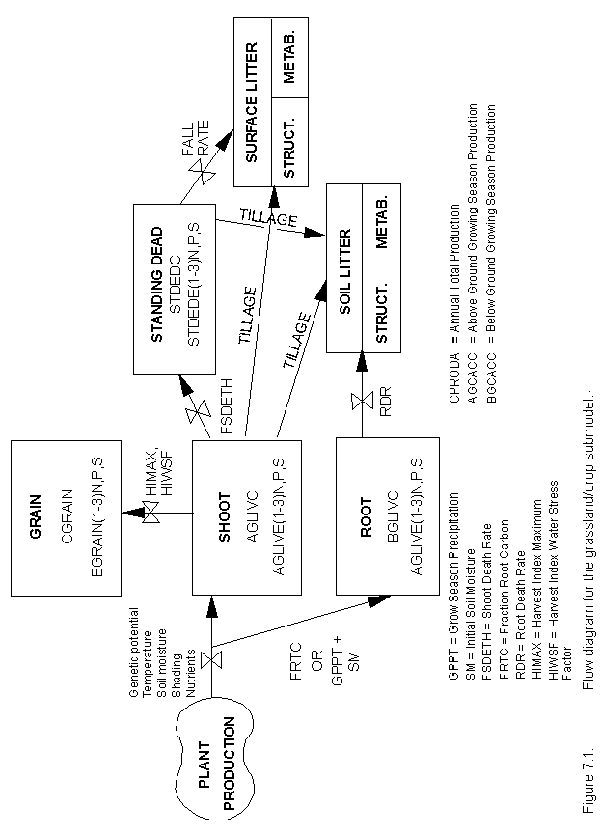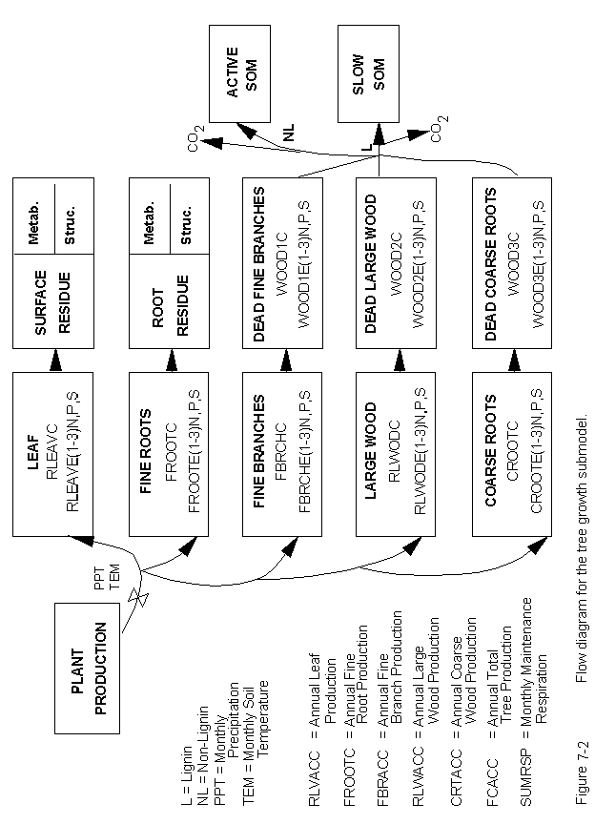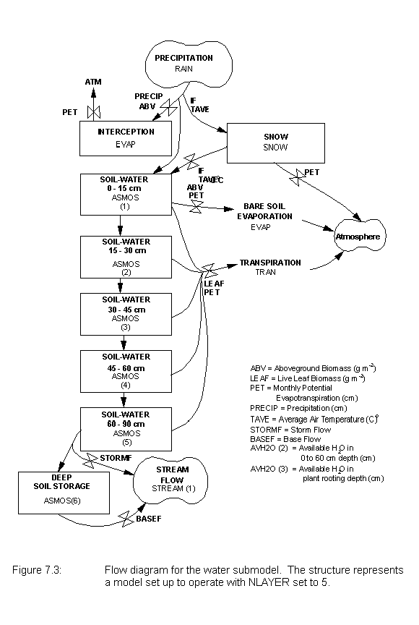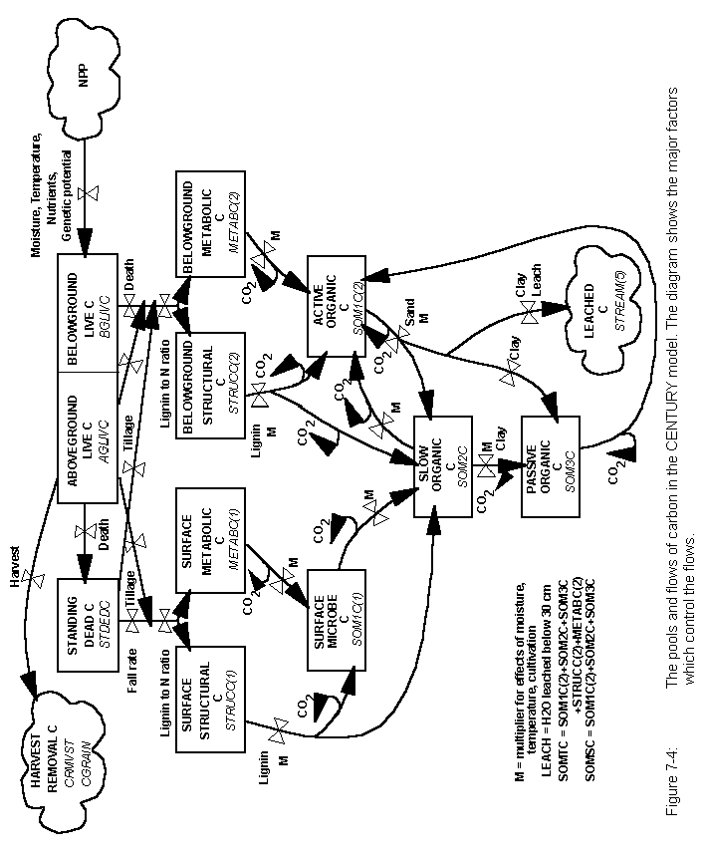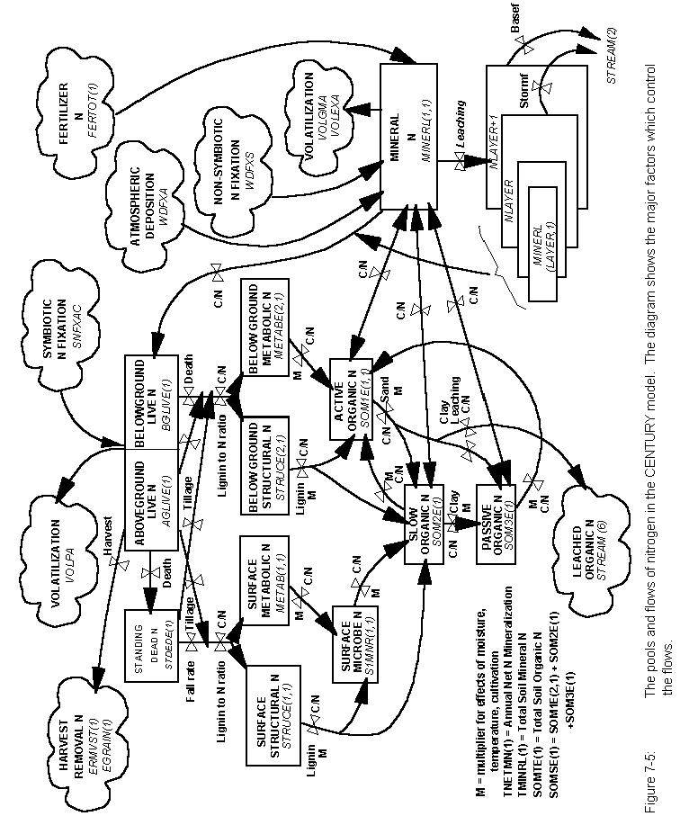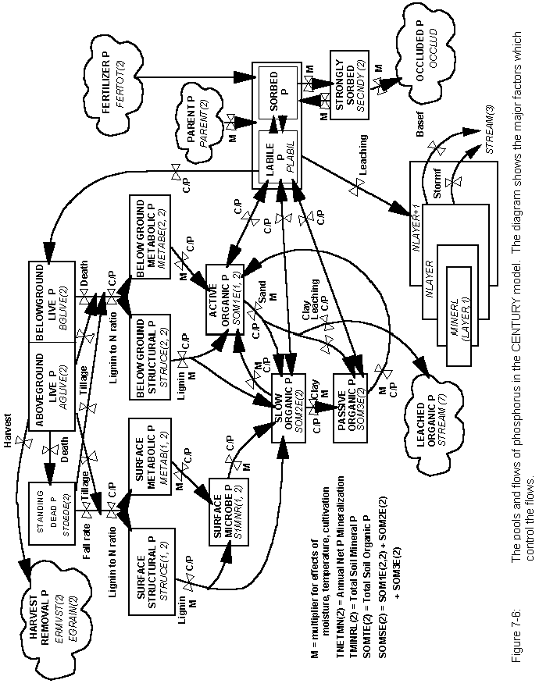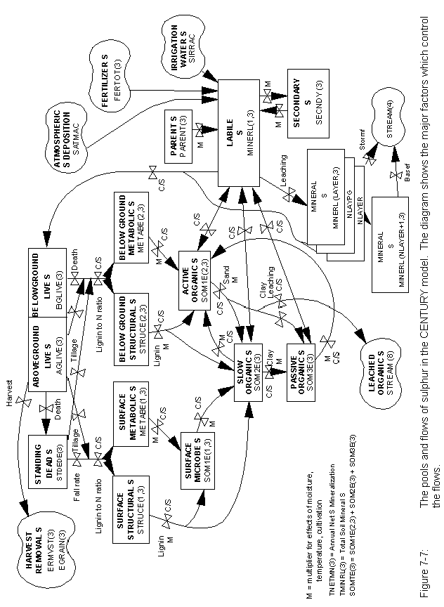

# 8. Advanced Options

**8.1. Run LIST100 Using Command Line Parameters**

LIST100 can be run using command line parameters and an ASCII text input file. This option is useful if you want to look at the same output parameters for several runs. It can be especially useful when you have a long list of output parameters that you wish to extract from the CENTURY binary output file.

Use the following command line to run LIST100 using command line parameters:

list100 <binary filename> <list filename> <variables filename> <start time> <end time>

The <binary filename> refers to the *.bin file that CENTURY creates. The <list filename> is the name of the file that you want LIST100 to create. The <variables filename> is an ASCII text file that contains the list of output variables you want to extract from the binary file, one variable per line.

For example, if you want to look at the output variables aglivc, bglivc, agcacc, and bgcacc create the following text file:

aglivc

bglivc

agcacc

bgcacc

Then, if your binary filename is named test.bin and you want LIST100 to create an ASCII file with the name test_out.lis and you have saved a list of variable names in a file named var_list.txt use the following command line to run LIST100:

list100 test test_out var_list.txt

The <start time> and <end time> command line parameters are optional. If you do not use them on the command line LIST100 will output all the information in the binary file from the time your simulation output begins to the time your simulation output ends. If you want to restrict the output created by LIST100 to a specific part of the run enter a start time that is greater than or equal to the first year of output for the run and an end time that is less than or equal to the last year of output for the run as defined in the schedule file used for the run.

**8.2. Run CENTURY Using a DOS Batch File**

You can automate CENTURY runs using a DOS batch file. This is helpful if you have several runs to do.

Start by creating the DOS batch file using a text editor such as Windows Notepad or DOS Edit. The file should contain the command lines for each of the CENTURY runs that you want to have done, one per line. For example, if you want to make two runs using the c3grs.sch and c4grs.sch schedule files and save the results to the c3grs.bin and c4grs.bin files respectively create the DOS batch file as follows:

century -s c3grs -n c3grs

century -s c4grs -n c4grs

Save the DOS batch file with a .bat extension. To run the DOS batch file type the DOS batch filename at the DOS prompt. For example, if you have saved your DOS batch file as century.bat to run it you would type century.bat at that DOS prompt in your run directory.

**NOTE**: Each binary file that you have CENTURY create **must** have a unique filename and the file **must** not exist in the run directory prior to executing the batch file.

## 8.3. Combining the Above Options

You can combine the two options listed above to further automate CENTURY runs. Use a DOS batch file and the command line parameter option for LIST100 to do CENTURY runs and create ASCII output files for the runs. The CENTURY command lines and the LIST100 command lines should be entered into the DOS batch file on separate lines, one per line. The LIST100 command lines **must** follow the CENTURY command lines. For example:

century -s c3grs -n c3grs

list100 c3grs c3grs var_list.txt

century -s c4grs -n c4grs

list100 c4grs c4grs var_list.txt

The following events will occur when running this batch file:

1. CENTURY will run using the c3grs.sch schedule file and it will create a binary output file named c3grs.bin.

2. LIST100 will run extracting output values from the c3grs.bin file and creating the c3grs.lis ASCII file using the list of variable names in the var_list.txt file.

3. CENTURY will run using the c4grs.sch schedule file and it will create a binary output file named c4grs.bin.

4. LIST100 will run extracting output values from the c4grs.bin file and creating the c4grs.lis ASCII file using the list of variable names in the var_list.txt file.

The DOS batch file could also be created as:

century -s c3grs -n c3grs

century -s c4grs -n c4grs

list100 c3grs c3grs var_list.txt

list100 c4grs c4grs var_list.txt

The order of event execution in this case will be as follows:

1. CENTURY will run using the c3grs.sch schedule file and it will create a binary output file named c3grs.bin.

2. CENTURY will run using the c4grs.sch schedule file and it will create a binary output file named c4grs.bin.

3. LIST100 will run extracting output values from the c3grs.bin file and creating the c3grs.lis ASCII file using the list of variable names in the var_list.txt file.

4. LIST100 will run extracting output values from the c4grs.bin file and creating the c4grs.lis ASCII file using the list of variable names in the var_list.txt file.

# Literature on CENTURY model

Baron, J., D.S. Ojima, E.A. Holland, and W.J. Parton. 1994. Analysis of nitrogen saturation potential in Rocky Mountain tundra and forest: implications for aquatic systems. Biogeochemistry **27**:61‑82. **698**

Bradley, R.I., and T.R. Mayr. Modelling soil organic matter change in English and Welsh soils using the CENTURY model. (In prep)

Bromberg, J.G., R. McKeown, L. Knapp, T.G.F. Kittel, D.S. Ojima, and D.S. Schimel. 1996. Integrating GIS and the CENTURY model to manage and analyze data. Pages 429-431 *in* GIS and Environmental Modeling: Progress and Research Issues.

Burke, I.C., D.S. Schimel, C.M. Yonker, W.J. Parton, L.A. Joyce, and W.K. Lauenroth. 1990. Regional modeling of grassland biogeochemistry using GIS. Landscape Ecology **4**:45‑54. **573**

Burke, I.C., T.G.F. Kittel, W.K. Lauenroth, P. Snook, C.M. Yonker, and W.J. Parton. 1991. Regional analysis of the Central Great Plains: sensitivity to climate variability. Bioscience **41**:685‑692. **628**

Burke, I.C., W.K. Lauenroth, W.J. Parton, and C.V. Cole. 1994. Interactions of landuse and ecosystem structure and function: a case study in the Central Great Plains. Pages 79‑95 *in* G.E. Likens and P.M. Groffman, editors. Integrated regional models: interactions between humans and their environment. Chapman and Hall, New York, New York, USA.

Carter, M.R., W.J. Parton, I.C. Rowland, J.E. Schultz, and G.R. Steed. 1993. Simulation of soil organic carbon and nitrogen changes in cereal and pasture systems of Southern Australia. Australian Journal of Soil Research **31**:481‑491. **662**

Cole, C.V., I.C. Burke, W.J. Parton, D.S. Schimel, D.S. Ojima, and J.W.B. Stewart. 1988. Analysis of historical changes in soil fertility and organic matter levels of the North American Great Plains. Pages 436‑438 *in* Challenges in dryland agriculture ‑ a global perspective. Proceedings of the International Conference on Dryland Farming, Amarillo/Bushland, Texas, USA. **570**

Cole, C.V., J.W.B. Stewart, D.S. Ojima, W.J. Parton and D.S. Schimel. 1989. Modelling land use effects of soil organic matter dynamics in the North American Great Plains. Pages 89‑98 *in* M. Clarholm and L. Bergström, editors. Ecology of arable land. Kluwer Academic Publishers, Amsterdam, Netherlands. **554**

Cole, C.V., K. Paustian, E.T. Elliott, A.K. Metherell, D.S. Ojima, and W.J. Parton. 1993. Analysis of agroecosystem carbon pools. Water, Air, and Soil Pollution **70**:357‑371. **660**

Crist, T.O., and J.A. Williams. Simulation of topographic and daily variation in colony activity of *Pogonomyrmex Occidentalis* (Hymenoptera: Formicidae) using a soil temperature model. Environmental Entomology (submitted).

Del Grosso, S.J., W.J. Parton, A.R. Mosier, D.S. Ojima, C.S. Potter, W. Borken, R. Brumme, K. Butterbach-Bahl, P.M. Crill, K. Dobbie, and K.A. Smith. 2000. General CH4 oxidation model and comparisons of CH4 oxidation in natural and managed systems. Global Biogeochemical Cycles **14**:999-1019.

Del Grosso, S.J., W.J. Parton, A.R. Mosier, D.S. Ojima, A.E. Kulmala, and S. Phongpan. 2000. General model for N2O and N2 gas emissions from soils due to denitrification. Global Biogeochemical Cycles **14**:1045-1060.

Del Grosso, S.J., W.J. Parton, A.R. Mosier, D.S. Ojima, and M.D. Hartman. 2000. Interaction of soil carbon sequestration and N20 flux with different land use practices. Pages 303-311 *in* J. van Ham et al, editors. Non-CO2 greenhouse gases: scientific understanding, control and implementation. Kluwer Academic Publishers, Amsterdam, Netherlands. **941**

Del Grosso, S.J., W.J. Parton, A.R. Mosier, M.D. Hartman, J. Brenner, D.S. Ojima, and D.S. Schimel. 2001. Simulated interaction of carbon dynamics and nitrogen trace gas fluxes using the DAYCENT model. Pages 303-332 *in* M. Schaffer et al, editors. Modeling carbon and nitrogen dynamics for soil management. CRC Press, Boca Raton, Florida, USA.

Del Grosso, S.J., W.J. Parton, A.R. Mosier, M.D. Hartman, C.A. Keough, G.A. Peterson, D.S. Ojima, and D.S. Schimel. 2001. Simulated effects of land use, soil texture, and precipitation on N gas emissions using DAYCENT. Pages *in* R.F. Follett, J.L. Hatfield, editors. Nitrogen in the environment: sources, problems, and management. Elsevier Science Publishers, The Netherlands. (in press)

Del Grosso, S.J., D.S. Ojima, W.J. Parton, A.R. Mosier, G.A. Peterson, and D.S. Schimel. Effects of dryland cropping intensification on SOM and greenhouse gas exchanges using the DAYCENT ecosystem model. Environmental Pollution (submitted).

Frolking, S.E., A.R. Mosier, D.S. Ojima, C. Li, W.J. Parton, C.S. Potter, E. Priesack, R. Stenger, C. Haberbosch, P. Dorsch, H. Flessa, and K.A. Smith. 1998. Comparison of N2O emissions from soils at three temperate agricultural sites: simulations of year-round measurements by four models. Nutrient Cycling in Agroecosystems **52**: 77-105.

Gijsman, A.J., G. Hoogenboom, W.J. Parton, and P.C. Kerridge. Modifying DSSAT for low-input agricultural systems, using a SOM module from CENTURY. Agronomy Journal (submitted).

Gijsman, A.J., A. Oberson, H. Tiessen, and D.K. Friesen. 1996. Limited applicability of the CENTURY model to highly weathered tropical soils. Agronomy Journal **88**:894‑903.

Gilmanov, T.G., W.J. Parton, and D.S. Ojima. 1997. Testing the CENTURY ecosystem level model on data sets from eight grassland sites in the former USSR representing wide climatic/soil gradient. Ecological Modelling **96**:191-210.

Hall, D.O., D.S. Ojima, W.J. Parton, and J.M.O. Scurlock. 1995. Response of temperate and tropical grasslands to CO2 and climate change. Journal of Biogeography **22**:537‑547.

Hall, D.O., J.M.O. Scurlock, D.S. Ojima, and W.J. Parton. 2000. Grasslands and the global carbon cycle: modelling the effects of climate change. Pages 102-114 *in* T.M.L. Wigley and D.S. Schimel, editors. The carbon cycle. Cambridge University Press, Cambridge, United Kingdom. **948**

Hartman, M.D., J.S. Baron, D.S. Ojima, and W. Parton. 1997. The effects of land use and temperature change on ecosystem processes in the South Platte River Basin. Supplement to Bulletin of the Ecological Society of America, Vol. 78.

Holland, E.A., W.J. Parton, J.K. Detling, and D.L. Coppock. 1992. Physiological responses of plant populations to herbivory and their consequences for ecosystem nutrient flow. American Naturalist **140**:685‑706. **647**

Howard, P.J.A., P.J. Loveland, R.I. Bradley, F.T. Dry, D.M. Howard, and D.C. Howard. 1995. The carbon content of soil and its geographical distribution in Great Britain. Soil Use and Management **11**:9‑15.

Ihori, T. I.C. Burke, W.K. Lauenroth, and D.P. Coffin. 1995. Effects of cultivation and abandonment on soil organic matter in Northeastern Colorado. Soil Science Society of America Journal **59**:1112‑1119.

Jackson, R.B., H.J. Schenk, E.G. Jobbagy, J. Canadell, G.D. Colello, R.E. Dickinson, T. Dunne, C.B. Field, P. Friedlingstein, M. Heimann, K. Hibbard, D.W. Kicklighter, A. Kleidon, R.P. Neilson, W.J. Parton, O.E. Sala, and M.T. Sykes. Belowground consequences of vegetation change and its treatment in models. Ecological Applications (submitted).

Keating, B.A., I. Vallis, W.J. Parton, V.R. Catchpoole, R.C. Muchow, and M.J. Robertson. 1994. Modelling and its application to nitrogen management and research for sugarcane. Pages 131‑142 *in* Proceedings of Australian Society of Sugar Cane Technologists. **707**

Kelly, R.H., I.C. Burke, and W.K. Lauenroth. 1996. Soil organic matter and nutrient availability responses to reduced plant inputs in shortgrass steppe. Ecology **77**:2516‑2527.

Kelly, R.H., W.J. Parton, G.J. Crocker, P.R. Grace, J. Klír, M. Körschens, P.R. Poulton, and D.D. Richter. 1997. Simulating trends in soil organic carbon in long‑term experiments using the Century model. Geoderma **81**:75-90.

Kelly, R.H., W.J. Parton, M.D. Hartman, L.K. Stretch, D.S. Ojima, D.S. Schimel, 2000. Intra and interannual variability of ecosystem processes in shortgrass steppe. Journal of Geophysical Research: Atmospheres 105, 20,093-20,100.

Kittel, T.G.F., D.S. Ojima, D.S. Schimel, R. McKeown, J.G. Bromberg, T.H. Painter, N.A. Rosenbloom, W.J. Parton, and F. Giorgi. 1996. Model GIS integration and data set development to assess terrestrial ecosystem vulnerability to climate change. Pages 293-297 *in* GIS and Environmental Modeling: Progress and Research Issues.

Lauenroth, W.K., D.L. Urban, D.P. Coffin, W.J. Parton, H.H. Shugart, T.B. Kirchner, and T.M. Smith. 1993. Modeling vegetation structure‑ecosystem process interactions across sites and ecosystems. Ecological Modelling **67**:49‑80. **656**

Lyon, D., C.A. Monz, R. Brown, and A.K. Metherell. Soil organic matter changes over two decades of winter wheat‑fallow cropping in western Nebraska. *In* E.A. Paul and C.V. Cole, editors. Soil organic matter in temperate agricultural ecosystems: a site network approach. Lewis Publishers, Chelsea, Michigan, USA.

Metherell, A.K. 1992. Simulation of soil organic matter dynamics and nutrient cycling in agroecosystems. Dissertation. Colorado State University, Fort Collins, Colorado, USA.

Metherell, A.K., C.V. Cole, and W.J. Parton. 1993. Dynamics and interactions of carbon, nitrogen, phosphorus and sulphur cycling in grazed pastures. Pages 1420‑1421 *in* Proceedings of the XVII International Grassland Congress.

Metherell, A.K., L.A. Harding, C.V. Cole, and W.J. Parton. 1993. CENTURY Soil organic matter model environment. Technical documentation. Agroecosystem version 4.0. Great Plains System Research Unit Technical Report No. 4. USDA‑ARS, Fort Collins, Colorado, USA.

Metherell, A.K., C.A. Cambardella, W.J. Parton, G.A. Peterson, L.A. Harding, and C.V. Cole. 1995. Simulation of soil organic matter dynamics in dryland wheat‑fallow cropping systems. Pages 259‑270 *in* R. Lal, J. Kimball, E. Levine, and B.A. Stewart, editors. Soil management and greenhouse effect. CRC Press, Inc., Boca Raton, Florida, USA.

Motavalli, P.P., C.A. Palm, W.J. Parton, E.T. Elliott, and S.D. Frey. 1994. Comparison of laboratory and modeling simulation methods for estimating soil carbon pools in tropical forest soils. Soil Biology & Biochemistry **26**:935‑944. **701**

Ojima, D.S., W.J. Parton, D.S. Schimel, and C.E. Owensby. 1990. Simulated impacts of annual burning on prairie ecosystems. Pages 118‑132 *in* S.L. Collins and L.L. Wallace, editors. Fire in North American tallgrass prairies. University of Oklahoma Press, Norman, Oklahoma, USA. **601**

Ojima, D.S., W.J. Parton, D.S. Schimel, T.G.F. Kittel, and J.M.O. Scurlock. 1993. Modeling the effects of climatic and CO2 changes on grassland storage of soil C. Water, Air, and Soil Pollution **70**:643‑657. **664**

Ojima, D.S., B.O.M. Dirks, E.P. Glenn, C.E. Owensby, and J.M.O. Scurlock. 1993. Assessment of C budget for grasslands and drylands of the world. Water, Air, and Soil Pollution **70**:95‑109. **663**

Ojima, D.S., D.S. Schimel, W.J. Parton, and C.E. Owensby. 1994. Long‑ and short‑term effects of fire on nitrogen cycling in tallgrass prairie. Biogeochemistry **24**:67‑84. **687**

Ojima, D.S., W.J. Parton, M.B. Coughenour, J.M.O. Scurlock, T. Kirchner, T.G.F. Kittel, D.O. Hall, D.S. Schimel, E. Garcia Moya, T.G. Gilmanov, T.R. Seastedt, Apinan Kamnalrut, J.I. Kinyamario, S.P. Long, J‑C. Menaut, O.E. Sala, R.J. Scholes, and J.A. van Veen. 1996. Impact of climate and atmospheric carbon dioxide changes on grasslands of the world. Pages 271-311 *in* A.I. Breymeyer, D.O. Hall, J.M. Melillo, and G.I. Ågren editors. Global change: effects on coniferous forests and grasslands. SCOPE volume 56. John Wiley & Sons, Chichester, West Sussex, England. **790**

Ojima, D.S., W.J. Parton, D.S. Schimel, and C.E. Owensby. Simulating the long‑term impact of burning on C, N, and P cycling in a tallgrass prairie. Pages 353‑370 *in* G. Giovannozzi‑Sermanni and P. Nannipieri, editors. Current perspectives in environmental biogeochemistry. C.N.R.‑I.P.R.A., Viterbo, Italy. **494**

Palm, C.A., M. van Noordwijk, P.L. Woomer, J. Alegre, L. Arevalo, C. Castilla, D.G. Cordeiro, K. Hairiah, J. Kotto-Same, A. Moukam, W.J. Parton, A. Riese, V. Rodrigues, and S.M. Sitompul. Carbon losses and sequestration following land use change in the humid tropics. American Society of Agronomy Special Publication (submitted).

Parfitt, R.L., B.K.G. Theng, J.S. Whitton, and T.G. Shepherd. 1997. Effects of clay minerals and land use on organic matter pools. Geoderma **75**:1-12.

Parfitt, R.L. 1995. Simulation of changes in soil organic matter and nutrient pools using the Century model for 1)the Puruki catchment and the Purutaka catchment for the last 85 years 2)Woodhill AK287. Manaaki Whenua Landcare Research, PB 11052, Palmerston North.

Parton, W.J., D.S. Schimel, C.V. Cole, and D.S. Ojima. 1987. Analysis of factors controlling soil organic matter levels in Great Plains grasslands. Soil Science Society of America Journal **51**:1173‑1179. **465**

Parton, W.J., J.W.B. Stewart, and C.V. Cole. 1988. Dynamics of C, N, P and S in grassland soils: a model. Biogeochemistry **5**:109‑131. **472**

Parton, W.J., C.V. Cole, J.W.B. Stewart, D.S. Ojima, and D.S. Schimel. 1989. Simulating regional patterns of soil C, N, and P dynamics in the U.S. central grasslands region. Pages 99‑108 *in* M. Clarholm and L. Bergström, editors. Ecology of arable lands. Kluwer Academic Publishers, Amsterdam, Netherlands. **546**

Parton, W.J., B. McKeown, V. Kirchner, and D.S. Ojima. 1992. CENTURY Users Manual. Colorado State University, NREL Publication, Fort Collins, Colorado, USA.

Parton, W.J., D.S. Ojima, D.S. Schimel, and T.G.F. Kittel. 1992. Development of simplified ecosystem models for applications in Earth system studies: the CENTURY experience. Pages 281‑302 *in* D.S. Ojima, editor. Earth system modeling. Proceedings from the 1990 Global Change Institute on Earth System Modeling, Snowmass, Colorado, USA. **689**

Parton, W.J., J.M.O. Scurlock, D.S. Ojima, T.G. Gilmanov, R.J. Scholes, D.S. Schimel, T. Kirchner, J‑C. Menaut, T. Seastedt, E. Garcia Moya, Apinan Kamnalrut, and J.L. Kinyamario. 1993. Observations and modeling of biomass and soil organic matter dynamics for the grassland biome worldwide. Global Biogeochemical Cycles **7**:785‑809. **672**

Parton, W. J., and P. E. Rasmussen. 1994. Long‑term effects of crop management in wheat/fallow: II. CENTURY model simulations. Soil Science Society of America Journal **58**:530‑536. **694**

Parton, W.J., D.S. Schimel, and D.S. Ojima. 1994. Environmental change in grasslands: assessment using models. Climatic Change **28**:111‑141. **696**

Parton, W.J., D.S. Schimel, D.S. Ojima, and C.V. Cole. 1994. A general model for soil organic matter dynamics: sensitivity to litter chemistry, texture and management. Pages 147‑167 *in* R.B. Bryant and R.W. Arnold, editors. Quantitative modeling of soil forming processes. SSSA Spec. Publ. 39. ASA, CSSA and SSA, Madison, Wisconsin, USA. **695**

Parton, W.J., P.L. Woomer, and A. Martin. 1994. Modelling soil organic matter dynamics and plant productivity in tropical ecosystems. Pages 171‑188 *in* P.L. Woomer and M.J. Swift, editors. The biological management of tropical soil fertility. TSBF/John Wiley & Sons, New York, New York, USA. **741**

Parton, W.J., J.M.O. Scurlock, D.S. Ojima, D.S. Schimel, D.O. Hall, M.B. Coughenour, E. Garcia Moya, T.G. Gilmanov, A. Kamnalrut, J.I. Kinyamario, T. Kirchner, T.G.F. Kittel, J‑C. Menaut, O.E. Sala, R.J. Scholes, and J.A. van Veen. 1995. Impact of climate change on grassland production and soil carbon worldwide. Global Change Biology **1**:13‑22. **717**

Parton, W.J., D.S. Ojima, and D.S. Schimel. 1996. Models to evaluate soil organic matter storage and dynamics. Pages 421‑448 *in* M.R. Carter and B.A. Stewart, editors. Structure and organic matter storage in agricultural soils. CRC Press, Inc., Boca Raton, Florida, USA. **740**

Parton, W.J. 1996. Ecosystem model comparison: science or fantasy world. Pages 133‑142 *in* D.S. Powlson, P. Smith, and J.U. Smith, editors. Evaluation of soil organic matter models using existing long‑term datasets. NATO ASI Series, Vol. I 38, Springer‑Verlag, Berlin, Germany.

Parton, W.J. 1996. The CENTURY model. Pages 283‑293 *in* D.S. Powlson, P. Smith, and J.U. Smith, editors. Evaluation of soil organic matter models using existing long‑term datasets. NATO ASI Series, Vol. I 38, Springer‑Verlag, Berlin, Germany. **759**

Parton, W.J., M.B. Coughenour, J.M.O. Scurlock, D.S. Ojima, T.G. Gilmanov, R.J. Scholes, D.S. Schimel, T. Kirchner, J‑C. Menaut, T.R. Seastedt, E. Garcia Moya, A. Kamnalrut, J.I. Kinyamario and D.O. Hall. 1996. Global grassland ecosystem modelling: development and test of ecosystem models for grassland systems. Pages 229-266 *in* A.I. Breymeyer, D.O. Hall, J.M. Melillo, and G.I. Ågren editors. Global change: effects on coniferous forests and grasslands. SCOPE volume 56. John Wiley & Sons, Chichester, West Sussex, England. **789**

Parton, W.J., M. Hartman, D. Ojima, and D. Schimel. 1998. DAYCENT and its land surface submodel: description and testing. Global and Planetary Change **19**:35-48. **883**

Parton, W.J., E.A. Holland, S.J. Del Grosso, M.D. Hartman, R.E. Martin, A.R. Mosier, D.S. Ojima, and D.S. Schimel. Generalized model for NOX and N2O emissions from soils. Journal of Geophysical Research: Atmospheres (in press).

Patwardhan, A.S., R.V. Chinnaswamy, A.S. Donigian, Jr., A.K. Metherell, R.L. Blevins, W.W. Frye, and K. Paustian. 1995. Application of the CENTURY soil organic matter model to a field site in Lexington, Kentucky. Pages 385-394 *in* R. Lal, J. Kimball, E. Levine, and B.A. Stewart, editors. Advances in soil science: soils and global change. CRC Press, Inc., Boca Raton, Florida, USA.

Paustian, K., O. Andrén, M. Clarholm, A.C. Hansson, G. Johansson, J. Lagerlöf, T. Lindberg, R. Pettersson, and B. Sohlenius. 1990. Carbon and nitrogen budgets of four agro‑ecosystems with annual and perennial crops, with and without N fertilization. Journal of Applied Ecology **27**:60‑84.

Paustian, K, W.J. Parton, and J. Persson. 1992. Modeling soil organic matter in organic‑amended and nitrogen‑fertilized long‑term plots. Soil Science Society of America Journal **56**:476‑488. **642**

Paustian, K, E.T. Elliott, G.A. Peterson, and K. Killian. 1996. Modelling climate, CO2 and management impacts on soil carbon in semi-arid agroecosystems. Plant and Soil **187**:351-365.

Peng, C., M.J. Apps, D.T. Price, I.A. Nalder, and D.H. Halliwell. 1998. Simulating carbon dynamics along the Boreal Forest Transect Case Study (BFTCS) in central Canada: 1. model testing. Global Biogeochemical Cycles **12**:381-392.

Peng, C., and M.J. Apps. 1998. Simulating carbon dynamics along the Boreal Forest Transect Case Study (BFTCS) in central Canada: 2. sensitivity to climate change. Global Biogeochemical Cycles **12**:393-402.

Probert, M.E., B.A. Keating, J.P. Thompson, and W.J. Parton. 1995. Modelling water, nitrogen, and crop yield for a long‑term fallow management experiment. Australian Journal of Experimental Agriculture **35**:941‑950.

Rasmussen, P.E., and W.J. Parton. 1994. Long‑term effects of residue management in wheat/fallow: I. Inputs, yield, and soil organic matter. Soil Science Society of America Journal **58**:523‑530. **694**

Ruimy, A., C.B. Field, D. Herbert, R.H. Kelly, R.E. McMurtrie, W.J. Parton, L.L. Pierce, and CMEAL participants. Forest and grassland responses to elevated atmospheric CO2: resource use factors from four ecosystem models. Ecological Applications (submitted).

Ryan, M.G., R.E. McMurtrie, G.I. Ågren, E.R. Hunt Jr., J.D. Aber, A.D. Friend, E.B. Rastetter, and W.M. Pulliam. 1996. Comparing models of ecosystem function for temperate conifer forests. II. Simulations of the effect of climate change. Pages 263-387 *in* A.I. Breymeyer, D.O. Hall, J.M. Melillo, and G.I. Ågren editors. Global change: effects on coniferous forests and grasslands. SCOPE volume 56. John Wiley & Sons, Chichester, West Sussex, England.

Sanford, R.L. Jr., W.J. Parton, D.S. Ojima, and D.J. Lodge. 1991. Hurricane effects on soil organic matter dynamics and forest production in the Luquillo Experimental Forest, Puerto Rico: results of simulation modeling. Biotropica **23**:364‑372. **630**

Schiere, M. 2000. Soil fertility on Linosa: quantifying the changes in soil organic matter on the semi-arid Mediterranean island of Linosa. Dissertation. Wageningen Agricultural University, Firenze, Italy.

Schimel, D.S., W.J. Parton, T.G.F. Kittel, D.S. Ojima, and C.V. Cole. 1990. Grassland biogeochemistry: links to atmospheric processes. Climatic Change **17**:13‑25. **592**

Schimel, D.S., T.G.F. Kittel, and W.J. Parton. 1991. Terrestrial biogeochemical cycles: global interactions with the atmosphere and hydrology. Tellus **43AB**:188‑203. **620**

Schimel, D.S., T.G.F. Kittel, D.S. Ojima, F. Giorgi, A. Metherell, R.A. Pielke, C.V. Cole, and J.G. Bromberg. 1994. Models, methods, and tools for regional models of the response of ecosystems to global climate change. Pages 227-238 *in* R.C. Wood and J. Dumanski editors. Proceedings, international workshop on sustainable land management for the 21st century. Agricultural Institute of Canada, Ottawa.

Schimel, D.S., B.H. Braswell, E.A. Holland, R. McKeown, D.S. Ojima, T.H. Painter, W.J. Parton, and A.R. Townsend. 1994. Climatic, edaphic, and biotic controls over storage and turnover of carbon in soils. Global Biogeochemical Cycles **8**:279‑293. **710**

Schimel, D.S., B.H. Braswell, R. McKeown, D.S. Ojima, W.J. Parton, and W. Pulliam. 1996. Climate and nitrogen controls on the geography and timescales of terrestrial biogeochemical cycling. Global Biogeochemical Cycles **10**:677-692.

Seastedt, T.R., C.C. Coxwell, D.S. Ojima, and W.J. Parton. 1994. Controls of plant and soil carbon in a semihumid temperate grassland. Ecological Applications **4**:344‑353.

Smith, P., J.U. Smith, D.S. Powlson, J.R.M. Arah, O.G. Chertov, K. Coleman, U. Franko, S. Frolking, H.K. Gunnewick, D.S. Jenkinson, L.S. Jensen, R.H. Kelly, A.S. Komarov, C. Li, J.A.E. Molina, T. Mueller, W.J. Parton, J.H.M. Thornley, and A.P. Whitmore. A comparison of the performance of nine soil organic matter models using datasets from seven long‑term experiments. Geoderma **81**:153-225.

Togtohyn, C., D.S. Ojima, J. Luvsandorjiin, J. Dodd, and S. Williams. 1996. Simulation studies of grazing in the Mongolian Steppe. Pages 561-562 *in* Rangelands in a sustainable biosphere. Proceedings of the Fifth International Rangeland Congress, Salt Lake City, Utah, USA.

Vallis, I., W.J. Parton, B.A. Keating, and A.W. Wood. 1996. Simulation of the effects of trash and N fertilizer management on soil organic matter levels and yields of sugarcane. Soil & Tillage Research **38**:115-132.

VEMAP, et al., J.M. Melillo, J. Borchers, J. Chaney, H. Fisher, S. Fox, A. Haxeltine, A. Janetos, D.W. Kicklighter, T.G.F. Kittel, A.D. McGuire, R. McKeown, R. Neilson, R. Nemani, D.S. Ojima, T. Painter, Y. Pan, W.J. Parton, L. Pierce, L. Pitelka, C. Prentice, B. Rizzo, N.A. Rosenbloom, S. Running, D.S. Schimel, S. Sitch, T. Smith, and I. Woodward. 1995. Vegetation/ecosystem modeling and analysis project: comparing biogeography and biogeochemistry models in a continental‑scale study of terrestrial ecosystem responses to climate change and CO2 doubling. Global Biogeochemical Cycles **9**:407‑437. **743**

Vitousek, P.M., D.R. Turner, W.J. Parton, and R.L. Sanford. 1994. Litter decomposition on the Mauna Loa environmental matrix, Hawai'i: patterns, mechanisms, and models. Ecology **75**:418‑429. **706**

Wedin, D.A. and D. Tilman. 1996. Influence of nitrogen loading and species composition on the carbon balance of grasslands. Science **274**:1720-1723.

Woomer, P.L., C.A. Palm, J. Alegre, C. Castilla, D.G. Cordeiro, K. Hairiah, J. Kotto-Same, A. Moukam, A. Riese, V. Rodrigues, and M. van Noordwijk. 2000. Pages 99-115 *in* R. Lal, J.M. Kimball, and B.A. Stewart, editors. Global Climate Change and Tropical Ecosystems. CRC Press, Inc., Boca Raton, Florida, USA.

Xiao, X., D.S. Ojima, and W.J. Parton. Long‑term dynamics of *Aneurolepidium chinese* and *Stipa grandis* steppe ecosystems: simulation of CENTURY model. Researches on Grassland Ecosystems (submitted).

Xiao, X., D.S. Ojima, W.J. Parton, and C. Zuozhong. 1993. Regional ecosystem database of Inner Mongolia, China. Proceedings of the Third International Workshop on Geographical Information Systems, Beijing, China, August 20‑23.

Xiao, X., D.S. Ojima, W.J. Parton, and Z. Chen. 1996. Modeling of soil organic matter dynamics in eastern Inner Mongolia. Pages 618-619 *in* Rangelands in a sustainable biosphere. Fifth International Rangeland Congress, Salt Lake City, Utah, USA.

Note. The highlighted numbers represent the code number of that paper located at the Natural Resource Ecology Lab, Colorado State University.

# CENTURY Output Variables By Category

## CO2 Output Variables

AMT1C2 - Annual accumulator for surface CO2 loss due to microbial respiration during litter decomposition.

AMT2C2 - Annual accumulator for soil CO2 loss due to microbial respiration during litter decomposition.

AS11C2 - Annual accumulator for CO2 loss due to microbial respiration during soil organic matter decomposition of surface SOM1 to SOM2.

AS21C2 - Annual accumulator for CO2 loss due to microbial respiration during soil organic matter decomposition of soil SOM1 to SOM2 and SOM3.

AS2C2 - Annual accumulator for CO2 loss due to microbial respiration during soil organic matter decomposition of SOM2 to soil SOM1 and SOM3.

AS3C2 - Annual accumulator for CO2 loss due to microbial respiration during soil organic matter decomposition of SOM3 to soil SOM1.

AST1C2 - Annual accumulator for CO2 loss due to microbial respiration during litter decomposition of surface structural into SOM1 and SOM2.

AST2C2 - Annual accumulator for CO2 loss due to microbial respiration during litter decomposition of soil structural into SOM1 and SOM2.

CO2CCE(1,1,1) - In a grassland/crop system, the calculated effect on minimum C / N ratios of doubling the atmospheric CO2 concentration from 350 ppm to 700 ppm.

CO2CCE(1,1,2) - In a grassland/crop system, the calculated effect on minimum C / P ratios of doubling the atmospheric CO2 concentration from 350 ppm to 700 ppm.

CO2CCE(1,1,3) - In a grassland/crop system, the calculated effect on minimum C / S ratios of doubling the atmospheric CO2 concentration from 350 ppm to 700 ppm.

CO2CCE(1,2,1) - In a grassland/crop system, the calculated effect on maximum C / N ratios of doubling the atmospheric CO2 concentration from 350 ppm to 700 ppm.

CO2CCE(1,2,2) - In a grassland/crop system, the calculated effect on maximum C / P ratios of doubling the atmospheric CO2 concentration from 350 ppm to 700 ppm.

CO2CCE(1,2,3) - In a grassland/crop system, the calculated effect on maximum C / S ratios of doubling the atmospheric CO2 concentration from 350 ppm to 700 ppm.

CO2CCE(2,1,1) - In a forest system, the calculated effect on minimum C / N ratios of doubling the atmospheric CO2 concentration from 350 ppm to 700 ppm.

CO2CCE(2,1,2) - In a forest system, the calculated effect on minimum C / P ratios of doubling the atmospheric CO2 concentration from 350 ppm to 700 ppm.

CO2CCE(2,1,3) - In a forest system, the calculated effect on minimum C / S ratios of doubling the atmospheric CO2 concentration from 350 ppm to 700 ppm.

CO2CCE(2,2,1) - In a forest system, the calculated effect on maximum C / N ratios of doubling the atmospheric CO2 concentration from 350 ppm to 700 ppm.

CO2CCE(2,2,2) - In a forest system, the calculated effect on maximum C / P ratios of doubling the atmospheric CO2 concentration from 350 ppm to 700 ppm.

CO2CCE(2,2,3) - In a forest system, the calculated effect on maximum C / S ratios of doubling the atmospheric CO2 concentration from 350 ppm to 700 ppm.

CO2CPR(1) - In a grassland/crop system, the calculated effect on production of doubling the atmospheric CO2 concentration from 350 ppm to 700 ppm.

CO2CPR(2) - In a forest system, the calculated effect on production of doubling the atmospheric CO2 concentration from 350 ppm to 700 ppm.

CO2CRS(1) - In a grassland/crop system, the calculated effect on root-shoot ratio of doubling the atmospheric CO2 concentration from 350 ppm to 700 ppm.

CO2CRS(2) - In a forest system, the calculated effect on root-shoot ratio of doubling the atmospheric CO2 concentration from 350 ppm to 700 ppm.

CO2CTR(1) - In a grassland/crop system, the calculated effect on transpiration rate of doubling the atmospheric CO2 concentration from 350 ppm to 700 ppm.

CO2CTR(2) - In a forest system, the calculated effect on transpiration rate of doubling the atmospheric CO2 concentration from 350 ppm to 700 ppm.

MT1C2(1) - Accumulator for unlabeled surface CO2 loss due to microbial respiration during litter decomposition.

MT1C2(2) - Accumulator for labeled surface CO2 loss due to microbial respiration during litter decomposition.

MT2C2(1) - Accumulator for unlabeled soil CO2 loss due to respiration.

MT2C2(2) - Accumulator for labeled soil CO2 loss due to respiration.

RESP(1) - Annual unlabeled CO2 respiration from decomposition (g/m2).

RESP(2) - Annual labeled CO2 respiration from decomposition (g/m2).

S11C2(1) - Accumulator for unlabeled CO2 loss due to microbial respiration during soil organic matter decomposition of surface SOM1 to SOM2.

S11C2(2) - Accumulator for labeled CO2 loss due to microbial respiration during soil organic matter decomposition of surface SOM1 to SOM2.

S21C2(1) - Accumulator for unlabeled CO2 loss due to microbial respiration during soil organic matter decomposition of soil SOM1 to SOM2 and SOM3.

S21C2(2) - Accumulator for labeled CO2 loss due to microbial respiration during soil organic matter decomposition of soil SOM1 to SOM2 and SOM3.

S2C2(1) - Accumulator for unlabeled CO2 loss due to microbial respiration during soil organic matter decomposition of SOM2 to soil SOM1 and SOM3.

S2C2(2) - Accumulator for labeled CO2 loss due to microbial respiration during soil organic matter decomposition of SOM2 to soil SOM1 and SOM3.

S3C2(1) - Accumulator for unlabeled CO2 loss due to microbial respiration during soil organic matter decomposition of SOM3 to soil SOM1.

S3C2(2) - Accumulator for labeled CO2 loss due to microbial respiration during soil organic matter decomposition of SOM3 to soil SOM1.

ST1C2(1) - Accumulator for unlabeled CO2 loss due to microbial respiration during litter decomposition of surface structural into SOM1 and SOM2.

ST1C2(2) - Accumulator for labeled CO2 loss due to microbial respiration during litter decomposition of surface structural into SOM1 and SOM2.

ST2C2(1) - Accumulator for unlabeled CO2 loss due to microbial respiration during litter decomposition of soil structural into SOM1 and SOM2.

ST2C2(2) - Accumulator for labeled CO2 loss due to microbial respiration during litter decomposition of soil structural into SOM1 and SOM2.

## Crop and Grass Output Variables

ACCRST - Accumulator of C in straw removed (g/m2).

AGCACC - Growing season accumulator for aboveground C production (g/m2/y).

AGCISA(1) - Growing season accumulator for aboveground unlabeled C production (g/m2).

AGCISA(2) - Growing season accumulator for aboveground labeled C production (g/m2) .

AGLCIS(1) - Aboveground unlabeled C (g/m2).

AGLCIS(2) - Aboveground labeled C (g/m2).

AGLCN - Aboveground live C/N ratio = -999 if either component = 0.

AGLIVC - C in aboveground live (g/m2).

BGCACC - Growing season accumulator for belowground C production (g/m2).

BGCISA(1) - Growing season accumulator for belowground unlabeled C production (g/m2).

BGCISA(2) - Growing season accumulator for belowground labeled C production (g/m2).

BGLCIS(1) - Belowground live unlabeled C (g/m2).

BGLCIS(2) - Belowground live labeled C (g/m2).

BGLCN - Belowground live C/N ratio; = -999 if either component = 0.

BGLIVC - C in belowground live (g/m2).

CGRACC - Accumulator for grain and tuber production (g/m2).

CGRAIN - Economic yield of C in grain + tubers (g/m2).

CINPUT - Annual C inputs.

CISGRA(1) - Unlabeled C in grain (g/m2).

CISGRA(2) - Labeled C in grain (g/m2).

CPRODC - Total monthly C production (g/m2/month).

CRETA - Annual accumulator of C returned to system during grazing/fire (g/m2/year).

CRMVST - Amount of C removed through straw during harvest (g/m2/month).

CRPVAL - A numerical representation of the current crop, used for sorting output by crop; created by a system of assigning values to characters as in A=1, B=2, etc. and 1=0.1, 2=0.2, etc. and adding the values together (example: AB2 = 3.2).

HARMTH - 0 = in non-harvest months, 1 = in a harvest month.

HI - Harvest index (CGRAIN / AGLIVC at harvest).

PTAGC - Growing season accumulator for potential aboveground C production (g/m2/y).

PTBGC - Growing season accumulator for potential belowground C production (g/m2/y).

SDREMA - Annual accumulator of C removed from standing dead during grazing/fire (g/m2).

SDRMAI(1) - Annual accumulator of unlabeled C removed from standing dead during grazing/fire (g/m2).

SDRMAI(2) - Annual accumulator of labeled C removed from standing dead during

grazing/fire (g/m2).

SHREMA - Annual accumulator of C removed from shoots during grazing/fire (g/m2).

SHRMAI(1) - Annual accumulator of unlabeled C removed from shoots during grazing/fire (g/m2).

SHRMAI(2) - Annual accumulator of labeled C removed from shoots during grazing/fire (g/m2).

STDCIS(1) - Unlabeled C in standing dead (g/m2).

STDCIS(2) - Labeled C in standing dead (g/m2).

STDEDC - C in standing dead material (g/m2).

## Forest Output Variables

ACRCIS(1) - Growing season accumulator for unlabeled C production in forest system coarse root component (g/m2/y).

ACRCIS(2) - Growing season accumulator for labeled C production in forest system coarse root component (g/m2/y).

AFBCIS(1) - Growing season accumulator for unlabeled C production in forest system fine branch component (g/m2/y).

AFBCIS(2) - Growing season accumulator for labeled C production in forest system fine branch component (g/m2/y).

AFRCIS(1) - Growing season accumulator for unlabeled C production in forest system fine root component (g/m2/y).

AFRCIS(2) - Growing season accumulator for labeled C production in forest system fine root component (g/m2/y).

ALVCIS(1) - Growing season accumulator for unlabeled C production in forest system leaf component (g/m2/y).

ALVCIS(2) - Growing season accumulator for labeled C production in forest system leaf component (g/m2/y).

ALWCIS(1) - Growing season accumulator for unlabeled C production in forest system large wood component (g/m2/y).

ALWCIS(2) - Growing season accumulator for labeled C production in forest system large wood component (g/m2/y).

CPRODA - Annual accumulator of C production in crop/grassland + forest = net primary production (g/m2/year).

CPRODF - Total monthly forest C production (g/m2/month).

CROOTC - C in forest system coarse root component (g/m2).

CRTACC - Growing season accumulator for C production in forest system coarse root component (g/m2/y).

CRTCIS(1) - Unlabeled C in forest system coarse root component (g/m2).

CRTCIS(2) - Labeled C in forest system coarse root component (g/m2).

FBRACC - Growing season accumulator for C production in forest system fine branch component (g/m2/y).

FBRCHC - C in forest system fine branch component (g/m2).

FBRCIS(1) - Unlabeled C in forest system fine branch component (g/m2).

FBRCIS(2) - Labeled C in forest system fine branch component (g/m2).

FCACC - Growing season accumulator for C production in forest system (g/m2/y).

FROOTC - C in forest system fine root component (g/m2).

FRSTC - Sum of C in forest system live components (RLEAVC + FROOTC + FBRCHC + RLWODC + CROOTC) (g/m2).

FRTACC - Growing season accumulator for C production in forest system fine root component (g/m2).

FRTCIS(1) - Unlabeled C in forest system fine root component (g/m2).

FRTCIS(2) - Labeled C in forest system fine root component (g/m2).

FSYSC - Total C in forest system i.e. sum of soil organic matter, trees, dead wood, forest litter.

RLEAVC - C in forest system leaf component (g/m2).

RLVACC - Growing season accumulator for C production in forest system leaf compartment.

RLVCIS(1) - Unlabeled C in forest system leaf component (g/m2)

RLVCIS(2) - Labeled C in forest system leaf component (g/m2).

RLWACC - Growing season accumulator for C production in forest system large wood component (g/m2/y).

RLWCIS(1) - Unlabeled C in forest system large wood component (g/m2).

RLWCIS(2) - Labeled C in forest system large wood component (g/m2).

RLWODC - C in forest system large wood component (g/m2).

SUMRSP - Monthly maintenance respiration in the forest system (g/m2).

TCREM - Total C removed during forest removal events (g/m2).

W1LIG - Lignin content of dead fine branches (fraction lignin in WOOD1).

W2LIG - Lignin content of dead large wood (fraction lignin in WOOD2).

W3LIG - Lignin content of dead coarse roots (fraction lignin in WOOD3).

WD1CIS(1) - Unlabeled C in forest system WOOD1 (dead fine branch) material (g/m2).

WD1CIS(2) - Labeled C in forest system WOOD1 (dead fine branch) material (g/m2).

WD2CIS(1) - Unlabeled C in forest system WOOD2 (dead large wood) material (g/m2).

WD2CIS(2) - Labeled C in forest system WOOD2 (dead large wood) material (g/m2).

WD3CIS(1) - Unlabeled C in forest system WOOD3 (dead coarse root) material (g/m2).

WD3CIS(2) - Labeled C in forest system WOOD3 (dead coarse root) material (g/m2).

WOOD1C - C in WOOD1 (dead fine branch) component of forest system (g/m2).

WOOD2C - C in WOOD2 (dead large wood) component of forest system (g/m2).

WOOD3C - C in WOOD3 (dead coarse roots) component of forest system (g/m2).

WOODC - Sum of C in dead components of forest system (g/m2).

## Nitrogen Output Variables

AGLIVE(1) - N in aboveground live for grass/crop (g/m2).

AMINRL(1) - Mineral N in layer 1 before uptake by plants.

BGLIVE(1) - N in belowground live for grass/crop (g/m2).

CROOTE(1) - N in forest system coarse root component (g/m2).

CRPSTG(1) - Retranslocation N storage pool for grass/crop (g/m2).

EGRACC(1) - Accumulator of N in grain + tuber production for grass/crop (g/m2).

EGRAIN(1) - Economic yield of N in grain + tubers for grass/crop (g/m2).

ELIMIT - Indicator of the limiting element, = 1 if N is the limiting element, = 2 if P is the limiting element, = 3 if S is the limiting element.

EPRODC(1) - Actual monthly N uptake for grass/crop (g/m2/month).

EPRODF(1) - Actual monthly N uptake in forest system (g/m2/month).

ERETA(1) - Annual accumulator of N returned to system during grazing/fire for grass/crop (g/m2/year) .

ERMVST(1) - Amount of N removed as straw during harvest for grass/crop (g/m2/month).

ESRSNK(1) - N source/sink (g/m2) .

EUPACC(1) - Growing season accumulator for N uptake by grass, crop, or tree (g/m2).

EUPAGA(1) - Aboveground growing season accumulator for N uptake by plants for grass/crop (g/m2).

EUPBGA(1) - Belowground growing season accumulator for N uptake by plants for grass/crop (g/m2).

EUPPRT(1,1) - Growing season accumulator for N uptake by forest leaf component (g/m2).

EUPPRT(2,1) - Growing season accumulator for N uptake by forest fine root component (g/m2).

EUPPRT(3,1) - Growing season accumulator for N uptake by forest fine branch component (g/m2).

EUPPRT(4,1) - Growing season accumulator for N uptake by forest large wood component (g/m2).

EUPPRT(5,1) - Growing season accumulator for N uptake by forest coarse root component (g/m2).

FBRCHE(1) - N in forest system fine branch component (g/m2).

FERTOT(1) - Accumulator for N fertilizer.

FORSTG(1) - Retranslocation N storage pool for forest.

FROOTE(1) - N in forest system fine root component (g/m2).

FRSTE(1) - Sum of N in forest system live components (RLEAVE(1) + FROOTE(1) + FBRCHE(1) + RLWODE(1) + CROOTE(1)) (g/m2).

FSYSE(1) - Total N in forest system i.e. sum of soil organic matter, trees, dead wood, forest litter.

GROMIN(1) - Gross mineralization of N.

LHZEAC(1) - Accumulator for N inputs to 0-20 cm layer from the lower horizon pools associated with soil erosion (g/m2).

METABE(1,1) - Metabolic N in surface litter (g/m2).

METABE(2,1) - Metabolic N in soil litter (g/m2).

METMNR(1,1) - Net mineralization for N for surface metabolic litter .

METMNR(2,1) - Net mineralization for N for soil metabolic litter .

MINERL(1,1) - Mineral N content for layer 1 (g/m2).

MINERL(2,1) - Mineral N content for layer 2 (g/m2).

MINERL(3,1) - Mineral N content for layer 3 (g/m2).

MINERL(4,1) - Mineral N content for layer 4 (g/m2).

MINERL(5,1) - Mineral N content for layer 5 (g/m2).

MINERL(6,1) - Mineral N content for layer 6 (g/m2).

MINERL(7,1) - Mineral N content for layer 7 (g/m2).

MINERL(8,1) - Mineral N content for layer 8 (g/m2).

MINERL(9,1) - Mineral N content for layer 9 (g/m2).

MINERL(10,1) - Mineral N content for layer 10 (g/m2).

MINERL(NLAYER +1,1) - Deep storage layer for N leached.

NFIX - Amount of symbiotic N fixation (g/m2/month).

NFIXAC- Accumulator for amount of symbiotic N fixation (g/m2/month).

PARENT(1) - Parent material N (g/m2).

RLEAVE(1) - N in forest system leaf component (g/m2).

RLWODE(1) - N in forest system large wood component (g/m2).

RNPML1 - Mineral N/P ratio used to control soil N - fixation using a regression equation based on Kansas data.

S1MNR(1,1) - Net mineralization for N for surface microbes SOM1E(1,1).

S1MNR(2,1) - Net mineralization for N for active pool SOM1E(2,1).

S2MNR(1) - Net mineralization for N for slow pool SOM2E(1).

S3MNR(1) - Net mineralization for N for passive pool SOM3E(1).

SDRMAE(1) - Annual accumulator of N removed from standing dead during grazing/fire for grass/crop (g/m2).

SECNDY(1) - Secondary N (g/m2).

SHRMAE(1) - Annual accumulator of N removed from shoots during grazing/fire for grass/crop (g/m2).

SNFXAC(1) - Annual accumulator for symbiotic N fixation for grass/crop system.

SNFXAC(2) - Annual accumulator for symbiotic N fixation for forest system.

SOILNM(1) - Annual accumulator for net mineralization of N in soil compartments (soil organic matter + belowground litter + dead coarse roots) (g/m2).

SOM1E(1,1) - N in surface microbe pool (g/m2).

SOM1E(2,1) - N in active soil organic matter (g/m2).

SOM2E(1) - N in slow pool soil organic matter (g/m2).

SOM3E(1) - N in passive soil organic matter (g/m2).

SOMSE(1) - Sum of N in SOM1E, SOM2E, and SOM3E (g/m2).

SOMTE(1) - Total N in soil organic matter including belowground structural + metabolic.

STDEDE(1) - N in standing dead for grass/crop (g/m2).

STREAM(2) - N from mineral leaching of stream flow (base flow + storm flow) (g/m2).

STREAM(6) - N from organic leaching of stream flow (base flow + storm flow) (g/m2).

STRMNR(1,1) - Net mineralization for N for surface structural litter.

STRMNR(2,1) - Net mineralization for N for soil structural litter.

STRUCE(1,1) - Surface litter structural N (g/m2).

STRUCE(2,1) - Soil litter structural N (g/m2).

SUMNRS(1) - Annual accumulator for net mineralization of N from all compartments except structural and wood (g/m2/y).

TCERAT(1) - Total C/N ratio in soil organic matter including belowground structural + metabolic.

TCNPRO - Total C/N ratio for grass, crop, or tree production.

TEREM(1) - Total N removed during forest removal events (g/m2).

TMINRL(1) - Total mineral N summed across layers (g/m2).

TNETMN(1) - Annual accumulator of net mineralization for N from all compartments (g/m2/y).

TOTALE(1) - Total N including source/sink.

VOLEX - Volatilization loss as a function of mineral N remaining after uptake by grass, crop, or tree (g/m2).

VOLEXA - Accumulator for N volatilization as a function of N remaining after uptake by grass, crop, or tree (total N for entire simulation) (g/m2).

VOLGM - Volatilization loss of N as a function of gross mineralization.

VOLGMA - Accumulator for N volatilized as a function of gross mineralization (total N for entire simulation) (g/m2).

VOLPL - Volatilization of N from plants during harvest for grass/crop.

VOLPLA - Accumulator for N volatilized from plant at harvest for grass/crop (total N for entire simulation) (g/m2).

W1MNR(1) - N mineralized from the WOOD1 (dead fine branch) component of a forest system (g/m2).

W2MNR(1) - N mineralized from the WOOD2 (dead large wood) component of a forest system (g/m2).

W3MNR(1) - N mineralized from the WOOD3 (dead coarse root) component of a forest system (g/m2).

WDFX - Annual atmospheric and non-symbiotic soil N fixation based on annual precipitation (wet and dry deposition) (g/m2).

WDFXA - Annual N fixation in atmosphere (wet and dry deposition) (g/m2).

WDFXAA - Annual accumulator for atmospheric N inputs (g/m2/y).

WDFXAS - Annual accumulator for soil N fixation inputs (g/m2/y).

WDFXMA - Monthly N fixation in atmosphere (g/m2).

WDFXMS - Monthly non-symbiotic soil N fixation (g/m2).

WDFXS - Annual non-symbiotic soil N fixation based on precipitation rather than soil N/P ratio (g/m2).

WOOD1E(1) - N in WOOD1 (dead fine branch) component of forest system (g/m2).

WOOD2E(1) - N in WOOD2 (dead large wood) component of forest system (g/m2).

WOOD3E(1) - N in WOOD3 (dead coarse roots) component of forest system (g/m2).

WOODE(1) - Sum of N in dead components of forest system (g/m2).

## Phosphorus Output Variables

AGLIVE(2) - P in aboveground live for grass/crop (g/m2).

AMINRL(2) - Mineral P in layer 1 before uptake by plants.

BGLIVE(2) - P in belowground live for grass/crop (g/m2).

CROOTE(2) - P in forest system coarse root component (g/m2).

CRPSTG(2) - Retranslocation P storage pool for grass/crop (g/m2).

EGRACC(2) - Accumulator of P in grain + tuber production for grass/crop (g/m2).

EGRAIN(2) - Economic yield of P in grain + tubers for grass/crop (g/m2).

EPRODC(2) - Actual monthly P uptake for grass/crop (g/m2/month).

EPRODF(2) - Actual monthly P uptake in forest system (g/m2/month).

ERETA(2) - Annual accumulator of P returned to system during grazing/fire for grass/crop (g/m2/year).

ERMVST(2) - Amount of P removed as straw during harvest for grass/crop (g/m2/month).

ESRSNK(2) - P source/sink (g/m2).

EUPACC(2) - Growing season accumulator for P uptake by grass, crop or tree (g/m2).

EUPAGA(2) - Aboveground growing season accumulator for P uptake by plants for grass/crop (g/m2).

EUPBGA(2) - Belowground growing season accumulator for P uptake by plants for grass/crop (g/m2).

EUPPRT(1,2) - Growing season accumulator for P uptake by forest leaf component (g/m2).

EUPPRT(2,2) - Growing season accumulator for P uptake by forest fine root component (g/m2).

EUPPRT(3,2) - Growing season accumulator for P uptake by forest fine branch component (g/m2).

EUPPRT(4,2) - Growing season accumulator for P uptake by forest large wood component (g/m2).

EUPPRT(5,2) - Growing season accumulator for P uptake by forest coarse root component (g/m2).

FBRCHE(2) - P in forest system fine branch component (g/m2).

FERTOT(2) - Accumulator for P fertilizer.

FORSTG(2) - Retranslocation P storage pool for forest.

FROOTE(2) - P in forest system fine root component (g/m2).

FRSTE(2) - Sum of P in forest system live components (RLEAVE(2) + FROOTE(2) + FBRCHE(2) + RLWODE(2) + CROOTE(2)) (g/m2).

FSYSE(2) - Total P in forest system i.e. sum of soil organic matter, trees, dead wood, forest litter.

GROMIN(2) - Gross mineralization of P.

LHZEAC(2) - Accumulator for P inputs to 0-20 cm layer from the lower horizon pools associated with soil erosion (g/m2).

METABE(1,2) - Metabolic P in surface litter (g/m2).

METABE(2,2) - Metabolic P in soil litter (g/m2).

METMNR(1,2) - Net mineralization for P for surface metabolic litter.

METMNR(2,2) - Net mineralization for P for soil metabolic litter.

MINERL(1,2) - Mineral P content for layer 1 (g/m2).

MINERL(2,2) - Mineral P content for layer 2 (g/m2).

MINERL(3,2) - Mineral P content for layer 3 (g/m2).

MINERL(4,2) - Mineral P content for layer 4 (g/m2).

MINERL(5,2) - Mineral P content for layer 5 (g/m2).

MINERL(6,2) - Mineral P content for layer 6 (g/m2).

MINERL(7,2) - Mineral P content for layer 7 (g/m2).

MINERL(8,2) - Mineral P content for layer 8 (g/m2).

MINERL(9,2) - Mineral P content for layer 9 (g/m2).

MINERL(10,2) - Mineral P content for layer 10 (g/m2).

MINERL(NLAYER +1,2) - Deep storage layer for P leached.

OCCLUD - Occluded P (g/m2).

PARENT(2) - Parent material P (g/m2).

PLABIL - Accumulator of labile phosphate in all layers.

RLEAVE(2) - P in forest system leaf component (g/m2).

RLWODE(2) - P in forest system large wood component (g/m2).

S1MNR(1,2) - Net mineralization for P for surface microbes SOM1E(1,2).

S1MNR(2,2) - Net mineralization for P for active pool SOM1E(2,2).

S2MNR(2) - Net mineralization for P for slow pool SOM2E(2).

S3MNR(2) - Net mineralization for P for passive pool SOM3E(2).

SDRMAE(2) - Annual accumulator of P removed from standing dead during grazing/fire for grass/crop (g/m2).

SECNDY(2) - Slowly sorbed P (g/m2).

SHRMAE(2) - Annual accumulator of P removed from shoots during grazing/fire for grass/crop (g/m2).

SOILNM(2) - Annual accumulator for net mineralization of P in soil compartments (soil organic matter + belowground litter + dead coarse roots) (g/m2).

SOM1E(1,2) - P in surface microbe pool (g/m2).

SOM1E(2,2) - P in active soil organic matter (g/m2).

SOM2E(2) - P in slow pool soil organic matter (g/m2).

SOM3E(2) - P in passive soil organic matter (g/m2).

SOMSE(2) - Sum of P in SOM1E, SOM2E, and SOM3E (g/m2).

SOMTE(2) - Total P in soil organic matter including belowground structural + metabolic.

STDEDE(2) - P in standing dead for grass/crop (g/m2).

STREAM(3) - P from mineral leaching of stream flow (base flow + storm flow) (g/m2).

STREAM(7) - P from organic leaching of stream flow (base flow + storm flow) (g/m2).

STRMNR(1,2) - Net mineralization for P for surface structural litter .

STRMNR(2,2) - Net mineralization for P for soil structural litter .

STRUCE(1,2) - Surface litter structural P (g/m2).

STRUCE(2,2) - Soil litter structural P (g/m2).

SUMNRS(2) - Annual accumulator for net mineralization of P from all compartments except structural and wood (g/m2/y).

TCERAT(2) - Total C/P ratio in soil organic matter including belowground structural + metabolic.

TEREM(2) - Total P removed during forest removal events (g/m2).

TMINRL(2) - Total mineral P summed across layers (g/m2).

TNETMN(2) - Annual accumulator of net mineralization for P from all compartments (g/m2/y).

TOTALE(2) - Total P including source/sink.

W1MNR(2) - P mineralized from the WOOD1 (dead fine branch) component of a forest system (g/m2).

W2MNR(2) - P mineralized from the WOOD2 (dead large wood) component of a forest system (g/m2).

W3MNR(2) - P mineralized from the WOOD3 (dead coarse root) component of a forest system (g/m2).

WOOD1E(2) - P in WOOD1 (dead fine branch) component of forest system (g/m2).

WOOD2E(2) - P in WOOD2 (dead large wood) component of forest system (g/m2).

WOOD3E(2) - P in WOOD3 (dead coarse roots) component of forest system (g/m2).

WOODE(2) - Sum of P in dead components of forest system (g/m2).

## Soil Output Variables

CLITTR(1,1) - Surface unlabeled residue (g/m2).

CLITTR(1,2) - Surface labeled residue (g/m2).

CLITTR(2,1) - Soil unlabeled residue (g/m2).

CLITTR(2,2) - Soil labeled residue (g/m2).

CLTFAC(1) - Effect of cultivation on decomposition for SOM1; = CLTEFF(1) if cultivation occurs in the current month; = 1 otherwise.

CLTFAC(2) - Effect of cultivation on decomposition for SOM2; = CLTEFF(2) if cultivation occurs in the current month; = 1 otherwise.

CLTFAC(3) - Effect of cultivation on decomposition for SOM3; = CLTEFF(3) if cultivation occurs in the current month; = 1 otherwise.

CLTFAC(4) - Effect of cultivation on decomposition for structural; = CLTEFF(4) if cultivation occurs in the current month; = 1 otherwise.

CSRSNK(1) - Unlabeled C source/sink (g/m2).

CSRSNK(2) - Labeled C source/sink (g/m2) .

DBLIT - Delta 13C value for belowground litter for stable isotope labeling.

DMETC(1) - Delta 13C value for metabolic surface C for stable isotope labeling.

DMETC(2) - Delta 13C value for metabolic soil C for stable isotope labeling.

DSLIT - Delta 13C value for surface litter for stable isotope labeling.

DSOM1C(1) - Delta 13C value for SOM1C(1) for stable isotope labeling.

DSOM1C(2) - Delta 13C value for SOM1C(2) for stable isotope labeling.

DSOM2C - Delta 13C value for SOM2C for stable isotope labeling.

DSOM3C - Delta 13C value for SOM3C for stable isotope labeling.

DSOMSC - Delta 13C value for soil organic matter for stable isotope labeling.

DSOMTC - Delta 13C value for total soil C for stable isotope labeling.

DSTRUC(1) - Delta 13C value for surface structural C for stable isotope labeling.

DSTRUC(2) - Delta 13C value for soil structural C for stable isotope labeling.

LHZCAC - Accumulator for C inputs to 0-20 cm layer from the lower horizon pools associated with soil erosion (g/m2).

METABC(1) - Metabolic C in surface litter (g/m2).

METABC(2) - Metabolic C in soil litter (g/m2).

METCIS(1,1) - Metabolic surface litter unlabeled C (g/m2).

METCIS(1,2) - Metabolic surface litter labeled C (g/m2).

METCIS(2,1) - Metabolic soil litter unlabeled C (g/m2).

METCIS(2,2) - Metabolic soil litter labeled C (g/m2).

SCLOSA - Accumulated C lost from soil organic matter by erosion (total C for entire simulation) (g/m2).

SCLOSS - Total C loss from soil organic matter by erosion for current month (g/m2).

SOM1C(1) - C in surface microbe pool (g/m2).

SOM1C(2) - C in active soil organic matter (g/m2).

SOM1CI(1,1) - Unlabeled C in surface microbe pool (g/m2).

SOM1CI(1,2) - Labeled C in surface microbe pool (g/m2).

SOM1CI(2,1) - Unlabeled C in active soil organic matter (g/m2).

SOM1CI(2,2) - Labeled C in active soil organic matter (g/m2).

SOM2C - C in slow pool soil organic matter (g/m2).

SOM2CI(1) - Unlabeled C in slow pool soil organic matter (g/m2).

SOM2CI(2) - Labeled C in slow pool soil organic matter (g/m2).

SOM3C - C in passive soil organic matter (g/m2).

SOM3CI(1) - Unlabeled C in passive soil organic matter (g/m2).

SOM3CI(2) - Labeled C in passive soil organic matter (g/m2).

SOMSC - Sum of labeled and unlabeled C from SOM1C, SOM2C, and SOM3C (g/m2).

SOMSCI(1) - Sum of unlabeled C in SOM1C, SOM2C, and SOM3C.

SOMSCI(2) - Sum of labeled C in SOM1C, SOM2C, and SOM3C.

SOMTC - Total soil C including belowground structural and metabolic (g/m2).

SOMTCI(1) - Total unlabeled C in soil including belowground structural + metabolic.

SOMTCI(2) - Total labeled C in soil including belowground structural + metabolic.

STRCIS(1,1) - Unlabeled surface litter structural C (g/m2).

STRCIS(1,2) - Labeled surface litter structural C (g/m2).

STRCIS(2,1) - Unlabeled soil litter structural C (g/m2).

STRCIS(2,2) - Labeled soil litter structural C (g/m2).

STREAM(5) - C from organic leaching of stream flow (base flow + storm flow) (g/m2).

STRLIG(1) - Lignin content of surface structural residue.

STRLIG(2) - Lignin content of soil structural residue.

STRUCC(1) - Surface litter structural C (g/m2).

STRUCC(2) - Soil litter structural C (g/m2).

TOMRES(1) - Total unlabeled C in soil, belowground, and aboveground litter.

TOMRES(2) - Total labeled C in soil, belowground, and aboveground litter.

TOTALC - Total C including source/sink.

TOTC - Minimum annual total non-living C, where total is: SOM1C(1) + SOM1C(2) + SOM2C + SOM3C + STRUCC(1) + STRUCC(2) + METABC(1) + METABC(2).

## Sulfur Output Variables

AGLIVE(3) - S in aboveground live for grass/crop (g/m2).

AMINRL(3) - Mineral S in layer 1 before uptake by plants.

BGLIVE(3) - S in belowground live for grass/crop (g/m2).

CROOTE(3) - S in forest system coarse root component (g/m2).

CRPSTG(3) - Retranslocation S storage pool for grass/crop (g/m2).

EGRACC(3) - Accumulator of S in grain + tuber production for grass/crop (g/m2).

EGRAIN(3) - Economic yield of S in grain + tubers for grass/crop (g/m2).

EPRODC(3) - Actual monthly S uptake for grass/crop (g/m2/month).

EPRODF(3) - Actual monthly S uptake in forest system (g/m2/month).

ERETA(3) - Annual accumulator of S returned to system during grazing/fire for grass/crop (g/m2/year).

ERMVST(3) - Amount of S removed as straw during harvest for grass/crop (g/m2/month).

ESRSNK(3) - S source/sink (g/m2).

EUPACC(3) - Growing season accumulator for S uptake by grass, crop, or tree (g/m2).

EUPAGA(3) - Aboveground growing season accumulator for S uptake by plants for grass/crop (g/m2).

EUPBGA(3) - Belowground growing season accumulator for S uptake by plants for grass/crop (g/m2).

EUPPRT(1,3) - Growing season accumulator for S uptake by forest leaf component (g/m2).

EUPPRT(2,3) - Growing season accumulator for S uptake by forest fine root component (g/m2).

EUPPRT(3,3) - Growing season accumulator for S uptake by forest fine branch component (g/m2).

EUPPRT(4,3) - Growing season accumulator for S uptake by forest large wood component (g/m2).

EUPPRT(5,3) - Growing season accumulator for S uptake by forest coarse root component (g/m2).

FBRCHE(3) - S in forest system fine branch component (g/m2).

FERTOT(3) - Accumulator for S fertilizer.

FORSTG(3) - Retranslocation S storage pool for forest.

FROOTE(3) - S in forest system fine root component (g/m2).

FRSTE(3) - Sum of S in forest system live components (RLEAVE(3) + FROOTE(3) + FBRCHE(3) + RLWODE(3) + CROOTE(3) (g/m2).

FSYSE(3) - Total S in forest system i.e. sum of soil organic matter, trees, dead wood, forest litter.

GROMIN(3) - Gross mineralization of S.

LHZEAC(3) - Accumulator for S inputs to 0-20 cm layer from the lower horizon pools associated with soil erosion (g/m2).

METABE(1,3) - Metabolic S in surface litter (g/m2).

METABE(2,3) - Metabolic S in soil litter (g/m2).

METMNR(1,3) - Net mineralization for S for surface metabolic litter.

METMNR(2,3) - Net mineralization for S for soil metabolic litter.

MINERL(1,3) - Mineral S content for layer 1 (g/m2).

MINERL(2,3) - Mineral S content for layer 2 (g/m2).

MINERL(3,3) - Mineral S content for layer 3 (g/m2).

MINERL(4,3) - Mineral S content for layer 4 (g/m2).

MINERL(5,3) - Mineral S content for layer 5 (g/m2).

MINERL(6,3) - Mineral S content for layer 6 (g/m2).

MINERL(7,3) - Mineral S content for layer 7 (g/m2).

MINERL(8,3) - Mineral S content for layer 8 (g/m2).

MINERL(9,3) - Mineral S content for layer 9 (g/m2).

MINERL(10,3) - Mineral S content for layer 10 (g/m2).

MINERL(NLAYER +1,3) - Deep storage layer for S leached.

PARENT(3) - Parent material S (g/m2).

RLEAVE(3) - S in forest system leaf component (g/m2).

RLWODE(3) - S in forest system large wood component (g/m2).

S1MNR(1,3) - Net mineralization for S for surface microbes SOM1E(1,3).

S1MNR(2,3) - Net mineralization for S for active pool SOM1E(2,3).

S2MNR(3) - Net mineralization for S for slow pool SOM2E(3).

S3MNR(3) - Net mineralization for S for passive pool SOM3E(3).

SATMAC - Accumulator for atmospheric S deposition (g/m2).

SDRMAE(3) - Annual accumulator of S removed from standing dead during grazing/fire for grass/crop (g/m2).

SECNDY(3) - Secondary S (g/m2).

SHRMAE(3) - Annual accumulator of S removed from shoots during grazing/fire for grass/crop (g/m2).

SIRRAC - Accumulator for irrigation S inputs (g S / m2).

SOILNM(3) - Annual accumulator for net mineralization of S in soil compartments (soil organic matter + belowground litter + dead coarse roots) (g/m2).

SOM1E(1,3) - S in surface microbe pool (g/m2).

SOM1E(2,3) - S in active soil organic matter (g/m2).

SOM2E(3) - S in slow pool soil organic matter (g/m2).

SOM3E(3) - S in passive soil organic matter (g/m2).

SOMSE(3) - Sum of S in SOM1E, SOM2E, and SOM3E (g/m2).

SOMTE(3) - Total S in soil organic matter including belowground structural + metabolic .

STDEDE(3) - S in standing dead for grass/crop (g/m2).

STREAM(4) - S from mineral leaching of stream flow (base flow + storm flow) (g/m2).

STREAM(8) - S from organic leaching of stream flow (base flow + storm flow) (g/m2).

STRMNR(1,3) - Net mineralization for S for surface structural litter.

STRMNR(2,3) - Net mineralization for S for soil structural litter.

STRUCE(1,3) - Surface litter structural S (g/m2).

STRUCE(2,3) - Soil litter structural S (g/m2).

SUMNRS(3) - Annual accumulator for net mineralization of S from all compartments except structural and wood (g/m2/y).

TCERAT(3) - Total C/S ratio in soil organic matter including belowground structural + metabolic.

TEREM(3) - Total S removed during forest removal events (g/m2).

TMINRL(3) - Total mineral S summed across layers (g/m2).

TNETMN(3) - Annual accumulator of net mineralization for S from all compartments (g/m2/y).

TOTALE(3) - Total S including source/sink.

W1MNR(3) - S mineralized from the WOOD1 (dead fine branch) component of a forest system (g/m2).

W2MNR(3) - S mineralized from the WOOD2 (dead large wood) component of a forest system (g/m2).

W3MNR(3) - S mineralized from the WOOD3 (dead coarse root) component of a forest system (g/m2).

WOOD1E(3) - S in WOOD1 (dead fine branch) component of forest system (g/m2).

WOOD2E(3) - S in WOOD2 (dead large wood) component of forest system (g/m2).

WOOD3E(3) - S in WOOD3 (dead coarse roots) component of forest system (g/m2).

WOODE(3) - Sum of S in wood components of forest system (g/m2).

## Water and Temperature Output Variables

ADEFAC - Average annual value of DEFAC, the decomposition factor which combines the effects of temperature and moisture.

ANERB - The effect of soil anaerobic conditions on decomposition; used as a multiplier on all belowground decomposition flows.

ASMOS(1) - Soil water content of layer 1 (cm).

ASMOS(2) - Soil water content of layer 2 (cm).

ASMOS(3) - Soil water content of layer 3 (cm).

ASMOS(4) - Soil water content of layer 4 (cm).

ASMOS(5) - Soil water content of layer 5 (cm).

ASMOS(6) - Soil water content of layer 6 (cm).

ASMOS(7) - Soil water content of layer 7 (cm).

ASMOS(8) - Soil water content of layer 8 (cm).

ASMOS(9) - Soil water content of layer 9 (cm).

ASMOS(10) - Soil water content of layer 10 (cm).

ASMOS(NLAYER + 1) - Soil water content in deep storage layer (cm).

AVH2O(1) - Water available to grass/crop/tree for growth in soil profile (sum of layers 1 through NLAYPG) (cm h2o).

AVH2O(2) - Water available to grass/crop/tree for survival in soil profile (sum of all layers in profile, 1 through NLAYER) (cm h2o).

AVH2O(3) - Water in the first 2 soil layers (cm h2o).

DEFAC - Decomposition factor based on temperature and moisture.

EVAP - Monthly evaporation (cm).

IRRACT - Actual amount of irrigation (cm h2o/month).

IRRTOT - Accumulator for irrigation (cm h2o).

PET - Monthly potential evapotranspiration (cm).

PETANN - Annual potential evapotranspiration (cm).

PRCANN - Annual precipitation (cm).

PRCFAL - Fallow period precipitation; the amount of rain which falls during the months after harvest until the month before the next planting (cm).

PTTR - Potential transpiration water loss for the month.

RAIN - Monthly precipitation (cm).

RWCF(1) - Relative water content for layer 1.

RWCF(2) - Relative water content for layer 2.

RWCF(3) - Relative water content for layer 3.

RWCF(4) - Relative water content for layer 4.

RWCF(5) - Relative water content for layer 5.

RWCF(6) - Relative water content for layer 6.

RWCF(7) - Relative water content for layer 7.

RWCF(8) - Relative water content for layer 8.

RWCF(9) - Relative water content for layer 9.

RWCF(10) - Relative water content for layer 10.

SNLQ - Liquid water in snowpack (cm).

SNOW - Snowpack water content (cm H2O).

STEMP - Average soil temperature in (deg C).

STREAM(1) - cm H2O of stream flow (base flow + storm flow).

TAVE - Average air temperature (deg C).

TRAN - Monthly transpiration (cm).

**CENTURY Parameterization Workbook**

**<site>.100 file**

Most of the parameters in the <site>.100 file will have to be adjusted to account for the unique properties of your particular system. However, some sets of parameters are more important than others. For example, climate and soil physical are very important but the initial organic matter and water parameters are not important if you include an equilibrium block in your schedule file. See Appendix 2.12 in the Century User’s Manual for definitions of the parameters in this file.

**SITE INFORMATION CENTURY PARAMERERIZATION**

Site Name:_______________________________________________________

Latitude :______________________ Longitude:______________________

Elevation:_______________________________________________________

System simulated:

Modeler:_________________________________ Date:__________________

**1. PHYSICAL ENVIRONMENT**

1.a. CLMATE PARAMETERS

Enter below the mean climate for the site. These are averages for each calendar month of *daily* maximum and minimum air temperatures and *monthly* total precipitation. Standard deviation and skewness of monthly precipitation totals are needed only if the stochastic precipitation option is to be used and can be generated by using the FILE100 utility.

TEMPERATURES (oC) PRECIPITATION (cm)

MONTH MINIMUM MAXIMUM MEAN S.D. SKEWNESS

|  |  |  |  |  |  |
| --- | --- | --- | --- | --- | --- |
| 1 |  |  |  |  |  |
| 2 |  |  |  |  |  |
| 3 |  |  |  |  |  |
| 4 |  |  |  |  |  |
| 5 |  |  |  |  |  |
| 6 |  |  |  |  |  |
| 7 |  |  |  |  |  |
| 8 |  |  |  |  |  |
| 9 |  |  |  |  |  |
| 10 |  |  |  |  |  |
| 11 |  |  |  |  |  |
| 12 |  |  |  |  |  |
| **VARIABLE** | **tmn2m** | **tmx2m** | **precip** | **prcstd** | **prcskw** |

Source for climate data:_________________________________________

1.b. SITE AND CONTROL PARAMTERS

**ivauto** controls how SOM pools are initialized.

**ivauto**=0 the initial SOM values in your <site>.100 file are used

**ivauto**=1 an equation for native grass soil initializes SOM pools

**ivauto**=2 an equation for cropped/disturbed soils initializes SOM

pools

**nelem** controls the number of elements you want to model. For example, **nelem=1** means that P and S will not limit C flows.

C, N **nelem** = 1

C, N, P **nelem** = 2

C, N, P, S **nelem** = 3

**sitlat** (lat.) ______ deg. N

**sitlng** (long.)______ deg. E (for reference only)

Enter the **soil texture**, **pH**, and **bulk density** for the top 20 cm of mineral soil (for organic soils use top 20 cm; enter actual mass fractions of sand, silt, and clay, these need not total to 1):

PROPERTY VALUE VARIABLE

|  |  |  |
| --- | --- | --- |
| SAND (fraction 0-1) |  | **sand** |
| SILT (fraction 0-1) |  | **silt** |
| CLAY (fraction 0-1) |  | **clay** |
| BULK DENSITY (g/cm3) |  | **bulkd** |
| PH |  | **ph** |

Check the appropriate **soil drainage class** below and circle the corresponding value for the variable DRAIN:

_____ Excessively to moderately well drained **drain** = 1.0

_____ Somewhat poorly drained **drain** = 0.75

_____ Poorly drained **drain** = 0.5

_____ Very poorly drained **drain** = 0.25

_____ No drainage from solum **drain** = 0.0

1.c. SOIL LAYERS

Enter the rooting zone depth (depth above which the large majority of fine roots are found):___________________ cm

Enter the soil thickness to be used for the soil water model:

--- For soils on deep saprolite or unconsolidated material,

enter the greater of rooting zone depth or depth to base of

Bt.

--- For shallow soils enter depth to lithic contact.

--- For permafrost soils enter depth of summer thaw.

Soil thickness = __________________ cm

Convert rooting zone depth and soil thickness to numbers of soil layers using the tables below. Circle the corresponding values for **nlaypg** (layers available for plant growth) and **nlayer** (total layers in solum):

Rooting zone Total

DEPTH **nlaypg nlayer**

0-22 cm 1 1

23-37 cm 2 2

38-52 cm 3 3

53-74 cm 4 4

75-104 cm 5 5

105-134 cm 6 6

135-164 cm 7 7

165-194 cm 8 8

195 cm or more 9 9

Sources for soils data:__________________________________________

1.d. STREAM FLOW CALBRATION

If you want, you can calibrate stream flow (**stream(1)**) by adjusting the parameters **stormf** and **basef**. These parameters control monthly distribution of streamflow, but they have no effect on water balance, decomposition, or production. **stormf** is the fraction of excess water that runs off immediately in the current month; the remainder goes to the baseflow storage pool in **asmos(nlayer+1)**. **basef** gives the fraction of this storage pool that runs off each month. These parameters can be calibrated iteratively by comparing an observed time sequence of streamflow to the model predictions. Note that to do this you must drive the model with the actual climate for the period, not simply with the mean climate.

1.e. FIELD CAPACITY AND WILTING POINT

Soil water contents at field capacity (FC) and wilting point (WP) for each soil layer can be set by the user or can be calculated based on different equations. If you want to use you own FC and WP values set **swflag=1** and enter appropriate WP and FC values for **awilt(1..10)** and **afiel(1..10)**. If you want to use an equation consult the Century User’s Manual for the interpretation of different values of **swflag**, we usually recommend **swflag=2**.

1.f. CONTROLS ON PHOSPHORUS SORPTION

Set the value for **sorpmx** to the maximum P sorption capacity for the soil (0-20 cm) expressed as g P sorbed / m2 (extreme values are 1-3 for sands and 10-20 for high sorption capacity clays):

**sorpmx** = _____________________

Set the value for **pslsrb** to the ratio between sorbed P and total (sorbed + labile) P (extreme values are .5 for sands to .95 for highly sorbing clays):

**pslsrb** = _____________________

Source for P sorption data:______________________________________

1.g. EXTERNAL NUTRIENT INPUT PARAMETERS

The <site>.100 file includes parameters for atmosphereic N and S deposition described below. Parameters controlling P and S inputs from weathering are in the fix.100 file.

1.h. NITROGEN

Enter your best estimates for rates of nitrogen input below:

Atmospheric deposition (wet + dry): ____________ g N m-2 yr-1

Non-symbiotic biological N fixation:____________ g N m-2 yr-1

Symbiotic biological N fixation: ____________ g N m-2 yr-1

For deposition and non-symbiotic fixation, you have two choices for each input:

1) Have input be fixed, constant amount each year:

**epnfa(1)** = deposition ___________________

**epnfa(2)** = 0.0

**epnfs(1)** = fixation ___________________

**epnfs(2)** = 0.0

2) Have input vary linearly with annual precipitation

**epnfa(2)** = ______________ * ___________ / _____________

dependence on average average

precipitation annual annual

(fraction, 0-1) deposition precipitation

= _______________________ g N m-2(cm H2O)-1

**epnfa(1)** = ______________ - ___________ * _____________

average EPNFA(2) average

annual annual

deposition precipitation

= _______________________ g N m-2 yr-1

**epnfs(2) =** ______________ * ___________ / _____________

dependence on average average

precipitation annual annual

(fraction, 0-1) fixation precipitation

= _______________________ g N m-2(cm H2O)-1

**epnfs(1) =** ______________ - ___________ * __________

average annual EPNFS(2) average annual

fixation precipitation

= _______________________ g N m-2 yr-1

1.i. SULFUR

Atmospheric deposition of S is simulated in the same manner as for N deposition (above), with a slope and intercept based on annual precipitation. You can choose fixed or variable S inputs:

Average atmospheric deposition (wet+dry) = _________(g S m-2 yr-1)

--- Input as a fixed, constant amount each year:

**satmos(1)**: Average deposition = _______________________

**satmos(2)** = 0.0

--- Have input vary linearly with annual precipitation:

**satmos(2)** = ______________ * ___________ / ____________

dependence on average average

precipitation annual annual

(fraction, 0-1) deposition precipitation

= _______________________ g S m-2(cm H2O)-1

**satmos(1)** = ______________ - ___________ * ____________

average **satmos(2)** average

annual annual

deposition precipitation

= _______________________ g S m-2 yr-1

S can also be added in irrigation water. If you are irrigating set **sirri** equal to the S concentration (mg S/l) of the water, oherwise set **sirri**=0.

2. SOIL BIOGEOCHEMISTRY

2.a. INITIAL SOIL CARBON POOLS

This parameterization is necessary only if **ivauto**=0. Two procedures are described, one for grassland/cropped soils and one for forest soils. Choose the appropriate procedure but note that precise initialization of these pools is not necessary if your schedule file includes an equilibrium block.

Grassland/cropped soils:

Enter the initial litter and soil carbon storages. Enter total in top 20 cm. Subdivisions by pedogenic horizons are not required but may help set apportioning to CENTURY SOM pools.

Observed soil carbon storages:

**a**. Litter _________g C/m2

**b**. Mineral soil_________g C/m2

**c**. TOTAL (a+b)__________g C m2

Calculate apportioning of SOM into CENTURY pools:

I. Based on simple horizons:

|  |  |  |  |  |  |
| --- | --- | --- | --- | --- | --- |
| Hori-  zon | **som1ci(1,1)** | **som1ci(2,1)** | **som2ci(1)** | **som3ci(1)** | **clittr(1,1)** |
| **a**: | **a**\*.12 = | **a**\*.03= | **a**\*.40= | **a**\*.02= | **a**\*.43= |
| **b**: | 0.0 | **b**\*.03= | **b**\*.44 | **b**\*.53 | 0.0 |
| TOTAL: |  |  |  |  |  |

Forest soils:

Enter the initial forest floor and soil carbon storages. For mineral soil enter total in top 20 cm (for organic soils enter 0-20 cm totals as forest floor, divided by horizons). Forest floor excludes woody debris. This parameterization can be done using simple horizons or subhorizons.

Observed soil carbon storages:

Simple Horizons Sub Horizons

**a**. Forest floor_________g C/m2; **a1**. L+F layer/01_________

**a2**. H layer/02 _________

**b**. Mineral soil_________g C/m2; **b1**. A, Ap _____________

**b2**. B, Bt, E_____________

**b3**. Bh _____________

**c**. TOTAL (a+b)__________g C m2

Calculate apportioning of SOM into CENTURY pools:

I. Based on simple horizons:

|  |  |  |  |  |  |
| --- | --- | --- | --- | --- | --- |
| Hori-  zon | **som1ci(1,1)** | **som1ci(2,1)** | **som2ci(1)** | **som3ci(1)** | **clittr(1,1)** |
| **a**: | **a**\*.12 = | **a**\*.03= | **a**\*.40= | **a**\*.02= | **a**\*.43= |
| **b**: | 0.0 | **b**\*.03= | **b**\*.65 | **b**\*.32 | 0.0 |
| TOTAL: |  |  |  |  |  |

II. Based on subhorizons:

|  |  |  |  |  |  |
| --- | --- | --- | --- | --- | --- |
| Hori-  zon | **som1ci(1,1)** | **som1ci(2,1)** | **som2ci(1)** | **som3ci(1)** | **clittr(1,1)** |
| **a1**: | **a1**\*.20= | 0.0 | 0.0 | 0.0 | **a1**\*.80= |
| **a2**: | **a2**\*.08= | **a2**\*.03= | **a2**\*.55= | **a2**\*.04= | **a2**\*.30= |
| **b1**: | 0.0 | **b1**\*.04= | **b1**\*.70= | **b1**\*.26= | 0.0 |
| **b2**: | 0.0 | **b2**\*.02= | **b2**\*.55= | **b2**\*.43= | 0.0 |
| **b3**: | 0.0 | **b3**\*0.2= | **b3**\*.80= | **b3**\*.18= | 0.0 |
| TOTAL: |  |  |  |  |  |

The values calculated from simple horizons generally indicate the "steady state" proportions of the soil pools around which the model will tend to settle over 1000’s of years. Those based on horizons suggest non-steady state values for younger or disturbed soils. Usually they differ little except in organic, very young, or highly disturbed soils.

Examine the estimates for the initial pools on the previous page and enter values chosen below:

**som1ci(1,1)**:_______________________ g C/m2

**som1ci(2,1)**:_______________________ g C/m2

**som2ci(1)**: _______________________ g C/m2

**som3ci(1)**: _______________________ g C/m2

**clittr(1,1)**:_______________________ g C/m2

Unless you want to simulate isotope labeling, all **som*ci(*,2)** and **clittr(*,2)** parameters should be set to zero.

Sources for soil carbon data:____________________________________

2.b. INITIAL SOM C/N, C/P, C/S RATIOS

Enter bulk C/N, C/P, C/S ratios for SOM below (make these calculations only for those elements you intend to simulate; enter zeros for other elements):

**a**. Litter or Forest floor_______C/N, _______C/P, ________C/S

**b**. Mineral soil _______C/N, _______C/P, ________C/S

**c**. TOTAL _______C/N, _______C/P, ________C/S

Calculate ratios for CENTURY pool:

VARIABLE EXPRESSION C/N (i=1) C/P (i=2) C/S (i=3)

|  |  |  |  |  |
| --- | --- | --- | --- | --- |
| **rces1(1,i)** | **a** / 2.0 |  |  |  |
| **rces1(2,i)** | **b** * 0.7 |  |  |  |
| **rces2(i)** | **c** * 1.35 |  |  |  |
| **rces3(i)** | **c** * 0.7 |  |  |  |
| **rcelit(1,i)**  **rcelit(2,i)** | **a** * 3.0 |  |  |  |

Sources for soil nutrient data:__________________________________

**3. BIOMASS INITIAL PARAMETERS**

This parameterization is not necessary for annual grasses or crops and is only necessary for perennial grasses and crops if **ivauto**=0. If you are simulating a forest or perennial grass or crop, proper initialization of these pools is not essential if you include an equilibrium block in your schedule file. If you have biomass and nutrient concentration estimates and want to set initial conditions calculate as indicated below.

3.a. GRASS/CROP ORGANIC MATTER INITIAL PARAMETERS

Carbon pools (if you have actual carbon data rather than just biomass, use them):

BIOMASS FRACTION EXPRESSION VARIABLE VALUE

|  |  |  |  |
| --- | --- | --- | --- |
| aboveground | biomass * 0.50 | **aglcis(1)** |  |
| belowground | biomass * 0.50 | **bglcis(1)** |  |
| standing dead | biomass * 0.50 | **stdcis(1)** |  |

Set all the corresponding **\*cis(2)** pools to 0.0 if you are not simulating isotope labeling.

Nutrient pools P (and S calculations are necessary only if

**nelem** = 2 (or 3):

Calculate each as (biomass)*(concentration)

N P S

FRACTION VARIABLE **i=1 i=2 i=3**

|  |  |  |  |  |
| --- | --- | --- | --- | --- |
| aboveground | **agliv(i)** |  |  |  |
| belowground | **bgliv(i)** |  |  |  |
| standing dead | **stdede(i)** |  |  |  |

3.b. FOREST ORGANIC MATTER INITIAL PARAMETERS

Carbon pools (if you have actual carbon data rather than just biomass, use them):

BIOMASS FRACTION EXPRESSION VARIABLE VALUE

|  |  |  |  |
| --- | --- | --- | --- |
| leaves | biomass * 0.50 | **rlvcis(1)** |  |
| FINE ROOT | biomass * 0.50 | **frtcis(1)** |  |
| FINE BRANCH | biomass * 0.50 | **frbcis(1)** |  |
| LARGE WOOD | biomass * 0.50 | **rlwcis(1)** |  |
| COARSE ROOT | biomass * 0.50 | **crtcis(1)** |  |

Set all the corresponding **\*cis(2)** pools to 0.0 if you are not simulating isotope labeling.

Nutrient pools(P and S calculations are necessary only if

**nelem** = 2 (or 3):

Calculate each as (biomass)*(concentration)

N P S

FRACTION VARIABLE **i=1 i=2 i=3**

|  |  |  |  |  |
| --- | --- | --- | --- | --- |
| leaves | **rleave(i)** |  |  |  |
| FINE ROOT | **froote(i)** |  |  |  |
| FINE BRANCH | **fbrche(i)** |  |  |  |
| LARGE WOOD | **rlwode(i)** |  |  |  |
| COARSE ROOT | **croote(i)** |  |  |  |

3.c. INITIAL WOODY DEBRIS AND ROOT LITTER POOLS

This parameterization is only necessary for forest systems. Enter the woody debris and belowground litter pools below. Small woody debris is the "wood litter" typically measured in forest floor sampling. Large woody debris is highly clumped spatially hence measures of its mass usually only come from deliberate efforts to quantify it specifically. Data for belowground woody debris are rarely available; a rough estimate can be made by assuming the ratio of belowground:aboveground large woody debris is equal to the ratio of coarse root:large wood live biomass. In the absence of any woody debris estimates, these values can be crudely estimated as anywhere from 10-30% of their corresponding live pools. "Belowground litter" is approximately the mass of dead fine roots; in the absence of data it can be estimated as of the same order of magnitude as live fine roots. If there is no data from which to initialize these pools, they may be set to zero and will gradually equilibrate during the model run. Calculate the initial pools:

Initial woody debris and root litter pools:

Pool Mass, g/m2 Variable Expression VALUE, g/m2

|  |  |  |  |  |
| --- | --- | --- | --- | --- |
| Small woody debris |  | **wd1cis(1)** | small wood * 0.50 |  |
| Large woody debris |  | **wd2cis(1)** | large wood * 0.50 |  |
| Coarse root debris |  | **wd3cis(1)** | dead coarse root * 0.50 |  |
| Fine root litter |  | **clittr(2)** | dead fine root * 0.40 |  |

Set all the corresponding **\*cis(2)** pools to **0.0** if you are not simulating isotope labeling.

Source for woody debris data:**____________________________________**

**4. MINERAL INITIAL PARAMETERS**

**minerl(1..n,1)** These set the initial N (g m-2) in each soil layer. If you have no data or estimates for this use 1 for the layers that include the top 20 cm of soil.

**minerl(1..n,2)** These set the initial P (g m-2) in each soil layer. If you have no data or estimates for this use 1 for the layers that include the top 20 cm of soil.

**minerl(1..n,3)** These set the initial S (g m-2) in each soil layer. If you have no data or estimates for this use 1 for the layers that include the top 20 cm of soil.

**5. WATER INITIAL PARAMETERS**

This is not necessary if you include an equilibrium block in your schedule file. But if you want to include precise initial conditions then enter measured or estimated values for:

**rwcf(1..n)** These parameters set the initial relative water content (RWC) for each soil layer.

RWC = (W - WP)/(FC – WP)

where W is the measured soil water content, WP is the soil water content at wilting point and FC is the soil water content at field capacity.

**snlq** is the liquid water in the snowpack (cm H2O)

**snow** is the snowpack water content (cm H2O)

**6. OTHER PARAMETERS**

Check the parameters listed below and be sure they are set to the indicated values:

**w1lig** = 0.0

**w2lig** = 0.0

**w3lig** = 0.0

**crop.100 file**

The crop 100 file is used to represent cropped and grassland systems. The CENTURY installation package contains a crop.100 file for many common crops (corn, wheat, etc.) and grasses (C3, C4, etc.) that have been used in the past. Most of the grasses were parameterized with data from LTER sites while many of the crop parameterizations use data from VEMAP sites. We suggest that you use one of these existing parameterizations as a starting point and use the following suggestions to modify the parameters as needed to represent the vegetation in your particular system. Do not hesitate to change the recommended values of parameters to better represent your vegetation, especially if you have data. See Appendix 2.1 in the Century User’s Manual for definitions of the parameters in this file.

**1. MAXIMUM PRODUCTION**

Maximum production is rarely directly observed in either the model or reality and must be inferred. Maximum net production is expressed as the theoretical maximum net biomass production per month in terms of total mass, not C. Values of 200-300 for grasses and slow growing crops (e.g. winter wheat) and up to 600 g biomass m-2 mo-1 for fast growing crops (corn) have been used.

**prdx(1)** = __________________________

**2. TEMPERATURE RESPONSES**

The effect of temperature on production is controlled by the parameter **ppdf**. Typical values for vegetation types are listed below. For temperate crops, **ppdf(1)** is approximately equal to the mean temperature of the warmest month. **ppdf(2)** is ~15 degrees higher. **ppdf(3)** and **ppdf(4)** affect production mostly at the extremes; values near 1.0 and 3.0 will serve adequately in most cases.

|  |  |  |  |  |
| --- | --- | --- | --- | --- |
| PARAMETER | **ppdf(1)** | **ppdf(2)** | **ppdf(3)** | **ppdf(4)** |
| MEANING | Optimum temp. | Maximum temp. | Left shape | Right shape |
| Winter wheat/ barley | 18 | 35 | 0.7 | 5.0 |
| Corn | 30 | 45 | 1.0 | 2.5 |
| Soy bean | 27 | 40 | 1.0 | 2.5 |
| C4 grass | 30 | 45 | 1.0 | 2.5 |
| C3 grass | 15 | 32 | 1.0 | 3.5 |
| Alfalfa | 22 | 35 | 0.8 | 3.5 |
| VALUE CHOSEN |  |  |  |  |

**3. REDUCTION FACTORS**

CENTURY allows for growth to be restricted due to physical obstruction of above ground live and standing dead material. Growth may also be reduced during the planting month. Values for these parameters that we have used include:

**bioflg** 0 for crop, 1 for grass

**biok5** 1800 for crops, 60-200 for grass

**pltmrf** 0.4-0.5 for annual crops, 1 for annual grass, and 0 for

perennial grass or crops (see Fig. 3-10 in the Century

User’s Manual)

**fulcan** 100-150 (see Fig. 3-10 in the Century User’s Manual)

**4. C ALLOCATION**

CENTURY accounts for variable allocation of C as plants mature. The user specifies the initial allocation, final allocation, and the number of months after the planting month when the final value is reached. These parameters only apply to crops and annual grasses (see Fig. 3.11 in the Century User’s Manual).

**frtc(1**) 0.4-0.6 for crops, 0 for grass

**frtc(2)** 0.1 for most crops, 0 for grass

**frtc(3**) 3 for most crops, 0 for grass

**5. C/E RATIOS**

CENURY allows for flexibility in the ranges of C/E ratios as above ground biomass increases. The following parameters (**pramn(i,j)** and **pramx(i,j)**) control the maximum and minimum C/E ratios (E = N, P, or S) for shoots when plant biomass is above and below **biomax.** The following table shows values that we have used for **pramn** and **pramx. biomax**=400 for most grasses and crops. (See Fig. 3-13 in the Century User’s Manual).

|  |  |  |  |  |  |  |
| --- | --- | --- | --- | --- | --- | --- |
|  | Tall grass | Winter wheat | Short grass | Alfalfa | Soy bean | Corn |
| **pramn(1,1)** | 20 | 12 | 30 | 8.5 | 7.55 | 10 |
| **pramn(2,1)** | 390 | 100 | 390 | 100 | 150 | 150 |
| **pramn(1,2)** | 30 | 40 | 90 | 8.5 | 30 | 40 |
| **pramn(2,2)** | 390 | 160 | 390 | 100 | 150 | 150 |
| **pramx(1,1)** | 30 | 25 | 35 | 15 | 10 | 20 |
| **pramx(2,1)** | 440 | 200 | 440 | 133 | 230 | 230 |
| **pramx(1,2)** | 80 | 100 | 95 | 15 | 40 | 60 |
| **pramx(2,2)** | 440 | 260 | 440 | 133 | 230 | 230 |

**prbmn(i,j)** and **prbmx(i,j)** control the minimum and maximum C/E (E = N, P, or S) of roots. We believe these parameters are mainly a function of plant type and commonly use a slope of 0.0. However, users have the option of making C/N of roots vary with precipitation (see parameter definitions).

|  |  |  |  |  |  |  |
| --- | --- | --- | --- | --- | --- | --- |
|  | Tall grass | Winter wheat | Short grass | Alfalfa | Soy bean | Corn |
| **prbmn(1,1)** | 60 | 45 | 50 | 17 | 24 | 34 |
| **prbmn(2,1)** | 390 | 390 | 390 | 100 | 390 | 390 |
| **prbmn(1,2)** | 0 | 0 | 0 | 0 | 0 | 0 |
| **prbmn(2,2)** | 0 | 0 | 0 | 0 | 0 | 0 |
| **prbmx(1,1)** | 80 | 60 | 55 | 22 | 28 | 60 |
| **prbmx(2,1)** | 420 | 420 | 420 | 133 | 420 | 420 |
| **prbmx(1,2)** | 0 | 0 | 0 | 0 | 0 | 0 |
| **prbmx(2,2)** | 0 | 0 | 0 | 0 | 0 | 0 |

**6. LIGNIN CONTENTS**

The lignin content of above and below ground material can be constant or made a function of annual rainfall. See parameter definitions. This table shows values we have used.

|  |  |  |  |  |  |  |
| --- | --- | --- | --- | --- | --- | --- |
|  | Tall grass | Winter wheat | Short grass | Alfalfa | Soy bean | Corn |
| **fligni(1,1)** | 0.02 | 0.15 | 0.02 | 0.04 | 0.12 | 0.12 |
| **fligni(2,1)** | 0.012 | 0.0 | 0.012 | 0.0 | 0.06 | 0 |
| **fligni(1,2)** | 0.26 | 0.06 | 0.26 | 0.12 | 0 | 0.06 |
| **fligni(2,2)** | -0.0015 | 0 | -0.0015 | 0.4 | 0 | 0 |

**7. HARVEST/SENESCENCE PARAMETERS**

The user controls the amount of C and nutrients allocated to grain, effects of water stress on harvest, and N volatilized at harvest or senescence through the following parameters. See parameter definitions and Fig. 3-15 the Century User’s Manual.

|  |  |  |  |  |  |  |
| --- | --- | --- | --- | --- | --- | --- |
|  | Tall grass | Winter wheat | Short grass | Alfalfa | Soy bean | Corn |
| **himax** | 0 | 0.5 | 0 | 0 | 0.4 | 0.6 |
| **hiwsf** | 0 | 0.42 | 0 | 0 | 0 | 0 |
| **himon(1)** | 0 | 1 | 0 | 2 | 2 | 2 |
| **himon(2)** | 0 | 1 | 0 | 1 | 1 | 1 |
| **efgrn(1)** | 0.5 | 0.75 | 0 | 0 | 0.67 | 0.75 |
| **efgrn(2)** | 0.5 | 0.6 | 0 | 0 | 0.6 | 0.6 |
| **vlossp** | 0.04 | 0.04 | 0.15 | 0.02 | 0.04 | 0.04 |

**8. SHOOT AND ROOT DEATH RATES AND NUTRIENT RETRANSLOCATION PARAMETERS**

The user controls the maximum monthly shoot death rate, senescence month shoot death rate, the influence of shading on death rate, shoot fall rate, maximum root death rate, and the fraction of nutrients retranslocated from leaves at death. See Fig. 3-16 the Century Users’s Manual.

|  |  |  |  |  |  |  |
| --- | --- | --- | --- | --- | --- | --- |
|  | Tall grass | Winter wheat | Short grass | Alfalfa | Soy bean | Corn |
| **fsdeth(1)** | 0.2 | 0 | 0.2 | 0.3 | 0 | 0 |
| **fsdeth(2)** | 0.95 | 0 | 0.95 | 0.4 | 0 | 0 |
| **fsdeth(3)** | 0.2 | 0 | 0.2 | 0.1 | 0 | 0 |
| **fsdeth(4)** | 150 | 200 | 150 | 500 | 500 | 500 |
| **fallrt** | 0.15 | 0.12 | 0.15 | 0.5 | 0.1 | 0.1 |
| **rdr** | 0.07 | 0.05 | 0.05 | 0.2 | 0.05 | 0.05 |
| **rtdtmp** | 2 | 2 | 2 | 2 | 2 | 2 |
| **crprtf(1)** | 0.5 | 0 | 0 | 0 | 0 | 0 |
| **crprtf(2)** | 0 | 0 | 0 | 0 | 0 | 0 |

**9. SYMBIOTIC BIOLOGICAL N FIXATION**

N fixation is parameterized as **snfxmx**(2) = maximum g N fixed per g C NPP. This can be approximated as (symbiotic N fixation)/(annual NPP g C). Remember to set this to the maximum value; it will be reduced if nitrogen availability is high enough. Enter the value used below

**snfxmx(2)** = _______________________ (g N fixed)/(g C NPP)

**10. DOUBLED CO2 PARAMETERS**

CENTURY allows simulations to be conducted assuming a doubling of atmospheric CO2 concentration from 350 ppm to 700 ppm. The following parameters control the effects of doubled CO2 on NPP, transpiration, C/E ratios, and root/shoot ratios.

**co2ipr(1)** is the multiplier that represents the effect of doubled CO2 on NPP.

**co2ipr(1)** = 1 for C4 and ~1.3 for C3

**co2itr(1)** is the multiplier that represents the effect of doubled CO2 on transpiration rate.

**co2itr(1)** = ~0.6

**co2ice(1,i,j)** is the multiplier that represents the effect of doubled CO2 on minimum and maximum C/E ratios.

**co2ice(1,i,j)** = ~1.0

**co2irs(1)** is the multiplier that represents the effect of doubled CO2 on root/shoot ratio.

**co2irs(1)** <= ~1.3

**tree.100**

The CENTURY installation package contains tree.100 parameterizations for deciduous, coniferous, and tropical systems that have been used in the past. We suggest that you use one of those files as a starting point and use the following procedure to modify parameters as needed to represent the trees in your particular system. See Appendix 2.10 in the Century User’s Manual for definitions of the parameters in this file.

**1. FOREST TYPE**

Decide whether to simulate your forest as evergreen, deciduous, or drought deciduous. In evergreen systems, allocation is fixed through the year and leaf fall is calculated each month. In deciduous forests, 80% of first month production goes to leaves and a given percentage of leaves senesce and fall at the end of the growing season which occurs when the days are shortening and temperatures are dropping into the fall seasonal range. In a drought deciduous forest, allocation is fixed throughout the year and a given percentage of leaves senesce and fall at the end of the growing season which is marked when the soil moisture reaches wilting point. In general, if the large majority of the canopy is deciduous (say 80% or greater) one of the deciduous system options will be adequate; otherwise use the evergreen option.

For evergreen or semi-evergreen systems:

**decid** = 0

For deciduous systems:

**decid** = 1

For drought deciduous systems:

**decid** = 2

**2. MAXIMUM PRODUCTION**

There are two maximum production values, one for gross production and the other for net production. Either of these can be disabled by setting it to a very high value (e.g. 10000) and allowing the other to control production. Maximum production is rarely directly observed in either the model or reality and must be inferred.

--- Maximum gross production

This is expressed as the theoretical maximum gross production per month *in terms of total organic matter produced, NOT in terms of carbon*. Common values are 1200-1500 g m-2 mo-1.

**prdx(2)** = __________________________

--- Maximum net production

This is expressed as the theoretical maximum net biomass production per month *in terms of carbon, NOT total mass*. Common values are 300-400 g C m-2 mo-1.

**prdx(3)** = __________________________

**3. CONTROLS ON PRODUCTION**

3.a. TEMPERATURE RESPONSES

The effect of temperature on production is controlled by the parameter **ppdf**. Typical values for generalized forest types are listed below (the example genera listed are heavily northamericano biased and are general guidelines only). For temperate forests, **ppdf(1)** is approximately equal to the mean temperature of the warmest month. **ppdf(2)** is at least 15 degrees higher. **ppdf(3)** and **ppdf(4)** affect production mostly at the extremes; 1.0 and 3.0 will serve adequately in most cases.

Select values for **ppdf**:

|  |  |  |  |  |
| --- | --- | --- | --- | --- |
| PARAMETER | **ppdf(1)** | **ppdf(2)** | **ppdf(3)** | **ppdf(4)** |
| MEANING | Optimum temp. | Maximum temp. | Left shape | Right shape |
| Arctic/alpine shrub  (*Ledum, Betula, Salix*) | 10 | 25 | 1.0 | 3.5 |
| Boreal/subalpine conifer (*Picea, Abies, Pinus*) | 18 | 35 | 1.0 | 3.0 |
| Northern hardwoods (*Betula, Populus, Acer*) | 22 | 42 | 1.0 | 3.5 |
| Temperate conifer (*Pinus, Juniperus*) | 27 | 45 | 1.0 | 3.0 |
| Temperate hardwood (*Quercus, Carya,* etc.) | 25 | 45 | 1.0 | 3.0 |
| Tropical and subtropical hardwood and conifer | 30 | 45 | 1.0 | 2.5 |
| **VALUE CHOSEN** |  |  |  |  |

3.b. BIOMASS CHEMISTRY

You have three options for calculating the biomass C/E. If you have actual carbon data instead of just biomass, then use C data instead of the generalized carbon percentages listed below. Select which option you prefer, mark it with a check, calculate the C/E ratios and retranslocation controls, and fill in the table with the values for **cerfor**.

__1. Simulate tissue chemistry as fixed, with no retranslocation

or response to nutrient availability:

Record the values for **cerfor** below:

**C/N C/P C/S**

VARIABLE EXPRESSION **i=1 i=2 i=3**

|  |  |  |  |  |
| --- | --- | --- | --- | --- |
| **cerfor**  **(*,1,i)** | 55%/leaf litter conc |  |  |  |
| **cerfor**  **(*,2,i)** | 50%/fine root conc |  |  |  |
| **cerfor**  **(*,3,i)** | 50%/fine branch conc |  |  |  |
| **cerfor**  **(*,4,i)** | 50%/large wood conc. |  |  |  |
| **cerfor**  **(*,5,i)** | 50%/coarse root conc. |  |  |  |

Set all values for **forrtf** equal to 0.

__2. Use fixed tissue chemistry (no response to nutrient

availability) but simulate retranslocation of nutrients from

senescent leaves before litterfall:

Record the values for **cerfor** below:

**C/N C/P C/S**

VARIABLE EXPRESSION **i=1 i=2 i=3**

|  |  |  |  |  |
| --- | --- | --- | --- | --- |
| **cerfor**  **(*,1,i)** | 45%/green leaf conc |  |  |  |
| **cerfor**  **(*,2,i)** | 50%/fine root conc |  |  |  |
| **cerfor**  **(*,3,i)** | 50%/fine branch conc |  |  |  |
| **cerfor**  **(*,4,i)** | 50%/large wood conc. |  |  |  |
| **cerfor**  **(*,5,i)** | 50%/coarse root conc. |  |  |  |

Set values for **forrtf** as

**forrtf(1)**: 1-(leaf litter %N)/(green leaf %N) = _____

**forrtf(2)**: 1-(leaf litter %P)/(green leaf %P) = _____

**forrtf(3)**: 1-(leaf litter %S)/(green leaf %S) = _____

__3. Use both variable tissue chemistry and retranslocation:

Based on data from fertilization trials, site

comparisons, literature, and/or educated guesses widen

the allowable range for one or more of the biomass

fractions. Foliar N content has the most extensive

data, but this option can be implemented for any or all

biomass pool(s) and nutrient(s). Assign the minimum

C/E ratio (maximum nutrient content) to **cerfor(1,*,*)**,

the maximum C/E ratio (minimum nutrient content) to

**cerfor(2,*,*)** and the initial C/E ratio to

**cerfor(3,*,*)**. Note that the maximum C/E ratio will

never actually be achieved in practice, so it must be

set higher than the observed highest value.

Record the values for **cerfor** below:

**C/N C/P C/S**

VARIABLE  **i=1 i=2 i=3**

|  |  |  |  |
| --- | --- | --- | --- |
| **cerfor(1,1,i)**  **cerfor(2,1,i)**  **cerfor(3,1,i)** |  |  |  |
| **cerfor(1,2,i)**  **cerfor(2,2,i)**  **cerfor(3,2,i)** |  |  |  |
| **cerfor(1,3,i)**  **cerfor(2,3,i)**  **cerfor(3,3,i)** |  |  |  |
| **cerfor(1,4,i)**  **cerfor(2,4,i)**  **cerfor(3,4,i)** |  |  |  |
| **cerfor(1,5,i)**  **cerfor(2,5,i)**  **cerfor(3,5,i)** |  |  |  |

Set values for **forrtf** as in option 2 above.

**4. WOOD DECOMPOSITION RATES**

No good general scheme exists for estimating wood decomposition rates from chemical or physical properties of the wood; therefore CENTURY sets wood decomposition as a system-specific parameter. To set this, first estimate the mean turnover times of each wood pool, then calculate the values for **decw**. Mean turnover times can be estimated as the half-life (in terms of mass loss) of an average piece of woody debris, or assuming steady state (questionable for large wood) as (standing stock)/(input rate). Again, for belowground woody debris there is often very little data; a value similar to that for large wood can be used in the absence of other information.

Calculate values for **decw**:

Perform a 3 year simulation using default parameters and mean weather for your system. Output and calculate average values of **defac** and **anerb** for the third year and complete the table:

DEBRIS COMPONENT TURNOVER TIME, yr EXPRESSION **decw**

|  |  |  |  |
| --- | --- | --- | --- |
| FINE BRANCH |  | 2.5/(turnover*  **defac**) | **decw1=** |
| LARGE WOOD |  | 2.5/(turnover*  **defac**) | **decw2=** |
| BELOWGROUND |  | 2.5/(turnover*  **defac**\***anerb**) | **decw3=** |

**5. BIOMASS AND WOODY DEBRIS**

5.a. BIOMASS AND NPP DATA

Enter below your best estimates for biomass pool sizes,chemistry, annual production, andturnover (comments on estimating values follow):

BIOMASS NPP LITTER

FRACTION g/m2 g m-2 yr-1 g m-2 yr-1 %N %P %S

|  |  |  |  |  |  |  |
| --- | --- | --- | --- | --- | --- | --- |
| GREEN LEAF |  |  | XXXXXXXXXXXXXX |  |  |  |
| LEAF LITTER | XXXXXXXXXXXXXX | XXXXXXXXXXXXXX |  |  |  |  |
| FINE BRANCH* |  |  |  |  |  |  |
| LARGE WOOD* |  |  |  |  |  |  |
| COARSE ROOT** |  |  |  |  |  |  |
| FINE ROOT** |  |  |  |  |  |  |
| TOTALS |  |  |  | XXXXXXX | XXXXXXX | XXXXXXX |

* Large wood is branch and stem wood > 10 cm diameter

**Fine roots are < 2 mm diameter

Measured "wood litterfall" collected in traps usually indicates fine branch litterfall, and can be used as an estimate of fine branch production in older forests. Large wood litterfall is rarely measured and must be estimated from guesses about turnover time and tree longevity. Coarse root production is likewise rarely measured; often even biomass data are lacking. Educated guesses as to biomass and turnover rates must be used in these cases.

Sources for biomass and production data:________________________

5.b. PRODUCTION ALLOCATION PATTERN

CENTURY allows for different C allocation patterns for juvenile and mature forests. Age indicator, i, is 1 for early forest, 2 for late forest. If you are simulating only 1 types of forest set **swold** = 0.0 and **fcfrac** the same for i = 1 and 2. Otherwise, perform the following calculations for each forest type and set **swold =** number of years after beginning of simulation when the forest changes from juvenile to mature:

**fcfrac(1,i)**:(leaf production)/(total NPP)= __________

**fcfrac(2,i)**:(fine root production)/(total NPP)= __________

**fcfrac(3,i)**:(fine branch production)/(total NPP)= __________

**fcfrac(4,i)**:(large wood production)/(total NPP)= __________

**fcfrac(5,i)**:(coarse root production)/(total NPP)= __________

**6. BIOMASS TURNOVER RATES**

6.a. SET LEAF DEATH RATES

Monthly leaf turnover is set in **leafdr**. In a deciduous or drought deciduous system, the values of **leafdr** indicate mortality during the growing season from causes such as herbivory, physical damage, or early senescence. The leaf mortality at the end of the growing season for deciduous or drought deciduous trees is determined by the value entered for **wooddr(1)**. In an evergreen or semievergreen system, **leafdr** indicates all leaf turnover including seasonal senescence and litterfall. In any case, these values are the fraction of leaves that are transferred to litter each month. These values should be estimated from observed rates of litterfall in comparison to observed or estimated leaf biomass.

In deciduous and drought deciduous systems **wooddr(1)** is the fraction of leaves that are lost during the month of leaf drop. For temperature deciduous systems the months of leaf out and leaf drop are controlled by temperature and day length while for drought deciduous systems leaf drop occurs when monthly soil water content is below the wilting point. Typical values for **wooddr(1)** for are ~0.95 for temperature deciduous and ~0.3 for drought deciduous but use estimates that best represent your system.

All forest systems:

**leafdr(1)** = _______________ **leafdr(7)**  = _______________

**leafdr(2)** = _______________ **leafdr(8)**  = _______________

**leafdr(3)** = _______________ **leafdr(9)**  = _______________

**leafdr(4)** = _______________ **leafdr(10)** = _______________

**leafdr(5)** = _______________ **leafdr(11)** = _______________

**leafdr(6)** = _______________ **leafdr(12)** = _______________

Sources for litterfall/seasonality information:_______________________

______________________________________________________________________

6.b ROOT AND WOOD DEATH RATES

Turnover of other pools is constant through the year and is in the parameter **wooddr**.

Monthly fine root death rate, **wooddr(2)**, is equal to

(annual fine root production)/(fine root biomass) = ________

12

Monthly fine branch death rate, **wooddr(3)**, is equal to

(annual f. branch litterfall)/(f. branch biomass) = ________

12

Monthly large wood death rate, **wooddr(4)**, is equal to

(annual l. wood litterfall)/(l. wood biomass) = _______;

12

It may also be estimated as approximately the rate of whole tree mortality per month.

Monthly coarse root death rate, **wooddr(5)**, is very difficult to estimate directly. It is typically similar in magnitude to large wood death, **wooddr(3)**. Enter the value used here:_______________

Sources:_________________________________________________________

6.c. LEAF AREA CONTROLS

Set the leaf area to biomass ratio (based on *biomass*, not carbon):

**btolai** = (leaf area, m2 projected)/(leaf dry mass, g)

= ___________________________ m2/g

Set the allometric controls on LAI as follows:

**maxlai**: maximum allowable LAI = ___________________ m2/m2

**klai**: large wood mass (g C/m2) at which half of the

maximum LAI is achieved = ___________________ g C/m2

Source for LAI data:_____________________________________________

6.d. SAPWOOD ALLOMETRIES

Set the relationship between sapwood and total wood as:

**sapk**: Maximum sapwood mass in mature stand; can be

approximately estimated as 10 years worth of wood

production = __________________________________ g C/m2

Symbiotic biological N fixation is parameterized as **snfxmx(2)** = maximum g N fixed per g C NPP. This can be approximated as (symbiotic N fixation)/(annual NPP g C). Remember to set this to the maximum value; it will be reduced if nitrogen availability is high enough. Enter the value used below:

**snfxmx(2)** = _______________________ (g N fixed)/(g C NPP)

Sources for N input data:________________________________________

**7. LIGNIN FRACTION OF FOREST COMPONENTS**

The lignin content of tree components is system specific. The following table shows ranges of values we have used:

tree component parameter lignin fraction

|  |  |  |
| --- | --- | --- |
| leaves | **wdlig(1)** | 0.14 – 0.18 |
| fine roots | **wdlig(2)** | 0.09 – 0.28 |
| fine branches | **wdlig(3)** | 0.20 – 0.35 |
| large wood | **wdlig(4)** | 0.20 - 0.35 |
| coarse roots | **wdlig(5)** | 0.20 – 0.35 |

**8. DOUBLED CO2 PARAMETERS**

CENTURY allows simulations to be conducted assuming a doubling of atmospheric CO2 concentration from 350 ppm to 700 ppm. The following parameters control the effects of doubled CO2 on NPP, transpiration, C/E ratios, and root/shoot ratios.

**co2ipr(2)** is the multiplier that represent the effect of doubled CO2 on NPP.

**co2ipr(2)** = ~1.3

**co2itr(2)** is the multiplier that represent the effect of doubled CO2 on transpiration rate.

**co2itr(2)** = ~0.75 for deciduous and ~0.9-0.95 for coniferous

**co2ice(2,i,j)** is the multiplier that represent the effect of doubled CO2 on minimum and maximum C/E ratios.

**co2ice(2,i,j)** = ~1.2

**co2irs(2)** is the multiplier that represent the effect of doubled CO2 on root/shoot ratio.

**co2irs(2)** <= ~1.3

**9. SAVANNA MODEL PARAMETERS**

CENTURY allows the user to simulate competition between trees and grasses. If you are not simulating a savanna (i.e. are only growing trees) set the following 3 parameters to 1.

**basfc2** relates tree basal area to grass N fraction.

**basfc2** = ~ 0.5

**basfct** ratio between basal area and wood biomass.

**basfct** = ~400

**sitpot** relates grass N fraction to N availability. This represents the above ground peak standing grass biomass without tree competition. Units are pounds/acre and values range from 1000-4000.

**sitpot** = ~2400

**10. OTHER PARAMETERS**

Check the parameters listed below and be sure they are set to the indicated values:

**laitop** = -0.5

**del13c** = -15 to –28

**fix.100**

If you want to simulate the effects of changes in atmospheric CO2 concentration you must specify the initial parts per million (**co2ppm(1)**) and final parts per million (**co2ppm(2))** of CO2 concentration and set **co2rmp** to specify a step (=0) or ramp (=1) function. Most of the other parameters in the fix.100 should not be changed. However, some parameters may need to be adjusted to represent differences in C/N ratios of SOM inputs for grasslands and forests and differences in P and S availability among various systems. No other parameters in the fix.100 should be changed unless the user has strong experimental evidence to justify the change. See Appendix 2.5 in the Century User’s Manual for definitions of parameters in the fix.100 file.

**1. FLOATING C/N RATIOS IN SOM POOLS**

The parameters controlling the C/N ratios may need to be adjusted from the default values, particularly for temperate forest soils. The default values listed in the table below are for grass/crop soils and forest soils with a bulk C/N < 15. In most cases you will use the default values from the table. If, however, your soil has a bulk C/N > ~15 use the alternate values from the table.

Parameter Default Bulk soil C/N > 15

**pcemic(1,1)** 16 16

**pcemic(2,1)** 10 10

**varat1(1,1)** 14 16

**varat1(2,1)** 3 8

**varat2(1,1)** 20 40

**varat2(2,1)** 12 12

**varat3(1,1)** 8 20

**varat3(2,1)** 6 8

**2. C/E OF NEWLY FORMED SOM**

The parameter **rad1p** is used to adjust the C/E ratio of newly formed slow SOM produced from surface active SOM. This value is calculated from the parameter **rad1p** as a function of C/E ratios of the surface active SOM pool. You can either set it up as fixed values or let it float. When using fixed values for **rad1p** it is a prescribed value that is generally higher when leaf litter is of lower initial quality.

Typical fixed values for different systems are:

|  |  |  |  |  |
| --- | --- | --- | --- | --- |
|  | Grass/  crops | Conifers  forest | Temperate  hardwood | Tropical  hardwood |
| **rad1p(1,1)** | 5 | 14 | 12 | 5 |
| **rad1p(2,1)** | 0 | 0 | 0 | 0 |
| **rad1p(3,1)** | 5 | 5 | 5 | 5 |
| **rad1p(1,2)** | 220 | 300 | 100 | 200 |
| **rad1p(2,2)** | 0 | 0 | 0 | 0 |
| **rad1p(3,2)** | 100 | 100 | 100 | 100 |
| **rad1p(1,3)** | 220 | 300 | 200 | 200 |
| **rad1p(2,3)** | 0 | 0 | 0 | 0 |
| **rad1p(3,3)** | 100 | 100 | 100 | 100 |

Typical floating values for different systems are:

|  |  |  |  |  |
| --- | --- | --- | --- | --- |
|  | Grass/  crops | Conifers  forest | Temperate  hardwood | Tropical  hardwood |
| **rad1p(1,1)** | 12 | -6 | -5 | 0 |
| **rad1p(2,1)** | 3 | 3 | 3 | 3 |
| **rad1p(3,1)** | 5 | 5 | 5 | 5 |
| **rad1p(1,2)** | 220 | -200 | -200 | -200 |
| **rad1p(2,2)** | 5 | 5 | 5 | 5 |
| **rad1p(3,2)** | 100 | 200 | 200 | 200 |
| **rad1p(1,3)** | 220 | -200 | -200 | -200 |
| **rad1p(2,3)** | 5 | 5 | 5 | 5 |
| **rad1p(3,3)** | 100 | 100 | 100 | 100 |

**3. PHOSPHORUS (AND SULFUR)**

If you are only modeling N (see **nelem** in your <site>.100 file) then these parameters are irrelevant. If you do want to model P (and S) then there are 2 ways to supply P inputs and 3 ways to supply S inputs. P (and S) can be supplied by weathering of parent material in which case you should appropriately adjust **parent(2)** (and **parent(3)**) in your <site>.100 file and **pparm(2)** (and **pparm(3)**) in the fix.100 file. **parent(i)** controls the amount of P (or S) in parent material and **pparm(i)** controls the weathering rate in units of the fraction of parent material weathered to mineral form per year. P (and S) can be supplied as fertilizer inputs in which case you should make an appropriate option in the fert.100 file. Atmospheric S inputs are accounted for in your <site>.100 file.

If you have estimates of parent material P (and S) and atmospheric deposition of S you can use the following table to parameterize **parent(i)** and **pparm(i**) (this scheme is not necessarily appropriate for detailed examination of long-term P dynamics and pedogenesis).

First, run the model for 3 years using mean weather and monthly output. Calculate the average value of **defac** then complete:

Phosphorus Sulfur

i = 2 i = 3

|  |  |  |
| --- | --- | --- |
| **a**. Atmospheric deposition, wet + dry (g m-2 yr-1) |  |  |
| Literature source: |  |  |
| **b**. Weathering  inputs that occur within the rooting zone (g m-2 yr-1) |  |  |
| Literature source: |  |  |
| **c**. TOTAL INPUTS =  **a** + **b** |  |  |
| **d**. **defac** (avg.) |  |  |
| **e. parent(i)**  {<*site>.100*} |  |  |
| **pparm(i)=c/(d*e)**  {*fix.100*} |  |  |

Set the flag for texture effect on parent P mineralization for no effect:

**TEXEPP(1) = 0.0**

Sources for P (and S) input data:________________________________

**CENTURY Command Lines**

Installing the PC Version of CENTURY

The file cent40.exe is an installation file that will install CENTURY, its associated utility programs, sample parameter and schedule files, and the Windows Help file version of the manual on your PC. To run the installation file select **Start | Run** from the Windows Start menu and use the **Browse** button to locate the cent40.exe file which you have downloaded. Once you have located the cent40.exe file select the **Run** button to start the installation process and follow the instructions on the screen. The README file can be viewed using Windows Notepad and contains additional information about the installation file.

The executable files that will be installed are:

CENTURY.EXE CENTURY executable

EVENT100.EXE Event scheduler for CENTURY

FILE100.EXE Parameterization utility

LIST100.EXE Used to create ASCII output file

This version of CENTURY runs from a DOS window in Windows 9x and Windows NT. The *.100 files are CENTURY parameter files. The *.def files are definitions that go with the *.100 files are will be used when you run FILE100. The *.sch files are sample schedule files.

# Running CENTURY and its Utility Programs

The PC version of CENTURY and its utility programs must be run from a DOS box in Windows 9x or Windows NT. To open a DOS box select **Start | Programs | MS-DOS Prompt** from the Windows Start menu. Use the **cd** command to change to the directory where you CENTURY files are located. For example, when you open the DOS box you will most likely be in the Windows directory and the DOS prompt will show C:\WINDOWS, to change to the root directory enter the following command at the DOS prompt:

cd ..

You should now be in the root directory. In most cases the DOS prompt should now read C:\. If you used the default CENTURY installation the CENTURY files will be in the C:\century directory. To get to the CENTURY directory enter this command at the DOS prompt:

cd century

If the command has executed successfully the DOS prompt will show C:\CENTURY. Use the **dir** command ensure that you are in the correct directory. If you enter the command as:

dir *.exe

you should the CENTURY executable and its utility programs listed:

century.exe

event100.exe

file100.exe

list100.exe

The usual sequence of events when running CENTURY:

1. Create the desired parameterizations in the *.100 files using FILE100.

2. Use EVENT100 to create the schedule file for your simulation.

3. Run the CENTURY simulation.

4. Use LIST100 to extract the desired output from the binary output file produced by your CENTURY run.

**FILE100**

The FILE100 program is designed to help the user create new options or change values in existing options in any of the *.100 data files used with EVENT100 and CENTURY. This utility also provides parameter definitions, units, and valid values or ranges.

To run FILE100 make sure the executable program, file100.exe, the *.100 data files, and the *.def parameter definition files are in the same directory. To start the program, enter:

file100

at the DOS prompt and follow the on screen menus.

**EVENT100**

EVENT100 is the scheduling preprocessor for the CENTURY Soil Organic Matter Model. This preprocessor allows the user to schedule management events and crop growth controls at specific times during the simulation and produces an ASCII output file which is read in by CENTURY. EVENT100 uses a grid-like display to allow the user to move among months and years to schedule crop type, tree type, planting and harvest months, first and last month of growth (for grassland or perennial crops), senescence month, cultivation, fertilizer addition, irrigation, addition of organic matter (straw or manure), grazing, fire, tree removal and erosion.

To use EVENT100, make sure that the executable program, event100.exe, and the *.100 data files are in the same directory. To start the program, enter:

event100

at the DOS prompt.

EVENT100 includes the option of reading from a previously generated schedule file through the -i option. The schedule file must exist in the current directory and be of the name <file>.sch. Start EVENT100 by entering:

event100 -i <file>

at the DOS prompt. Note that the .sch extension is not included. For example, to modify a schedule file named c3grs.sch enter the following command line:

event100 -i c3grs

# Command Line Parameters for Running Century

To run CENTURY, use command-line arguments as follows:

*century ‑s <schedule.file> ‑n <binary.output.file>*

<schedule.file> is the schedule file you will be using without the .sch extension and <binary.output.file> is the name that you wish to use for the file which will contain the output from your simulation run. Do not include an extension on the <binary.output.file> name. For example, if you want to run the c3grs.sch schedule file and save the output to a file named test.bin you would enter the following at the command line:

century -s c3grs -n test

The program will show the *Model is running...* message and will return to the DOS prompt after completion. Typing **dir** will show that *test.bin* has been created

**LIST100**

LIST100 is used to generate an ASCII text file listing of selected output variables from the binary file produced by a CENTURY run.

To run LIST100 enter the following command line at the DOS prompt in your working directory:

list100

and follow the on screen prompts.